Mariehamn, Åland Islands, Finland
A Swedish-speaking Finnish archipelago where the world's last great windjammer fleet once called home — and Esplanaden's thousand lindens still line the walk from pier to town.
⚓ Pier (West Harbour) · 🕒 Typical call: 6-10 hrs · 💶 Euro (cashless) · 🗣️ Swedish (English widely spoken) · 🚲 Excellent cycling
✍️ MY DAY IN PORT (FILL IN)
Ship / Date
In port | arrive ______ · all aboard ______
Booked excursion
Notes / meeting point
GETTING ASHORE
- Docking: Pier at West Harbour (Västerhamn), Quay 1–2 — no tender
- Walk to center: ~900 m (12–15 min) straight up Esplanaden
- Best For: Maritime history, cycling, Nordic food, relaxed walks
- Don't Miss: Boarding the 1903 four-masted barque Pommern, right at the pier
GETTING AROUND
- 🚕 Taxi: €6–15 — Traditional taxis operate 24/7. Base fare is around €4.50–6.50 with ~€1.20/km after that; a short in-town ride runs €6–1
- 📱 Rideshare: ❌ not available
TOP THINGS TO DO
- Pommern & Maritime Museum — Board the fully preserved 1903 four-masted barque Pommern — the only windjammer of her kind left in original condition…
- Kastelholm Castle Day Trip — A 14th-century medieval castle in the Sund municipality where Swedish kings stayed and Eric XIV was imprisoned.
- Cycling the Archipelago — Rent bikes at the pier and pedal Mariehamn's flat peninsula — or take a ferry to a nearby island for quiet roads, apple orchards…
- Maritime Quarter & East Harbour — Stroll to Sjökvarteret for living wooden boatbuilding workshops, a blacksmith, a sailor's chapel, and craft shops — all free to…
- Åland Pancake & Local Flavors — Try the iconic Ålandspannkaka (thick oven-baked pancake with stewed prunes and cream), cold-smoked salmon, local Stallhagen craft…
BEST WALKS
- West to East Harbour via Esplanaden: 2.5 km round trip | 30–40 min | Easy — Walk straight up Esplanaden from the cruise pier under a canopy of linden trees, past the town…
- Lilla Holmen Beach Loop: 1 km | 15 min | Easy — From the East Harbour, cross the footbridge to Lilla Holmen — a small island with a sandy beach…
WEATHER · DAYLIGHT · MONEY
Month | High °F | Low °F | Rainy days
May | 53 | 42 | 7
Jul | 68 | 58 | 10
Sep | 59 | 52 | 10
Daylight: May 5:02AM–10:12PM · Jul 4:43AM–10:47PM · Sep 7:08AM–8:00PM
cruiseports.org/mariehamn-aland · Confirm terminal & all-aboard time with your ship

Mariehamn, Åland Islands, Finland — Port Map
Red = walkable sights · Amber = excursions farther out · P = cruise terminal
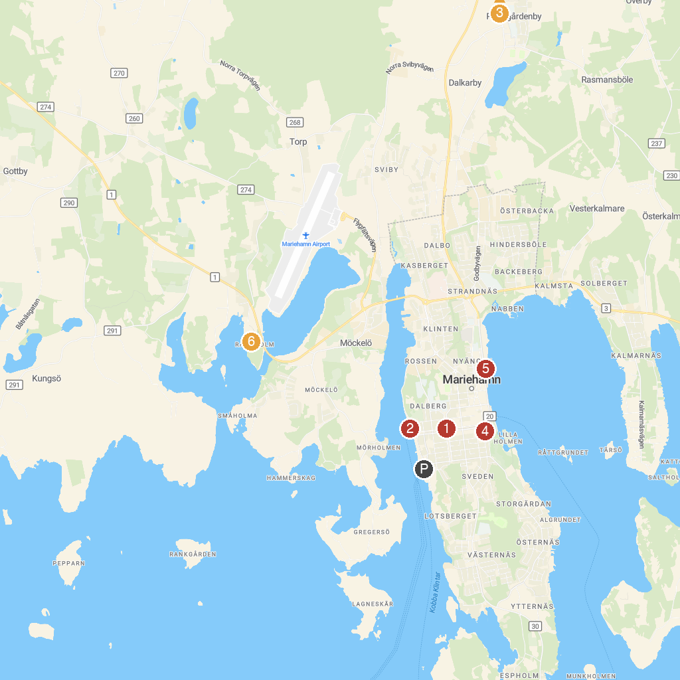
MAP KEY
1. St. George Church | 4. Åland Museum
2. Museum ship Pommern | 5. Sjökvarteret
3. St. Olaf's Church, Jomala | 6. Ramsholmen
P. Cruise port / terminal
Map © MapTiler © OpenStreetMap contributors · cruiseports.org

