Marigot, Saint Martin, France
The French Caribbean at its finest — pastel waterfront, a hilltop fort, open-air lolos, and sun-drenched beaches minutes from town. Marigot feels like a slice of the Riviera dropped into the tropics.
⚓ Tender or small pier · 🕒 Typical call: 6–8 hrs · 💶 Euro (USD widely accepted) · 🗣️ French / English spoken
✍️ MY DAY IN PORT (FILL IN)
Ship / Date
In port | arrive ______ · all aboard ______
Booked excursion
Notes / meeting point
GETTING ASHORE
- Docking: Small ships dock at Marigot quay; large ships anchor in bay and tender in
- Walk to center: 0 min — tender drops right on the waterfront market
- Best For: French cuisine, Fort Louis views, market shopping, nearby beaches
- Don't Miss: A lolo lunch and the climb up Fort Louis for panoramic bay views
GETTING AROUND
- 🚕 Taxi: $20–$35 per taxi (1–2 passengers) — Taxis use fixed government-regulated zone rates — no meters. From Philipsburg cruise dock to Marigot costs $20–$35; add
- 📱 Rideshare: ❌ not available
TOP THINGS TO DO
- Fort Louis & Panoramic Views — Built in 1789, Fort Louis crowns the hill above town.
- Marigot Market & Waterfront Stroll — The open-air market alongside the ferry terminal buzzes with spices, tropical fruit, batik clothing, and rhum arrangé.
- Loterie Farm Zipline & Jungle Pool — A lush nature reserve at the foot of Pic Paradis, the island's highest peak.
- Friar's Bay & Baie Rouge Beach — Two of the French side's best beaches are a short taxi ride from town.
- Lolo Lunch on the Waterfront — The lolos — casual open-air Creole BBQ stalls near the ferry terminal — are an institution.
BEST WALKS
- Waterfront & Fort Louis Loop: 1.5–2 hrs · Easy to moderate · Free — Start at the Marigot Ferry Terminal, browse the market stalls, then stroll along the waterfront to…
- Rue de la République Architecture Walk: 30–45 min · Easy · Free — A short stroll through the heart of Marigot's old town.
WEATHER · DAYLIGHT · MONEY
Month | High °F | Low °F | Rainy days
May | 80 | 78 | 9
Jul | 82 | 80 | 13
Sep | 83 | 80 | 16
Daylight: May 5:39AM–6:38PM · Jul 5:45AM–6:51PM · Sep 6:00AM–6:14PM
cruiseports.org/marigot · Confirm terminal & all-aboard time with your ship

Marigot, Saint Martin, France — Port Map
Red = walkable sights · Amber = excursions farther out · P = cruise terminal
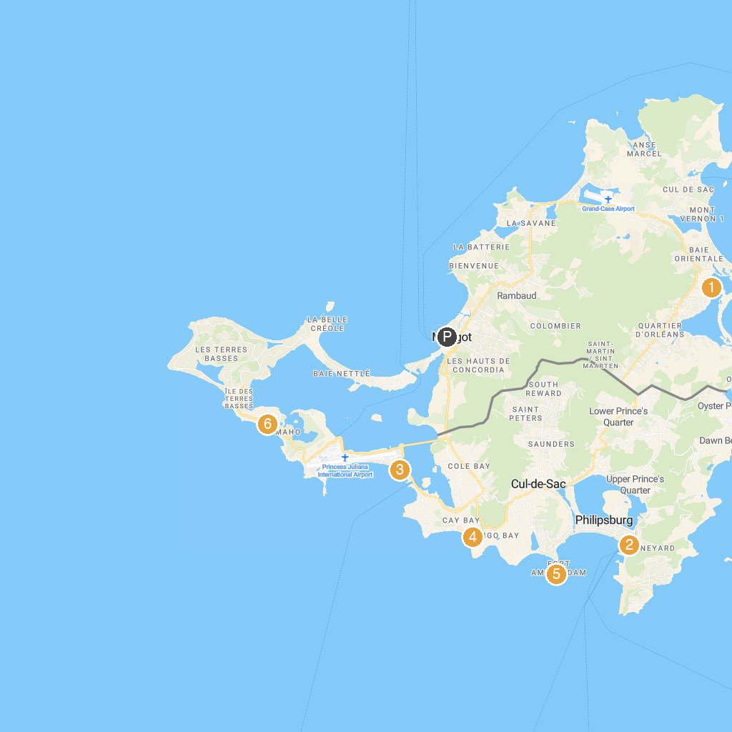
MAP KEY
1. The Butterfly Farm | 4. Seaside Ranch St. Maarten
2. Diamond Casino SXM | 5. Fort Amsterdam
3. Mary, Star of the Sea Catholic Church | 6. Starz City Casino
P. Cruise port / terminal
Map © MapTiler © OpenStreetMap contributors · cruiseports.org

