Marmaris, Muğla, Turkey
Where pine-forested mountains plunge into a landlocked turquoise bay, Marmaris blends a medieval castle, a sprawling bazaar, and one of Turkey's finest gulet harbours — all within easy walking distance of the pier.
⚓ Pier (docked) · 🕒 Typical call: 8–10 hrs · 💵 Turkish Lira (TRY); EUR/USD widely accepted · 🗣️ Turkish · 🌡️ Hot Mediterranean summers
✍️ MY DAY IN PORT (FILL IN)
Ship / Date
In port | arrive ______ · all aboard ______
Booked excursion
Notes / meeting point
GETTING ASHORE
- Docking: Cruise Pier — ships dock at Marmaris Cruise Port on the eastern bay; no tender required
- Walk to centre: ~15–20 min (1.2 km) along Netsel Marina promenade to Old Town
- Best For: Bazaar shopping, castle views, Turkish hamam, Dalyan/Kaunos rock tombs day trip
- Don't Miss: Marmaris Castle ramparts for panoramic harbour views
GETTING AROUND
- 🚕 Taxi: ₺200–300 — Metered yellow taxis queue at the port entrance. Fares start around ₺200 minimum; most city-center destinations are a sh
TOP THINGS TO DO
- Marmaris Castle & Archaeology Museum — Rebuilt by Suleiman the Magnificent in 1522 before his Rhodes campaign, this compact hilltop fortress holds ancient artefacts and…
- Grand Bazaar & Old Town — Hundreds of covered stalls selling spices, Turkish delight, ceramics, lamps, and leather.
- İçmeler Beach Day — A 15-minute dolmuş ride south brings you to a wider, cleaner beach backed by pine-covered mountains.
- Dalyan River & Kaunos Rock Tombs — Drive about 1.5 hours to Dalyan, then cruise the reed-lined river past the 4th-century BC Carian rock tombs of ancient Kaunos…
- Cleopatra Island (Sedir Adası) Boat Trip — A scenic boat excursion across Gökova Bay to a small island famous for its rare, fine white oolitic sand — legend says Mark…
BEST WALKS
- Port to Castle Loop: 2.5 km · ~1 hr · Easy — Walk the marina promenade from the cruise terminal to the Old Town, climb the cobbled lane to…
- Atatürk Park Promenade: 3 km one-way · ~45 min · Flat — Head west along the seafront promenade past Atatürk Park, public beaches, and the town centre.
WEATHER · DAYLIGHT · MONEY
Month | High °F | Low °F | Rainy days
May | 79 | 62 | 7
Jul | 97 | 76 | 0
Sep | 89 | 71 | 2
Daylight: May 5:59AM–8:07PM · Jul 5:59AM–8:25PM · Sep 6:49AM–7:14PM
cruiseports.org/marmaris · Confirm terminal & all-aboard time with your ship

Marmaris, Muğla, Turkey — Port Map
Red = walkable sights · Amber = excursions farther out · P = cruise terminal
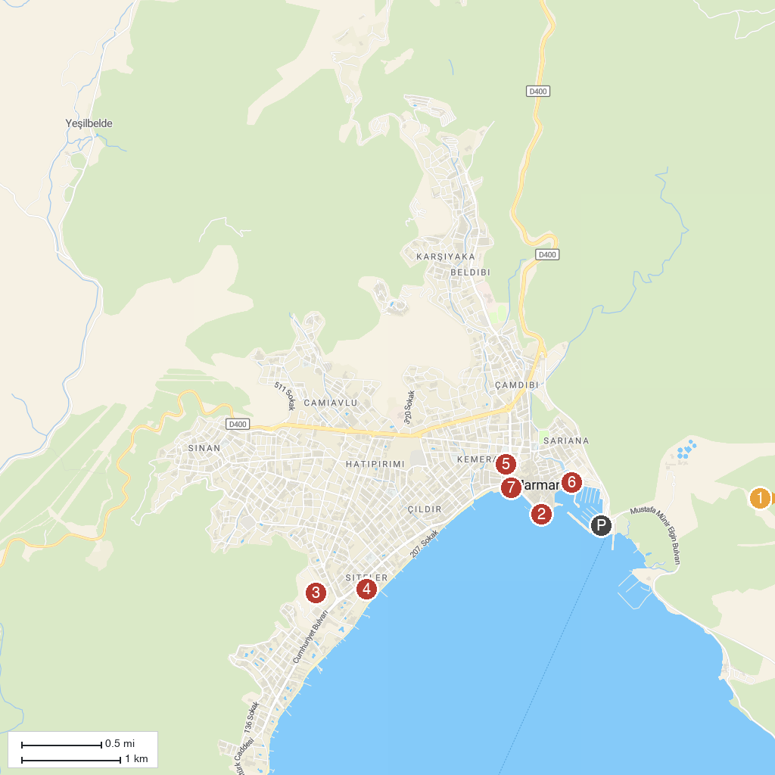
MAP KEY
1. Marmaris National Park | 5. Dancing Fountain
2. Marmaris Castle and Archeology Museum | 6. Marmaris Harbour viewpoint
3. Aqua Dream Water Park | 7. Atatürk Heykeli
4. Atlantis Water Park
P. Cruise port / terminal
Map © MapTiler © OpenStreetMap contributors · cruiseports.org

