Melk, Lower Austria, Austria
A Baroque masterpiece towering over the Danube, Melk's hilltop abbey rewards every river cruiser who steps ashore into one of Austria's most photogenic towns.
⚓ Docked (riverside pier) · 🕒 Typical call: 4–6 hrs · 💶 Currency: Euro (€) · 🗣️ Language: German (English widely spoken) · 🍑 Wachau apricot country
✍️ MY DAY IN PORT (FILL IN)
Ship / Date
In port | arrive ______ · all aboard ______
Booked excursion
Notes / meeting point
GETTING ASHORE
- Docking: Direct berth on the Donaulände (Danube embankment) — no tender
- Walk to Abbey: 20–25 min on foot; shuttle often available
- Best For: Baroque history, scenic Wachau cycling, Austrian food
- Don't Miss: Melk Abbey Library and Marble Hall
GETTING AROUND
- 🚕 Taxi: €4–€10 — Local taxis are available in Melk. Given the compact town size, most rides will hit minimum fare. Confirm rates on arriv
TOP THINGS TO DO
- Melk Abbey Tour — Explore the Benedictine monastery that has crowned this Danube cliff for over 900 years.
- Wachau Valley Cycling — The EuroVelo Danube Cycle Path runs straight through Melk.
- Schallaburg Castle — A 5 km drive from Melk, Schallaburg is a stunning Renaissance castle famous for its ornate terracotta courtyard and rotating…
- Wachau Wine & Apricot Tasting — The Wachau Valley holds an EU-protected designation for its Grüner Veltliner and Riesling whites and the legendary Wachauer…
BEST WALKS
- Pier to Abbey via Old Town: ~2 km round-trip | 45–60 min | Moderate — Walk the flat riverfront path from the pier to Hauptplatz, pause at the decorated 'Zur Alten Post'…
- Abbey Park & Garden Pavilion: ~30 min | Easy (within Abbey grounds) — After touring the interior, stroll the Abbey's Baroque garden.
WEATHER · DAYLIGHT · MONEY
Month | High °F | Low °F | Rainy days
May | 66 | 50 | 15
Jul | 79 | 61 | 12
Sep | 70 | 54 | 11
Daylight: May 5:19AM–8:31PM · Jul 5:14AM–8:54PM · Sep 6:36AM–7:10PM
cruiseports.org/melk · Confirm terminal & all-aboard time with your ship

Melk, Lower Austria, Austria — Port Map
Red = walkable sights · Amber = excursions farther out · P = cruise terminal
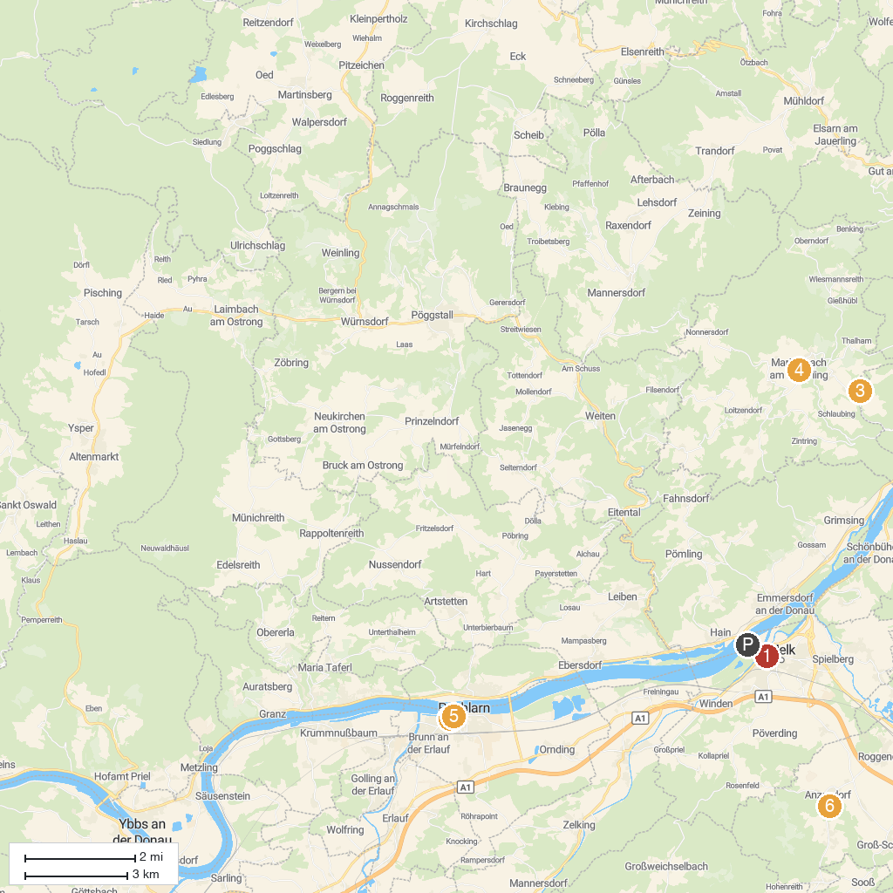
MAP KEY
1. Melk Abbey | 5. Nibelungendenkmal
2. Oskar Kokoschka Museum | 6. Pfarr- und Wallfahrtskirche Mariae Geburt
3. Family Park Wachau, amusement park Hubhof | 7. Schloss Pöggstall
4. Jauerling-Wachau Nature Park | 8. Schallaburg
P. Cruise port / terminal
Map © MapTiler © OpenStreetMap contributors · cruiseports.org

