Messina, Sicily, Italy
Gateway to Sicily, Messina docks you in the heart of the city — the cathedral's giant astronomical clock performs at noon, and Taormina and Etna are an hour away.
⚓ Docked (pier) · 🕒 Typical call: 8-10 hrs · 💶 Currency: Euro (€) · 🗣️ Language: Italian
✍️ MY DAY IN PORT (FILL IN)
Ship / Date
In port | arrive ______ · all aboard ______
Booked excursion
Notes / meeting point
GETTING ASHORE
- Docking: All ships dock at Molo Marconi / Terminal Crociere — no tender
- Walk to center: ~500 m, 5-10 min to Piazza del Duomo
- Best For: Day trips to Taormina, Mount Etna, and Godfather villages
- Don't Miss: The Duomo astronomical clock show at noon
GETTING AROUND
- 🚕 Taxi: €8–12 — Official taxis are available at the port exit. Short ride to city center or Messina Centrale train station (~2 km). Fixe
- 📱 Rideshare: ✅ Uber
- 🚌 Hop-on hop-off: ✅ City Sightseeing Messina
TOP THINGS TO DO
- Taormina & the Greek Theatre — Sicily's most photogenic hilltop town sits about 50 km south, its ancient Greek-Roman theatre framing a postcard view of Etna.
- Mount Etna Craters — Europe's tallest active volcano dominates the skyline.
- Godfather Villages — Savoca & Forza d'Agrò — The Bar Vitelli in Savoca and the hilltop streets of Forza d'Agrò stood in for Corleone in Francis Ford Coppola's trilogy.
- Duomo & Astronomical Clock — Messina's rebuilt Norman cathedral houses one of the world's largest and most complex mechanical clocks.
- Alcantara Gorges — The Gole dell'Alcantara cut through lava rock to form a dramatic canyon you can wade through in summer.
BEST WALKS
- Cathedral & Waterfront Loop: 1.5 km • ~45 min • Easy — Walk inland from the port along Via I Settembre to Piazza del Duomo for the cathedral and Orion…
- Art & Architecture Walk: 2 km • ~1 hr • Easy — From the Duomo head north-west to the Church of Santissima Annunziata dei Catalani (a rare Norman…
WEATHER · DAYLIGHT · MONEY
Month | High °F | Low °F | Rainy days
May | 71 | 58 | 9
Jul | 85 | 71 | 5
Sep | 80 | 68 | 11
Daylight: May 5:47AM–8:01PM · Jul 5:47AM–8:20PM · Sep 6:39AM–7:05PM
cruiseports.org/messina · Confirm terminal & all-aboard time with your ship

Messina, Sicily, Italy — Port Map
Red = walkable sights · Amber = excursions farther out · P = cruise terminal
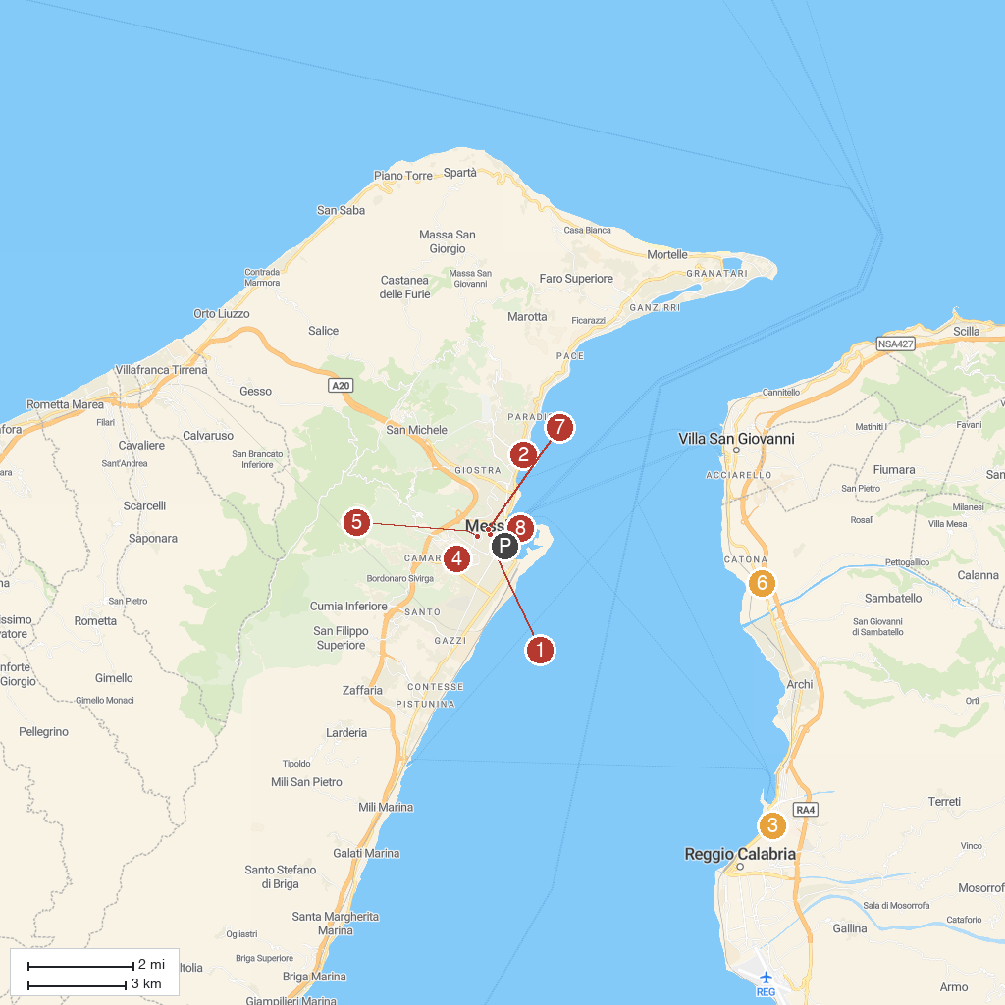
MAP KEY
1. Palazzo del Monte di Pietà | 5. Chiesa di San Camillo
2. Museo Regionale Interdisciplinare di Messina | 6. Sanctuary of Saint Francis of Paola
3. Museo Archeologico Nazionale di Reggio Calabria | 7. Tempio di Cristo Re
4. Forte Gonzaga | 8. Stele della Madonna della Lettera
P. Cruise port / terminal
Map © MapTiler © OpenStreetMap contributors · cruiseports.org

