Middelburg, Zeeland, Netherlands
Zeeland's quiet capital once rivalled Amsterdam as a VOC trading hub. Today its Gothic town hall, 12th-century abbey, and cobblestone canal lanes offer one of the Netherlands' most rewarding compact days ashore.
⚓ Docked (river ships) / Pier at Vlissingen (ocean ships) · 🕒 Typical call: 6-8 hrs · 💶 Currency: Euro (€) · 🗣️ Language: Dutch (English widely spoken)
✍️ MY DAY IN PORT (FILL IN)
Ship / Date
In port | arrive ______ · all aboard ______
Booked excursion
Notes / meeting point
GETTING ASHORE
- Docking: River ships berth at Loskade canal — steps from centre. Ocean ships dock Vlissingen (6 km south; 8-min train).
- Walk to centre: River dock: 5-10 min on foot. From Vlissingen pier: train or shuttle to Middelburg.
- Best For: History lovers, foodies, canal strolls, Dutch Golden Age architecture
- Don't Miss: Climbing Lange Jan tower (90 m) and the Zeeuws Museum tapestries inside the Abbey
GETTING AROUND
- 🚕 Taxi: €25–€35 — If your ship docks at Vlissingen (~7 km away), taxis to Middelburg city centre run €25–€35. Local companies include Stax
- 📱 Rideshare: ✅ Uber
TOP THINGS TO DO
- Middelburg Abbey & Lange Jan Tower — The 12th-century Abbey complex anchors the city.
- Zeeuws Museum — Tapestries & Maritime History — Inside the Abbey, this museum houses stunning 16th-century tapestries depicting naval battles against Spain, traditional Zeeland…
- Canal Boat Tour (Rondvaart) — Open-air boats wind under low medieval bridges and past 17th-century gabled façades.
- Vlissingen & Zeeland Beaches — The Walcheren peninsula has some of the Netherlands' finest beaches.
- Delta Works & Neeltje Jans — The Eastern Scheldt storm surge barrier — one of the greatest engineering feats of the 20th century — lies 35 km east.
BEST WALKS
- Old Town Highlights Loop: 2 km · 45 min · Easy — Start at the Markt and admire the Late-Gothic Stadhuis façade with its row of sculpted counts and…
- Canal Quay Stroll: 1 km · 20 min · Easy — A gentle out-and-back walk along the main canal quay from the river dock at Loskade toward the…
WEATHER · DAYLIGHT · MONEY
Month | High °F | Low °F | Rainy days
May | 61 | 50 | 12
Jul | 70 | 60 | 13
Sep | 67 | 56 | 11
Daylight: May 5:51AM–9:32PM · Jul 5:44AM–9:58PM · Sep 7:19AM–8:01PM
cruiseports.org/middelburg · Confirm terminal & all-aboard time with your ship

Middelburg, Zeeland, Netherlands — Port Map
Red = walkable sights · Amber = excursions farther out · P = cruise terminal
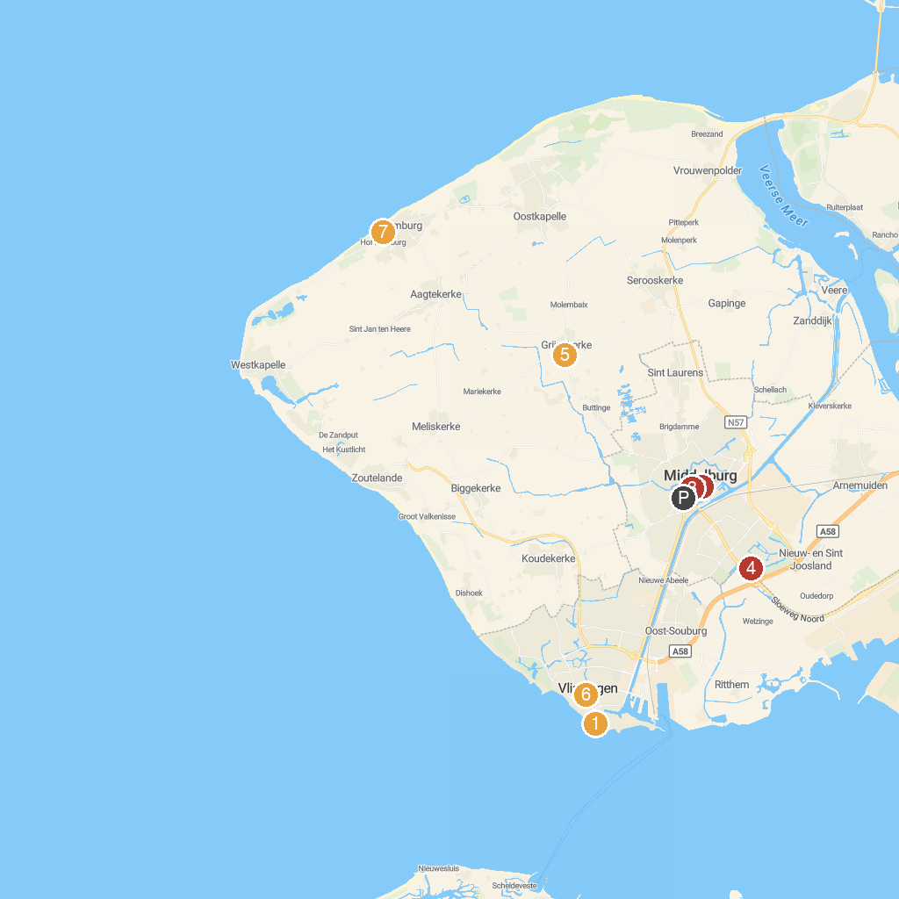
MAP KEY
1. Iguana reptile Zoo | 5. Molen 't Welvaaren van Grijpskerke
2. New Church Middelburg | 6. Museum Panorama Walcheren
3. Foundation Public Observatory Philippus Lansbergen | 7. Domburgsche Golfclub
4. ZEP
P. Cruise port / terminal
Map © MapTiler © OpenStreetMap contributors · cruiseports.org

