Milwaukee, Wisconsin, USA
The Cream City on the Fresh Coast — Milwaukee pairs world-class architecture and a legendary brewing heritage with free lakefront walks, farm-to-table kitchens, and warm Midwestern hospitality.
⚓ Pier (docked) · 🕒 Typical call: 8-10 hrs · 💵 US Dollar (USD) · 🗣️ English · 🌊 Great Lakes port
✍️ MY DAY IN PORT (FILL IN)
Ship / Date
In port | arrive ______ · all aboard ______
Booked excursion
Notes / meeting point
GETTING ASHORE
- Docking: Pier — no tender. Pier Wisconsin (downtown) or Jones Island Heavy Lift Dock (south, shuttle required)
- Walk to center: 2 min from Pier Wisconsin; Jones Island requires a ~15-min rideshare or cruise shuttle
- Best For: Architecture, brewery tours, lakefront strolls, Midwestern food
- Don't Miss: Milwaukee Art Museum's Calatrava wing-fold at 10 AM, noon, or 5 PM
GETTING AROUND
- 🚕 Taxi: $6–10 — From Pier Wisconsin (downtown), a taxi is a short $6–10 ride. From South Shore dock (across the Hoan Bridge), expect $12
- 📱 Rideshare: ✅ Uber, Lyft
- 🚌 Hop-on hop-off: ✅
TOP THINGS TO DO
- Milwaukee Art Museum & the Calatrava Wings — One of the most spectacular museum buildings in the world — Santiago Calatrava's Quadracci Pavilion features 217-foot wings (the…
- Harley-Davidson Museum — Even non-riders find this 20-acre campus compelling.
- Lakefront Brewery Tour — Consistently rated one of the best brewery tours in America — irreverent, fast, and entertaining, with souvenir pint glasses and…
- Pabst Mansion & Old World Third Street — Tour the gilded Flemish Renaissance mansion of beer baron Captain Frederick Pabst, then stroll Old World Third Street — the heart…
- Bradford Beach & the Lakefront Path — Lake Michigan looks and feels like an ocean — miles of horizon, soft sand, and waves.
BEST WALKS
- Lakefront Landmark Loop: 2.5 miles · Easy · 60-90 min — Walk north from Pier Wisconsin past the Milwaukee Art Museum to Veterans Park and Bradford Beach…
- Riverwalk Stroll: 1.5 miles · Easy · 45 min — Follow the Milwaukee RiverWalk from the Third Ward north through downtown.
WEATHER · DAYLIGHT · MONEY
Month | High °F | Low °F | Rainy days
May | 62 | 47 | 12
Jul | 79 | 64 | 10
Sep | 72 | 59 | 11
Daylight: May 5:28AM–8:08PM · Jul 5:26AM–8:28PM · Sep 6:31AM–7:00PM
cruiseports.org/milwaukee-wi · Confirm terminal & all-aboard time with your ship

Milwaukee, Wisconsin, USA — Port Map
Red = walkable sights · Amber = excursions farther out · P = cruise terminal
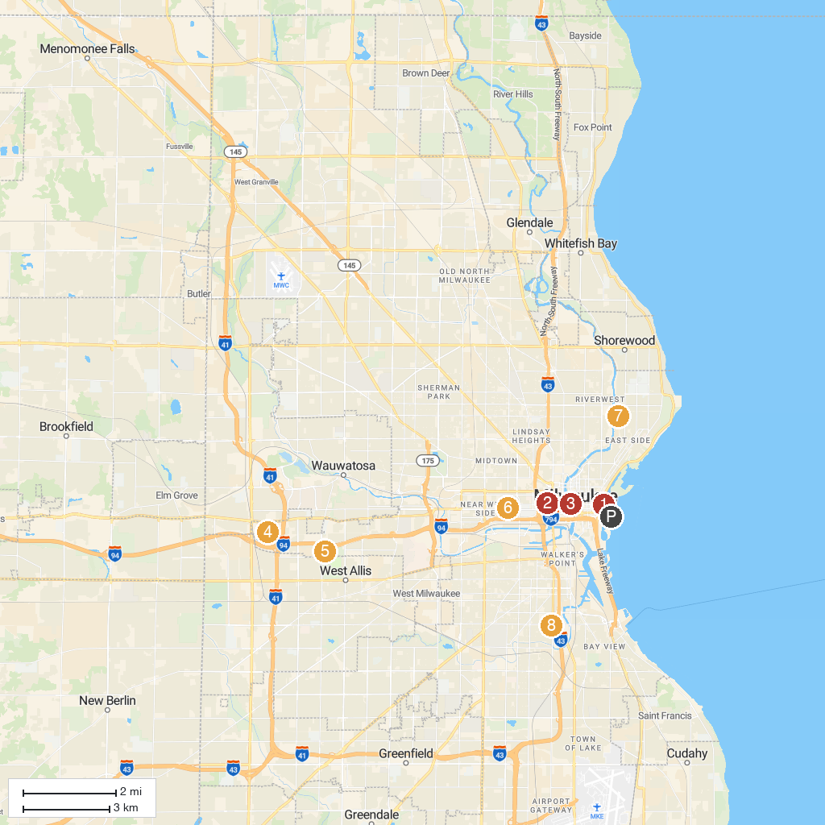
MAP KEY
1. Milwaukee Art Museum | 5. Pettit National Ice Center
2. Milwaukee Public Museum | 6. Pabst Mansion
3. “Bronze Fonz” by Gerald P. Sawyer | 7. Urban Ecology Center - Riverside Park
4. Milwaukee County Zoo | 8. Basilica of Saint Josaphat
P. Cruise port / terminal
Map © MapTiler © OpenStreetMap contributors · cruiseports.org

