Minden, North Rhine-Westphalia, Germany
Minden is the only place in Europe where you can watch a canal float above a river — and that engineering marvel is just the opening act. Add a soaring Prussian monument, a Romanesque cathedral, and a town that still smells like smoked ham.
⚓ Docked (riverside pier) · 🕒 Typical call: 6–8 hrs · 💶 Euro (€) — carry cash · 🗣️ German
✍️ MY DAY IN PORT (FILL IN)
Ship / Date
In port | arrive ______ · all aboard ______
Booked excursion
Notes / meeting point
GETTING ASHORE
- Docking: Docked at Schlagde riverside quay; no tender
- Walk to centre: 5–10 min from dock to Marktplatz
- Best For: Engineering wonders, history, Westphalian food
- Don't Miss: Wasserstraßenkreuz aqueduct — canal crossing the Weser
GETTING AROUND
- 🚕 Taxi: €8–€12 — Local taxis cover the short ride to the city center. Base fare ~€4.40 plus ~€2.75/km; the port-to-center distance is rou
- 📱 Rideshare: ✅ Uber
TOP THINGS TO DO
- Wasserstraßenkreuz — Canal Over the River — Europe's most striking waterway junction: the Mittelland Canal crosses high above the Weser River on twin aqueducts (1914…
- Kaiser Wilhelm Monument & Porta Westfalica — The 88-metre monument atop Wittekindsberg hill honours Germany's first emperor and commands sweeping views over the Weser Valley…
- Minden Cathedral & Old Town Walk — The Dom St.
- Mindener Museum — Housed in a row of 16th-century Weser Renaissance buildings, this local museum covers the region's military, trade, and cultural…
- Weserpromenade & Kanzlers Weide Walk — Stroll the landscaped riverside promenade, cross the Glacisbrücke pedestrian suspension bridge to Kanzlers Weide — a wide green…
BEST WALKS
- Dock to Altstadt & Cathedral: 0.5 km · 10 min · Easy — From the Schlagde quay, walk uphill along Weserstraße to the Dom, then loop through the Marktplatz…
- Riverside Path to the Aqueduct: 3 km one-way · 35 min · Flat — Follow the Weser riverside path north from the dock to the Wasserstraßenkreuz.
WEATHER · DAYLIGHT · MONEY
Month | High °F | Low °F | Rainy days
May | 64 | 48 | 11
Jul | 74 | 58 | 12
Sep | 68 | 53 | 10
Daylight: May 5:30AM–9:12PM · Jul 5:20AM–9:40PM · Sep 6:58AM–7:40PM
cruiseports.org/minden-weser · Confirm terminal & all-aboard time with your ship

Minden, North Rhine-Westphalia, Germany — Port Map
Red = walkable sights · Amber = excursions farther out · P = cruise terminal
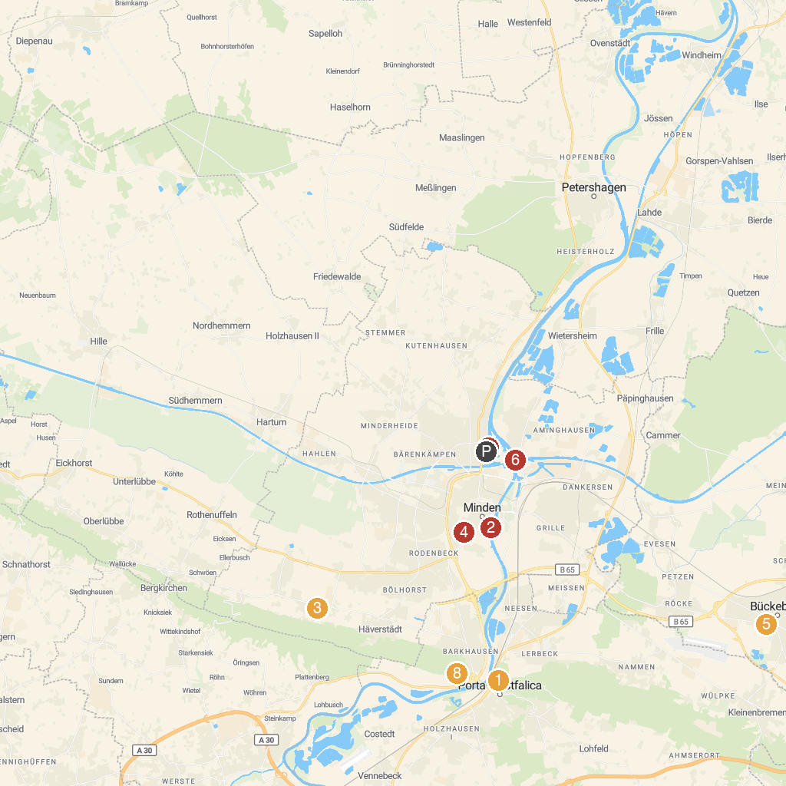
MAP KEY
1. Porta-Kanzel | 5. Schloss Park
2. Schiffmühle | 6. Minden Aqueduct
3. potts park - Heinrich Pott GmbH & Co. KG | 7. Schachtschleuse Minden
4. LWL-Preußenmuseum Minden | 8. Emperor William Monument
P. Cruise port / terminal
Map © MapTiler © OpenStreetMap contributors · cruiseports.org

