Miyako, Iwate, Japan
Where dramatic volcanic rock formations meet crystal-clear Pacific waters — Miyako's Sanriku Coast is one of Japan's most jaw-dropping natural shores, paired with a story of extraordinary resilience.
⚓ Pier (Fujiwara Wharf) · 🕒 Typical call: 8-10 hrs · 💴 Currency: Japanese Yen (JPY) · 🗣️ Language: Japanese
✍️ MY DAY IN PORT (FILL IN)
Ship / Date
In port | arrive ______ · all aboard ______
Booked excursion
Notes / meeting point
GETTING ASHORE
- Docking: Pier at Fujiwara Wharf — ships berth alongside, no tender needed
- Walk to center: ~4 km to Miyako Station — shuttle bus usually provided free
- Best For: Jodogahama Beach, sappa boat cave tour, fresh sea urchin and bin-don
- Don't Miss: A sappa boat ride into the glowing Aonodōkutsu (Blue Cave)
GETTING AROUND
- 🚕 Taxi: ~¥1,500 (~) — Taxis are available at the pier. The ride to Miyako Station takes about 10 minutes and costs roughly ¥1,500.
TOP THINGS TO DO
- Jodogahama Beach — Named 'Pure Land Beach' by a Buddhist monk who likened it to Paradise, this iconic cove features white volcanic spires rising…
- Sappa Boat Blue Cave Tour — Board a traditional flat-bottomed sappa fishing boat for a guided coastal cruise around the rocky headlands and into the…
- Tsunami Resilience Tour (Taro District) — Taro, north of Miyako, was devastated in 2011 despite massive seawalls.
- Bin-Don Seafood Bowl — Miyako's signature dish: fresh uni (sea urchin), ikura (salmon roe), and scallops layered in a glass milk bottle over rice.
- Sanno Rocks Coastal Walk (Taro) — Three towering sea stacks rise up to 50 m from the Pacific at Sanno-iwa.
BEST WALKS
- Jodogahama Coastal Trail: 1.5 km loop · Easy · Free — From the Jodogahama Rest House, a well-maintained path winds through pine-forested headlands above…
- Miyako Station Shopping Stroll: 30-45 min · Easy — Walk from Miyako Station through the covered arcade to the fish market area for fresh catches…
WEATHER · DAYLIGHT · MONEY
Month | High °F | Low °F | Rainy days
May | 66 | 51 | 11
Jul | 77 | 68 | 16
Sep | 74 | 63 | 13
Daylight: May 4:18AM–6:39PM · Jul 4:17AM–6:58PM · Sep 5:13AM–5:41PM
cruiseports.org/miyako-iwate · Confirm terminal & all-aboard time with your ship

Miyako, Iwate, Japan — Port Map
Red = walkable sights · Amber = excursions farther out · P = cruise terminal
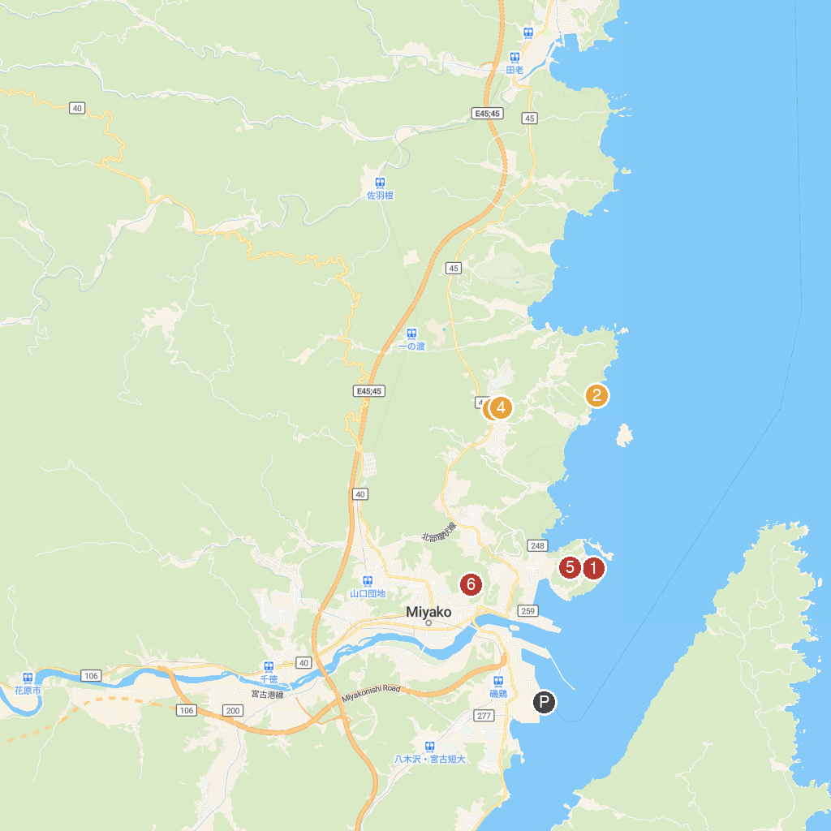
MAP KEY
1. Hachinohe-ana (Blue Cave) | 4. Miyakoshi Sakiyamakaizukajomonnomori Park
2. Shiofuki-ana Blowhole | 5. Iwate Prefectural Fishery Science Museum
3. Sakiyama Shell Mound Jomon-no-mori Museum | 6. Joanji
P. Cruise port / terminal
Map © MapTiler © OpenStreetMap contributors · cruiseports.org

