Mobile, Alabama, USA
America's original Mardi Gras city sits right on the waterfront. From the cruise terminal steps you can walk to 300 years of history, great Southern food, and one of the Gulf Coast's most authentic downtowns.
⚓ Pier (no tender) · 🕒 Homeport — full day · 💵 USD · 🗣️ English · 🎭 America's original Mardi Gras city
✍️ MY DAY IN PORT (FILL IN)
Ship / Date
In port | arrive ______ · all aboard ______
Booked excursion
Notes / meeting point
GETTING ASHORE
- Docking: Pier — ships dock directly at the downtown terminal (201 S. Water St.)
- Walk to center: Dauphin Street shops & restaurants ~0.5 mi; Fort Condé ~0.3 mi
- Best For: Southern history, Mardi Gras culture, Gulf Coast cuisine, battleship fans
- Don't Miss: USS Alabama Battleship Memorial Park (short drive) and the Mobile Carnival Museum
GETTING AROUND
- 🚕 Taxi: $10–$20 — Taxis are available at the port. Metered fares start at $2.50 plus ~$2.04/mile. Most downtown destinations cost under $1
- 📱 Rideshare: ✅ Uber, Lyft
TOP THINGS TO DO
- USS Alabama Battleship Memorial Park — Board the massive WWII battleship USS Alabama and explore the submarine USS Drum, vintage aircraft, and military hardware spread…
- Mobile Carnival Museum — Discover why Mobile — not New Orleans — claims the title of America's original Mardi Gras city (founded 1703).
- Fort Condé & Downtown Historic Walk — Start at the reconstructed 18th-century French fort (free entry) with costumed guides and cannon demonstrations, then stroll to…
- GulfQuest National Maritime Museum — An impressive waterfront museum with 90+ interactive exhibits covering Gulf of Mexico maritime heritage — shipwrecks, the oil…
- Dauphin Street Dining & MoonPie Store — Wander Mobile's historic restaurant row for Gulf shrimp po'boys, gumbo, and classic Southern plates.
BEST WALKS
- Waterfront to Dauphin Street: 0.5 mi | Easy | 30–45 min — Head north from the terminal along Water Street to the GulfQuest Maritime Museum, then cut up to…
- Historic Core Loop: 1 mi | Easy | 45–60 min — From Dauphin Street, loop through Bienville Square, past the Cathedral Basilica, and back down to…
WEATHER · DAYLIGHT · MONEY
Month | High °F | Low °F | Rainy days
May | 82 | 67 | 11
Jul | 89 | 76 | 19
Sep | 86 | 72 | 12
Daylight: May 5:57AM–7:40PM · Jul 6:00AM–7:55PM · Sep 6:36AM–6:57PM
cruiseports.org/mobile · Confirm terminal & all-aboard time with your ship

Mobile, Alabama, USA — Port Map
Red = walkable sights · Amber = excursions farther out · P = cruise terminal
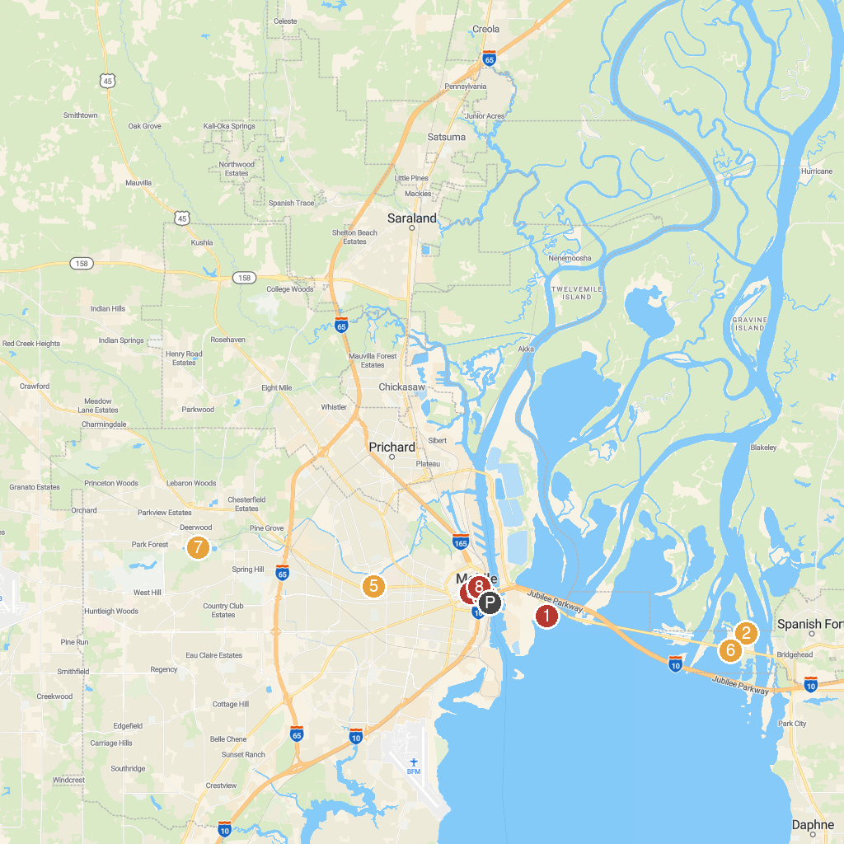
MAP KEY
1. USS ALABAMA Battleship Memorial Park | 5. Bragg-Mitchell Mansion
2. AWF Delta & Bay Conservation Center | 6. Meaher State Park
3. Cathedral-Basilica of the Immaculate Conception | 7. Langan Park
4. Colonial Fort Condé | 8. Bienville Square
P. Cruise port / terminal
Map © MapTiler © OpenStreetMap contributors · cruiseports.org

