Monemvasia, Peloponnese, Greece
Called the 'Gibraltar of the East,' Monemvasia is a secret world of cobblestone alleys, Byzantine churches, and clifftop ruins hidden inside a single dramatic sea rock — entered only through one narrow gate.
⚓ Tender port (no pier) · 🕒 Typical call: 7–9 hrs · 💶 Currency: Euro (€) · 🗣️ Language: Greek · 🏛️ UNESCO-listed medieval town
✍️ MY DAY IN PORT (FILL IN)
Ship / Date
In port | arrive ______ · all aboard ______
Booked excursion
Notes / meeting point
GETTING ASHORE
- Docking: Tender to Gefyra marina — no cruise pier
- Walk to castle gate: ~1 mi (1.5 km) from tender; shuttle bus ~€1.50
- Best For: History lovers, photographers, medieval architecture
- Don't Miss: Upper Town ruins & Church of Agia Sofia views
GETTING AROUND
- 🚕 Taxi: €4.50–6 one-way — Taxis are available near the tender pier in Gefyra for the ~1.5 km ride to the castle gate. Cars are not permitted insid
TOP THINGS TO DO
- Lower Town Kastro Self-Guided Walk — Wander the labyrinth of cobblestone alleys, visit the Church of Elkomenos Christos (Christ in Chains), and browse boutiques…
- Upper Town Ruins & Church of Agia Sofia — A steep 15–20 minute climb from the Lower Town leads to the uninhabited Upper Town ruins and the remarkable 12th-century…
- Malvasia Wine Tasting — Monemvasia is the birthplace of the medieval Malmsey (Malvasia) wine.
- Portello Sea Swimming — The Portello (Sea Gate) in the Lower Town's southern wall opens directly onto the Aegean.
- Kakavos Beach (Gefyra) — A pebble beach just left of the mainland bridge, a short walk from the tender pier.
BEST WALKS
- Lower Town Loop: 45–60 min · Easy–Moderate · Cobblestone — Enter through the main gate, walk the main cobblestone street to the central square and Elkomenos…
- Climb to the Upper Town: 1–1.5 hrs · Strenuous · Steep stone steps — From the main square of the Lower Town, follow the Voltes path upward through the old town wall to…
WEATHER · DAYLIGHT · MONEY
Month | High °F | Low °F | Rainy days
May | 76 | 60 | 4
Jul | 90 | 73 | 2
Sep | 83 | 68 | 4
Daylight: May 6:20AM–8:28PM · Jul 6:21AM–8:46PM · Sep 7:10AM–7:34PM
cruiseports.org/monemvasia · Confirm terminal & all-aboard time with your ship

Monemvasia, Peloponnese, Greece — Port Map
Red = walkable sights · Amber = excursions farther out · P = cruise terminal
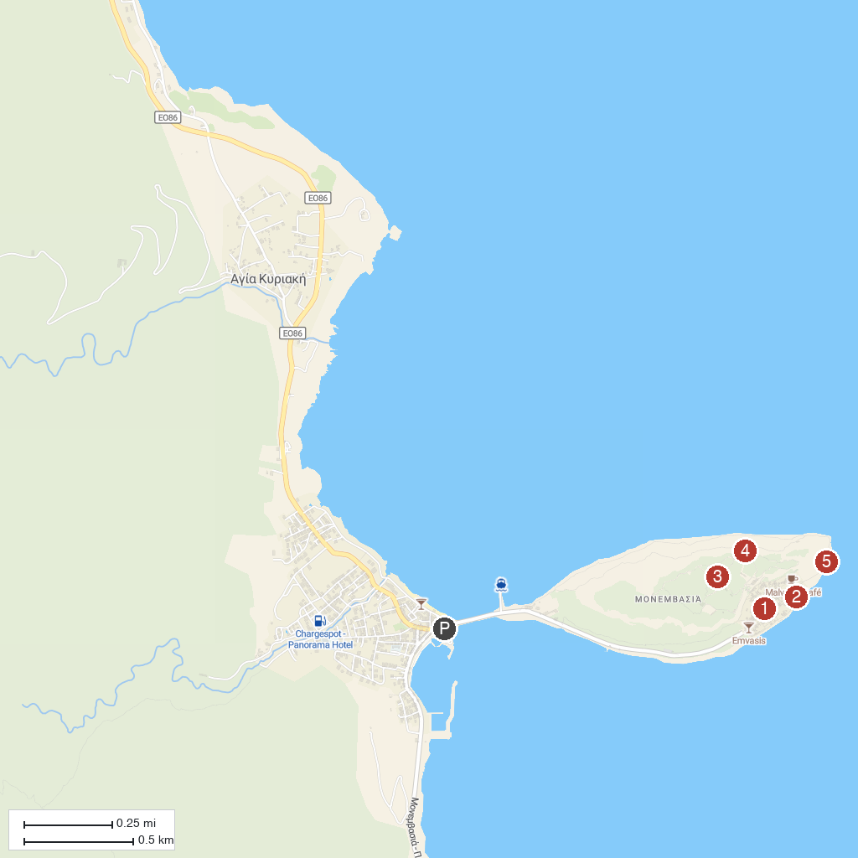
MAP KEY
1. Holy Church of Christ Elkomenos | 4. Holy Church of Hagia Sophia
2. Holy Church of the Virgin Mary Chrysaphitissa | 5. Lighthouse of Monemvasia
3. Upper Town
P. Cruise port / terminal
Map © MapTiler © OpenStreetMap contributors · cruiseports.org

