Monopoli, Puglia, Italy
Less famous than its neighbors but more genuine — Monopoli is Puglia at its most unhurried, with postcard harbors, candy-colored fishing boats, and beach coves you can walk to straight off the tender.
⚓ Tender (most ships anchor offshore) · 🕒 Typical call: 7–10 hrs · 💶 Currency: Euro · 🗣️ Language: Italian · 🏖️ Walkable beaches
✍️ MY DAY IN PORT (FILL IN)
Ship / Date
In port | arrive ______ · all aboard ______
Booked excursion
Notes / meeting point
GETTING ASHORE
- Docking: Tender for most ships; small luxury vessels may dock at Molo Margherita
- Walk to center: 2–5 min from tender pier to Old Town entrance
- Best For: Authentic Italian atmosphere, beaches, Baroque architecture, Pugliese food
- Don't Miss: Porto Vecchio fishing harbor, Cathedral of the Madonna della Madia, Cala Porta Vecchia beach
GETTING AROUND
- 🚕 Taxi: €10–€20 — Local taxis are available at the port and in the town center. Fares within Monopoli are typically €10–€20; confirm the r
TOP THINGS TO DO
- Monopoli Old Town Walk — Wander the whitewashed lanes of the Centro Storico, visit the Baroque cathedral and its Roman crypt, and admire the 16th-century…
- Polignano a Mare — Just ~9 km north by train or taxi, this dramatic cliff-top village with houses hanging over the Adriatic is one of the most…
- Alberobello Trulli — UNESCO-listed stone cone houses unique to Puglia, located about 22 km inland.
- Pugliese Food & Market Tour — Sample orecchiette con cime di rapa, fresh focaccia barese, burrata, and crudo di mare at the local fish market and family-run…
- Cala Porta Vecchia Beach — A free sandy cove tucked between the old town walls and the sea — turquoise, shallow, and walkable from the tender pier in 12…
BEST WALKS
- Porto Vecchio to Cathedral Loop: 1.5 km · 30–40 min · Easy — Start at the old harbor, walk along the sea walls past Castello Carlo V, cut into the alley network…
- Coastal Path to Cala Porta Vecchia: 1 km · 20 min · Easy — Follow the seafront promenade south from the tender pier along the old town walls to reach the…
WEATHER · DAYLIGHT · MONEY
Month | High °F | Low °F | Rainy days
May | 72 | 59 | 8
Jul | 87 | 73 | 3
Sep | 80 | 67 | 7
Daylight: May 5:33AM–8:01PM · Jul 5:32AM–8:21PM · Sep 6:31AM–6:59PM
cruiseports.org/monopoli · Confirm terminal & all-aboard time with your ship

Monopoli, Puglia, Italy — Port Map
Red = walkable sights · Amber = excursions farther out · P = cruise terminal
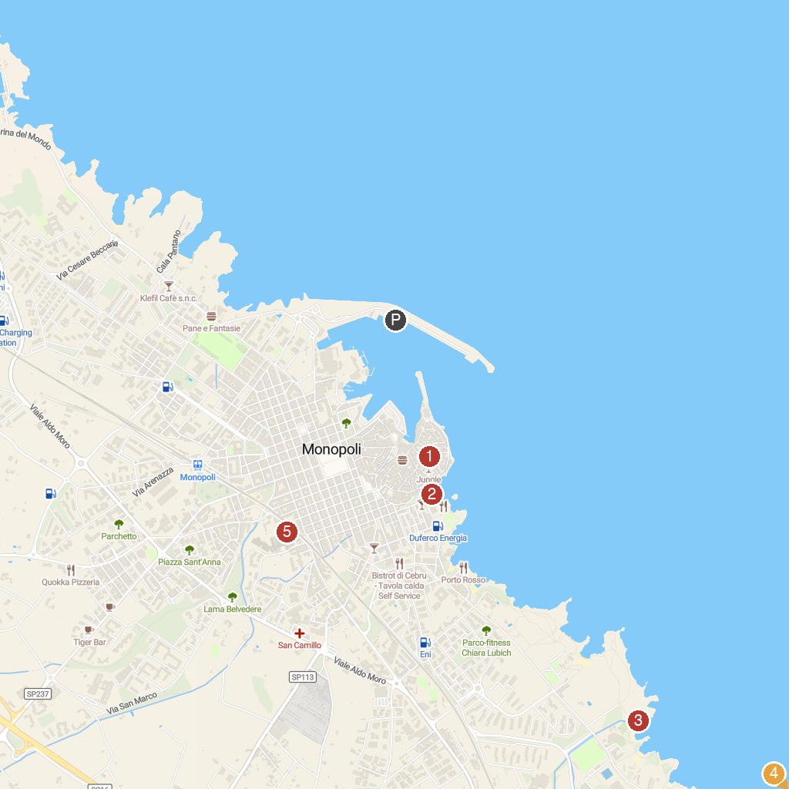
MAP KEY
1. Palazzo Palmieri | 5. Lido Le Macchie
2. Zoosafari Fasanolandia | 6. Casina Municipale
3. Cala Porta Vecchia | 7. Torre Castiglione
4. Grotta della Cala Tre Buchi | 8. Church of Saint Mary of the Carmel
P. Cruise port / terminal
Map © MapTiler © OpenStreetMap contributors · cruiseports.org

