Monte Carlo, Monaco
The world's most glamorous microstate packs a palace, a legendary casino, a Formula 1 street circuit, and a harbor full of superyachts into less than 2 square kilometers. Everything is walkable — if you don't mind hills.
⚓ Tender (larger ships) / dock (small ships) · 🕒 Typical call: 8-12 hrs · 💵 Euro (€) · 🗣️ French / English widely spoken · 🏙️ Ultra-walkable city-state
✍️ MY DAY IN PORT (FILL IN)
Ship / Date
In port | arrive ______ · all aboard ______
Booked excursion
Notes / meeting point
GETTING ASHORE
- Docking: Port Hercule — larger ships anchor and tender ashore; ships up to ~250m berth at Quai Rainier III
- Walk to center: 10 min on foot to Casino Square; 15 min to Prince's Palace
- Best For: Glamour, history, F1 fans, designer shopping, jaw-dropping views
- Don't Miss: The Oceanographic Museum and the Casino de Monte-Carlo exterior
GETTING AROUND
- 🚕 Taxi: €7–€20 — Metered taxis wait at Port Hercule. Fares within Monaco are modest given short distances — €7–€10 to the Prince's Palace
- 📱 Rideshare: ❌ not available
- 🚌 Hop-on hop-off: ✅ Monaco Le Grand Tour
TOP THINGS TO DO
- Casino de Monte-Carlo & Casino Square — The Belle Époque casino is the symbol of Monaco.
- Prince's Palace & Old Town (Monaco-Ville) — Perched on the Rock, the Prince's Palace hosts the daily changing of the guard at 11:55 AM.
- Musée Océanographique de Monaco — Founded by Prince Albert I in 1910, this cliffside museum has a world-class aquarium, marine research exhibits, and stunning…
- Formula 1 Circuit Walking Tour — Monaco hosts the most famous F1 street race in the world.
- Eze Village & Côte d'Azur Day Trip — The medieval perched village of Eze, about 6 km from Monaco, offers fragrant gardens, stone alleys, and panoramic views over the…
BEST WALKS
- Port to Casino Square Loop: 1.5 km · 30-45 min · Easy — The classic Monaco stroll.
- The Rock (Monaco-Ville) Walk: 2 km · 1-1.5 hrs · Moderate — Take bus 1 or 2 (or walk uphill) to Monaco-Ville, the Old Town on the Rock.
WEATHER · DAYLIGHT · MONEY
Month | High °F | Low °F | Rainy days
May | 87 | 70 | 14
Jul | 85 | 70 | 20
Sep | 83 | 69 | 23
Daylight: May 6:05AM–8:48PM · Jul 6:02AM–9:09PM · Sep 7:09AM–7:40PM
Representative sunrise/sunset — 2025, 15th of each month; local civil time including DST (Europe/Monaco). Source: Astral; not a forecast or climate average.
cruiseports.org/monte-carlo · Confirm terminal & all-aboard time with your ship

Monte Carlo, Monaco — Port Map
Red = walkable sights · Amber = excursions farther out · P = cruise terminal
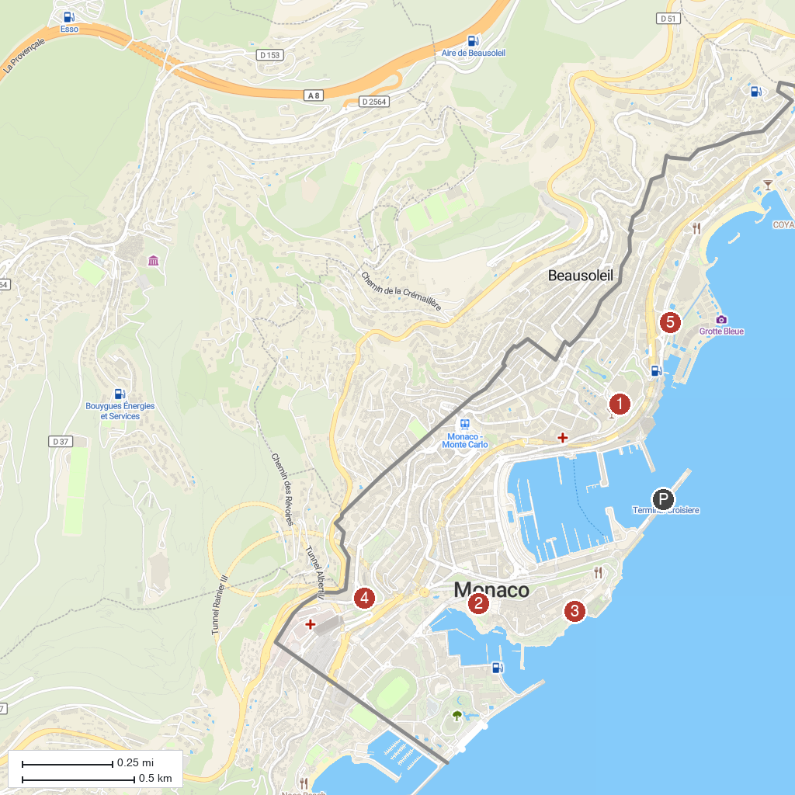
MAP KEY
1. Pyramid of Falicon | 5. Marc Chagall National Museum
2. Casino de Monte-Carlo | 6. Exotic Garden of Monaco
3. Prince's Palace of Monaco | 7. Modern and Contemporary Art Museum (MAMAC)
4. Musée océanographique de Monaco | 8. Princess Grace Japanese Garden
P. Cruise port / terminal
Map © MapTiler © OpenStreetMap contributors · cruiseports.org

