Montevideo, Uruguay
Uruguay's laid-back capital — a walkable old town of faded grandeur, the world's longest waterfront promenade, sizzling parrilla grills, and a mate cup in every hand.
⚓ Docked (central port) · 🕒 Typical call: 8–10 hrs · 💵 Uruguayan Peso (UYU) · USD ok · 🗣️ Spanish · some English
✍️ MY DAY IN PORT (FILL IN)
Ship / Date
In port | arrive ______ · all aboard ______
Booked excursion
Notes / meeting point
GETTING ASHORE
- Docking: Port terminal (central)
- Walk to Old Town: 5–10 min
- Best For: Old town · Food · Walks
- Don't Miss: Mercado del Puerto
GETTING AROUND
- 🚕 Taxi: $5–10 — Taxis are plentiful at the cruise terminal and the city center is only 3–4 km away (~10 min). USD is widely accepted; me
- 📱 Rideshare: ✅ Uber, Cabify
- 🚌 Hop-on hop-off: ✅
TOP THINGS TO DO
- Ciudad Vieja Walking Tour — The colonial old town — Plaza Independencia with the Artigas mausoleum and the Palacio Salvo, the Metropolitan Cathedral, Plaza…
- Mercado del Puerto Parrilla Lunch — The iron-and-glass market hall by the port, packed with parrilla grills serving Uruguay's legendary asado (barbecue).
- The Rambla & Parque Rodó — Stroll or cycle a stretch of the Rambla — said to be the world's longest continuous waterfront promenade — out to leafy Parque…
- Colonia del Sacramento Day Trip — A longer drive west to the UNESCO-listed Portuguese colonial town of Colonia — cobbled streets, a lighthouse, and the Río de la…
BEST WALKS
- Ciudad Vieja & Plaza Independencia: ~2.5 km · 1.5 hrs · easy — From the port through the old town's lanes to Plaza Matriz and the cathedral, ending at grand Plaza…
- Rambla waterfront promenade: ~3 km · 1.5 hrs · easy — The breezy seafront promenade along the Río de la Plata, popular with joggers, mate-sippers, and…
- Calle Sarandí & Mercado del Puerto: ~2 km · 1.5 hrs · easy — The pedestrian spine of the old town from Plaza Independencia down Sarandí to the antiques market…
WEATHER · DAYLIGHT · MONEY
Month | High °F | Low °F | Rainy days
May | 63 | 54 | 7
Jul | 57 | 48 | 10
Sep | 62 | 52 | 8
Daylight: May 7:32AM–5:49PM · Jul 7:50AM–5:51PM · Sep 6:44AM–6:36PM
cruiseports.org/montevideo · Confirm terminal & all-aboard time with your ship

Montevideo, Uruguay — Port Map
Red = walkable sights · Amber = excursions farther out · P = cruise terminal
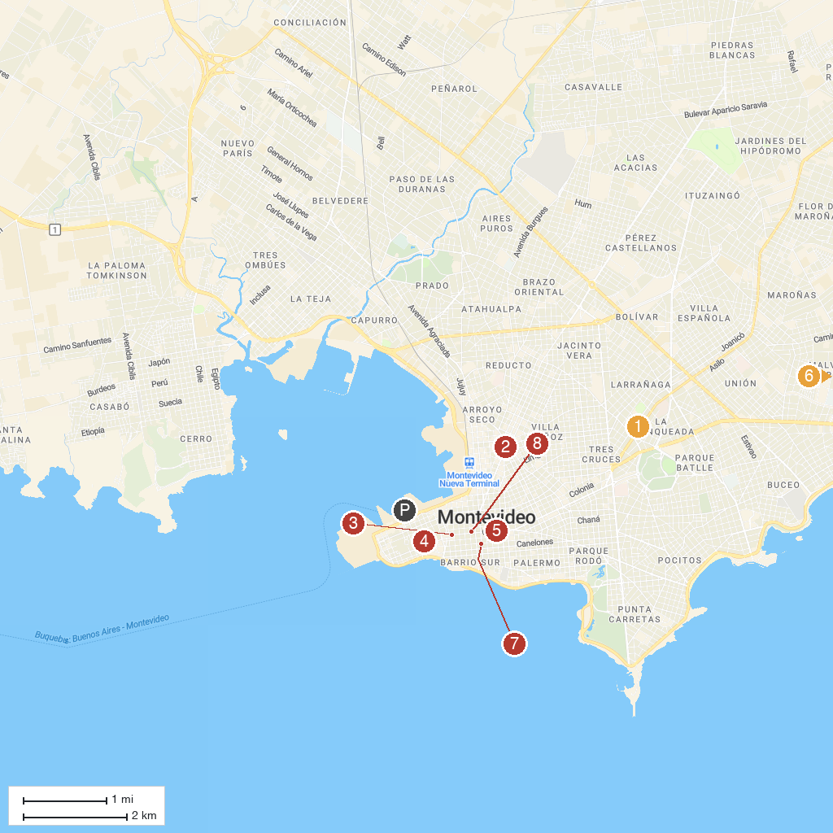
MAP KEY
1. Our Lady of Sorrows Holy Land | 5. Fountain of the Padlocks
2. Palacio Legislativo | 6. Espacio Ciencia
3. Salvo Palace | 7. Department of Historical Studies
4. Museo Gurvich | 8. Montevideo Exhibition Center
P. Cruise port / terminal
Map © MapTiler © OpenStreetMap contributors · cruiseports.org

