Montreal, Quebec, Canada
Quebec's cosmopolitan heart docks right in the old city — step off your ship onto 400-year-old cobblestones with Notre-Dame Basilica just minutes away.
⚓ Docked (pier) · 🕒 Typical call: 8-12 hrs · 💵 Canadian Dollar (CAD) · 🗣️ French / English
✍️ MY DAY IN PORT (FILL IN)
Ship / Date
In port | arrive ______ · all aboard ______
Booked excursion
Notes / meeting point
GETTING ASHORE
- Docking: Iberville Passenger Terminal (Grand Quai), Old Port — no tender
- Walk to center: Immediate — Old Montreal is right at the pier
- Best For: History, architecture, French-Canadian food, city exploring
- Don't Miss: Notre-Dame Basilica interior and Place Jacques-Cartier
GETTING AROUND
- 🚕 Taxi: CAD 15–25 — Short taxi ride from the Old Port to downtown Montreal. Taxis queue at the terminal; metered fares apply.
- 📱 Rideshare: ✅ Uber, Lyft
- 🚌 Hop-on hop-off: ✅ Gray Line Montreal
TOP THINGS TO DO
- Notre-Dame Basilica & Old Montreal — The Gothic Revival interior of Notre-Dame Basilica is jaw-dropping — gold leaf, cobalt blue vaulting, and thousands of…
- Mount Royal Park — Frederick Law Olmsted's mountain park at the center of the island offers panoramic views of the city skyline and St.
- Old Port & Bonsecours Market — The Old Port waterfront is right at your ship.
- French-Canadian Food Tour — Sample poutine, smoked meat sandwiches (the real thing — Schwartz's is legendary), bagels, and local craft beer.
- Pointe-à-Callière Archaeology Museum — Built over the actual 17th-century foundations of the city's first settlement, this world-class museum lets you walk through…
BEST WALKS
- Old Montreal Heritage Walk: 2 km · Easy · 1.5-2 hrs — Start at the Iberville Terminal on De la Commune Street, walk west to Place Jacques-Cartier, turn…
- Old Port Waterfront Loop: 1.5 km · Easy · 45 min — Follow the Old Port promenade east from the terminal past Clock Tower Pier (Tour de l'Horloge)…
WEATHER · DAYLIGHT · MONEY
Month | High °F | Low °F | Rainy days
May | 64 | 45 | 10
Jul | 77 | 62 | 12
Sep | 68 | 53 | 9
Daylight: May 5:23AM–8:18PM · Jul 5:20AM–8:39PM · Sep 6:33AM–7:04PM
cruiseports.org/montreal · Confirm terminal & all-aboard time with your ship

Montreal, Quebec, Canada — Port Map
Red = walkable sights · Amber = excursions farther out · P = cruise terminal
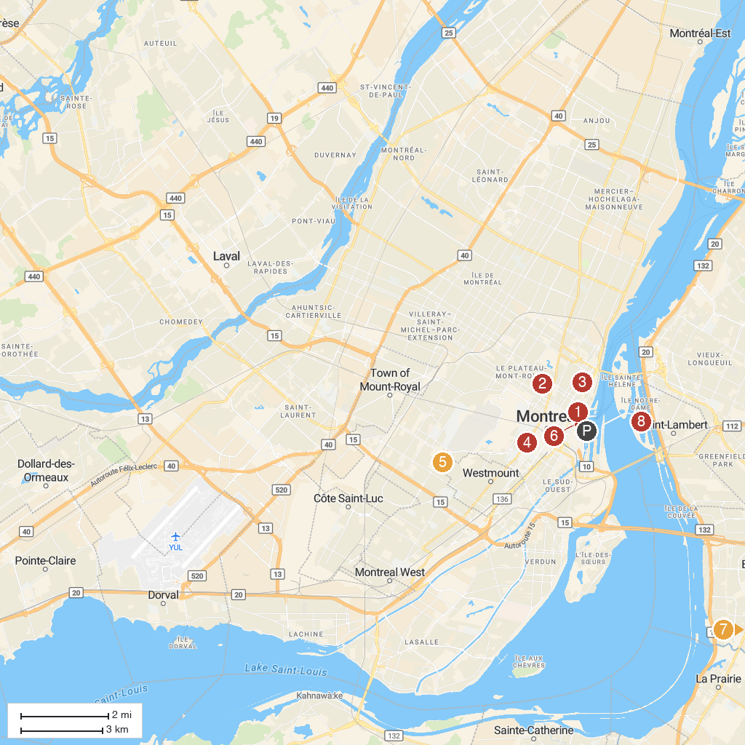
MAP KEY
1. Le Champ-de-Mars | 5. Saint Joseph's Oratory of Mount Royal
2. Musée des Fusiliers Mont-Royal | 6. Notre-Dame Basilica of Montreal
3. St. Peter the Apostle Catholic Church | 7. Cache-A-L'Eau
4. Montreal Museum of Fine Arts | 8. Casino de Montréal
P. Cruise port / terminal
Map © MapTiler © OpenStreetMap contributors · cruiseports.org

