Moorea, Society Islands, French Polynesia
A heart-shaped volcanic island wrapped in electric-blue lagoon, just 17 km from Tahiti — where jagged basalt peaks overlook twin bays, rays glide beneath your snorkel, and a single mountain road connects it all.
⚓ Tender port (no pier) · 🕒 Typical call: 7–9 hrs · 💵 CFP Franc (XPF) · 🗣️ French / Tahitian
✍️ MY DAY IN PORT (FILL IN)
Ship / Date
In port | arrive ______ · all aboard ______
Booked excursion
Notes / meeting point
GETTING ASHORE
- Docking: Tender into Cook's Bay
- Walk to center: ~10 min to Maharepa village
- Best For: Snorkeling · Scenic drives
- Don't Miss: Belvedere Lookout & lagoon rays
GETTING AROUND
- 🚕 Taxi: $13–$40 USD — Taxis meet tender boats at the pier. Starting fare ~1,500 XPF ($13 USD), then ~130 XPF/km. Always agree on price before
- 📱 Rideshare: ❌ not available
TOP THINGS TO DO
- Lagoon Snorkeling with Rays & Reef Sharks — The most popular Moorea experience: wade or snorkel in shallow lagoon water alongside blacktip reef sharks and schools of…
- Belvedere Lookout (Belvédère) — Drive or ride up to the Belvedere viewpoint — also called Magic Mountain — for a panoramic sweep over both Cook's Bay and Opunohu…
- ATV / 4x4 Mountain Tour — Tear up mountain trails through pineapple plantations, jungle valleys, and viewpoints in a 4x4 or on an ATV.
- Tiki Village Cultural Center — A re-created traditional Polynesian village on the lagoon edge near Haapiti, demonstrating tattooing, weaving, dance, and…
- Temae Beach — Moorea's best public white-sand beach, on the northeast shore near the airport.
BEST WALKS
- Cook's Bay Waterfront Stroll: ~2 km · 45 min · easy — From the tender dock, walk the flat coastal road along Cook's Bay past small shops, the Moorea…
- Opunohu Valley Overlook Trail: ~1 km · 30 min · easy–moderate — A short walk from the Belvedere parking area along a viewpoint path gives unobstructed views over…
WEATHER · DAYLIGHT · MONEY
Month | High °F | Low °F | Rainy days
May | 81 | 76 | 15
Jul | 78 | 74 | 12
Sep | 78 | 74 | 13
cruiseports.org/moorea · Confirm terminal & all-aboard time with your ship

Moorea, Society Islands, French Polynesia — Port Map
Red = walkable sights · Amber = excursions farther out · P = cruise terminal
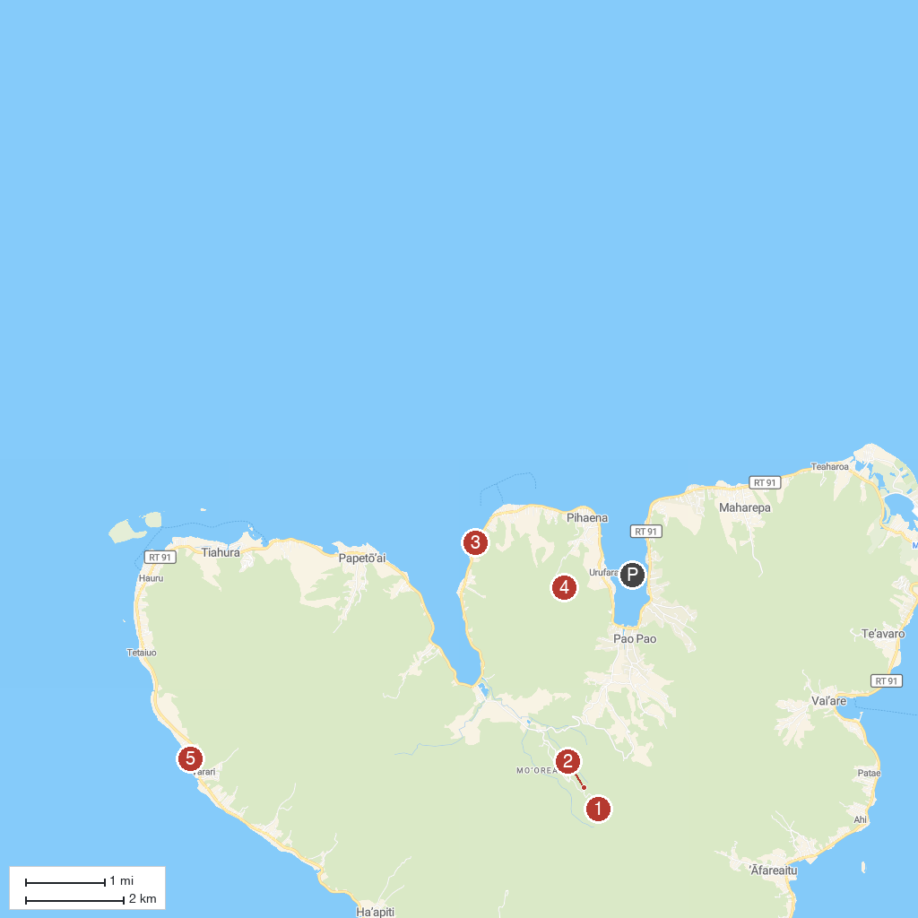
MAP KEY
1. Belvedere Lookout | 4. Rotui Mountain
2. Marae Titiroa (Opunohu Valley) | 5. Tiki Theatre Village
3. Ta'ahiamanu Beach
P. Cruise port / terminal
Map © MapTiler © OpenStreetMap contributors · cruiseports.org

