Motril, Andalusia, Spain
Gateway to the Alhambra and the Costa Tropical, Motril offers cruise passengers an irresistible choice: Granada's world-famous palace complex or sun-drenched beaches just minutes from the pier.
⚓ Pier (docked) · 🕒 Typical call: 8-10 hrs · 💶 Currency: Euro (€) · 🗣️ Spanish · 🌊 Costa Tropical
✍️ MY DAY IN PORT (FILL IN)
Ship / Date
In port | arrive ______ · all aboard ______
Booked excursion
Notes / meeting point
GETTING ASHORE
- Docking: Pier — ships dock directly; no tendering
- Walk to centre: ~2 km / 25 min flat walk; taxi ~€10-12
- Best For: Alhambra day trip, beaches, Granada tapas
- Don't Miss: Book Alhambra tickets months in advance
GETTING AROUND
- 🚕 Taxi: €7–€15 — Taxis are available at the port and reach Motril city center in about 7–10 minutes (2–4 km).
TOP THINGS TO DO
- Alhambra Palace & Generalife, Granada — The Alhambra is one of Spain's greatest treasures — a stunning Moorish palace complex perched above Granada with intricate tile…
- Granada City Walk: Albaicín & Cathedral — Wander the UNESCO-listed Albaicín quarter with its whitewashed lanes and Moorish heritage, then visit Granada Cathedral and the…
- Costa Tropical Beach Day — Motril's beaches are some of Andalusia's least-crowded.
- Salobreña White Village & Castle — Ten minutes west of Motril, Salobreña is a picture-perfect hilltop white village crowned by a Moorish castle with panoramic views…
- Motril Town: Sugar Museum & Rum Distillery — Motril was once the heart of Spain's sugarcane industry.
BEST WALKS
- Motril Old Town Stroll: 1.5 km loop · Easy · 30-40 min — From Plaza España, explore the Baroque Ayuntamiento, Iglesia Mayor de la Encarnación, the old…
- Playa Poniente Promenade: 2 km one-way · Easy · Flat seafront walk — Motril's main beach promenade runs along Playa Poniente with seafood restaurants, sunbeds and views…
WEATHER · DAYLIGHT · MONEY
Month | High °F | Low °F | Rainy days
May | 73 | 61 | 4
Jul | 85 | 72 | 0
Sep | 81 | 69 | 2
Daylight: May 7:06AM–9:14PM · Jul 7:07AM–9:32PM · Sep 7:56AM–8:21PM
cruiseports.org/motril · Confirm terminal & all-aboard time with your ship

Motril, Andalusia, Spain — Port Map
Red = walkable sights · Amber = excursions farther out · P = cruise terminal
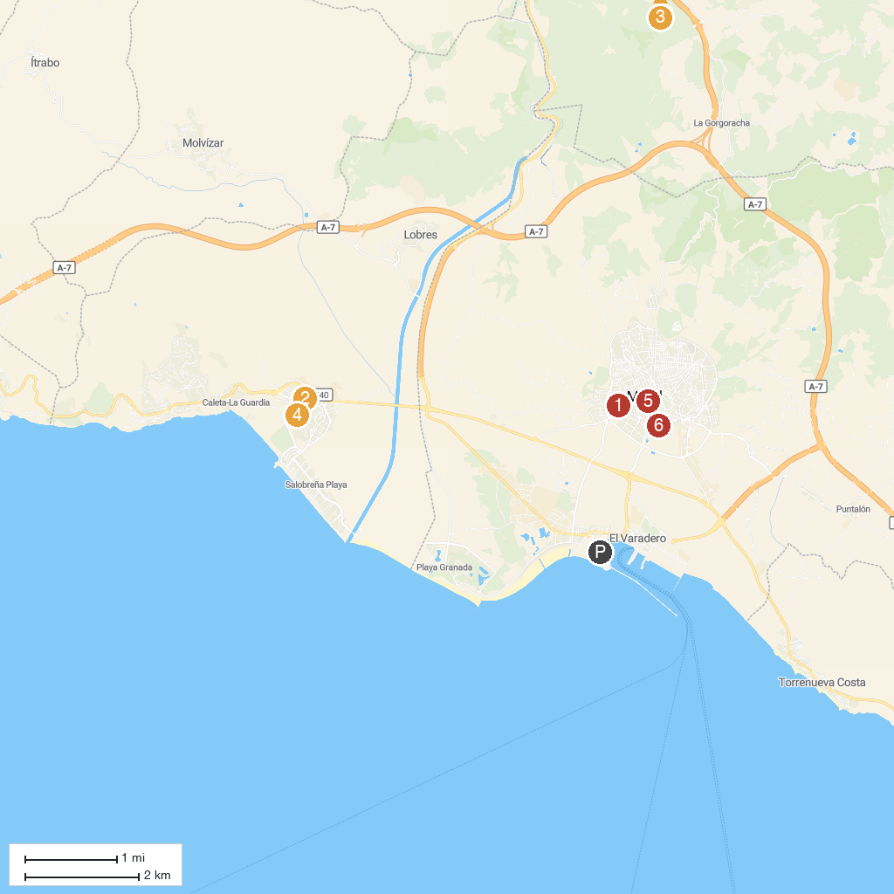
MAP KEY
1. Preindustrial Museum Sugarcane | 5. Aquatropic Water Park
2. Auditorium Villa de Salobreña | 6. Castillo de Salobreña
3. Nazarí Garden | 7. Museo de Historia de Motril
4. Dam Rules | 8. Parque de los Pueblos de América
P. Cruise port / terminal
Map © MapTiler © OpenStreetMap contributors · cruiseports.org

