MSC Ocean Cay, Bahamas
A former industrial sand-extraction site transformed into a pristine marine reserve, MSC Ocean Cay trades waterslides for 8 white-sand beaches, a glowing lighthouse, and some of the most protected waters in the Bahamas.
⚓ Docked (pier) · 🕒 Typical call: 8–12 hrs (often late night or overnight) · 💵 USD / cashless island (cruise card) · 🗣️ English · 🐠 Marine Reserve — reef-safe sunscreen required
✍️ MY DAY IN PORT (FILL IN)
Ship / Date
In port | arrive ______ · all aboard ______
Booked excursion
Notes / meeting point
GETTING ASHORE
- Docking: Pier — walk straight off the ship, no tender
- Walk to beach: 5–10 min to nearest beach; 15–20 min to far end
- Best For: Beaches, snorkeling, late-night lighthouse light show
- Don't Miss: Lighthouse LED show after dark — stay for it
GETTING AROUND
- 📱 Rideshare: ❌ not available
TOP THINGS TO DO
- Snorkeling Safari — Explore the marine reserve's protected reef and coral nursery, home to colorful fish and marine life.
- Lighthouse Climb — Climb the 100-foot lighthouse for 360° panoramic views of the island and your ship.
- Jet Ski Tour — Guided wave runner tour outside the marine reserve boundaries — open ocean speed with turquoise Bahamian scenery.
- Cabana Rental — Private beachside cabana on North, South, or Bimini Beach with cushioned furniture, floating mats, and complimentary refreshments.
- Kayak & Paddleboard — Crystal kayaks, standard kayaks, and paddleboards available at ocean sports centers.
BEST WALKS
- Pier to Lighthouse Bay Beach: 10 min • Easy • Free — From the Welcome Center, follow the main path past Springer's Bar to Lighthouse Bay.
- Full Island Loop: 30–40 min • Easy • Free — Walk the full perimeter: pier → Lighthouse Bay → Bimini Beach → South Beach → North Beach → Seakers…
WEATHER · DAYLIGHT · MONEY
Month | High °F | Low °F | Rainy days
May | 80 | 77 | 12
Jul | 85 | 81 | 18
Sep | 85 | 81 | 17
Daylight: May 6:31AM–7:54PM · Jul 6:36AM–8:09PM · Sep 7:03AM–7:20PM
cruiseports.org/msc-ocean-cay · Confirm terminal & all-aboard time with your ship

MSC Ocean Cay, Bahamas — Port Map
Red = walkable sights · Amber = excursions farther out · P = cruise terminal
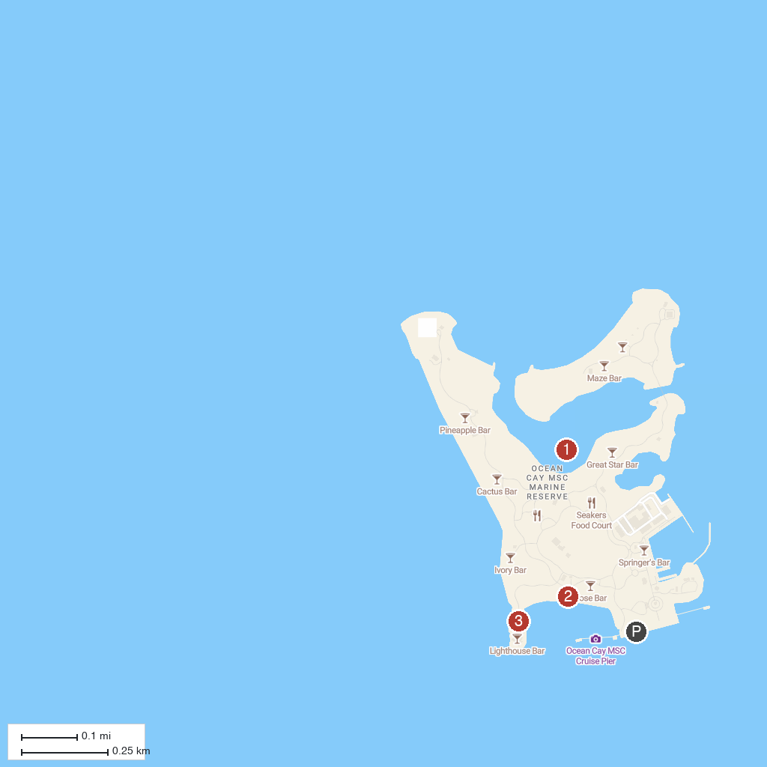
MAP KEY
1. MSC CRUISE_Sunrise at Ocean Cay | 3. Ocean Cay Lighthouse Bimini
2. Lighthouse Bay
P. Cruise port / terminal
Map © MapTiler © OpenStreetMap contributors · cruiseports.org

