Muscat, Muscat Governorate, Oman
Gateway to Arabia's most welcoming nation — Muscat blends 16th-century Portuguese forts, one of the world's great mosques, and a labyrinthine frankincense souk all within a short ride of the pier.
⚓ Docked (Port Sultan Qaboos) · 🕒 Typical call: 8-10 hrs · 💵 Omani Rial (OMR) · 🗣️ Arabic (English widely spoken) · 👗 Modest dress required
✍️ MY DAY IN PORT (FILL IN)
Ship / Date
In port | arrive ______ · all aboard ______
Booked excursion
Notes / meeting point
GETTING ASHORE
- Docking: Alongside at Port Sultan Qaboos, Muttrah district. Shuttle bus to port gate (walking through port not permitted).
- Walk to Muttrah Souk: ~15 min (1 km) from port gate along the waterfront; or take the ship's shuttle.
- Best For: Souks, Islamic architecture, wadi hiking, dhow cruises, desert day trips.
- Don't Miss: Sultan Qaboos Grand Mosque — one of the world's largest; open to non-Muslims mornings only.
GETTING AROUND
- 🚕 Taxi: OMR 2–5 (~$5–13) to Mutrah; OMR 5–10 (~$13–26) to Royal Opera House area — Official taxis operate from the port with regulated fares (OMR 1.50 base + 0.25 OMR/km). Negotiate or confirm the meter
- 📱 Rideshare: ❌ not available
- 🚌 Hop-on hop-off: ✅ Big Bus Tours
TOP THINGS TO DO
- Sultan Qaboos Grand Mosque — One of the largest mosques in the world, open to non-Muslim visitors weekday mornings.
- Muttrah Souk & Corniche Walk — One of Arabia's oldest covered markets, laced with the scent of frankincense, myrrh, and rose water.
- Old Muscat — Al Alam Palace & Portuguese Forts — A 10-minute taxi ride brings you to the ceremonial heart of Oman.
- Wadi Shab & Bimmah Sinkhole — Full-day adventure along the coast road south of Muscat.
- Wahiba Sands Desert Safari — Venture into the red dunes of the Sharqiyah (Wahiba) Sands for 4x4 dune bashing, camel riding, and a visit to a Bedouin camp.
BEST WALKS
- Muttrah Corniche & Souk Loop: 2.5 km · 1.5-2 hrs · Easy — From the port gate, walk left along the waterfront promenade past colourful dhows to Muttrah Souk.
- Old Muscat Stroll: 1.5 km · 1 hr · Easy (taxi to start) — Take a taxi to Old Muscat (Al Alam Gate), then walk the palm-lined boulevard past Al Alam Palace…
WEATHER · DAYLIGHT · MONEY
Month | High °F | Low °F | Rainy days
May | 100 | 84 | 0
Jul | 100 | 87 | 1
Sep | 96 | 82 | 0
Daylight: May 5:24AM–6:41PM · Jul 5:28AM–6:55PM · Sep 5:53AM–6:09PM
cruiseports.org/muscat · Confirm terminal & all-aboard time with your ship

Muscat, Muscat Governorate, Oman — Port Map
Red = walkable sights · Amber = excursions farther out · P = cruise terminal
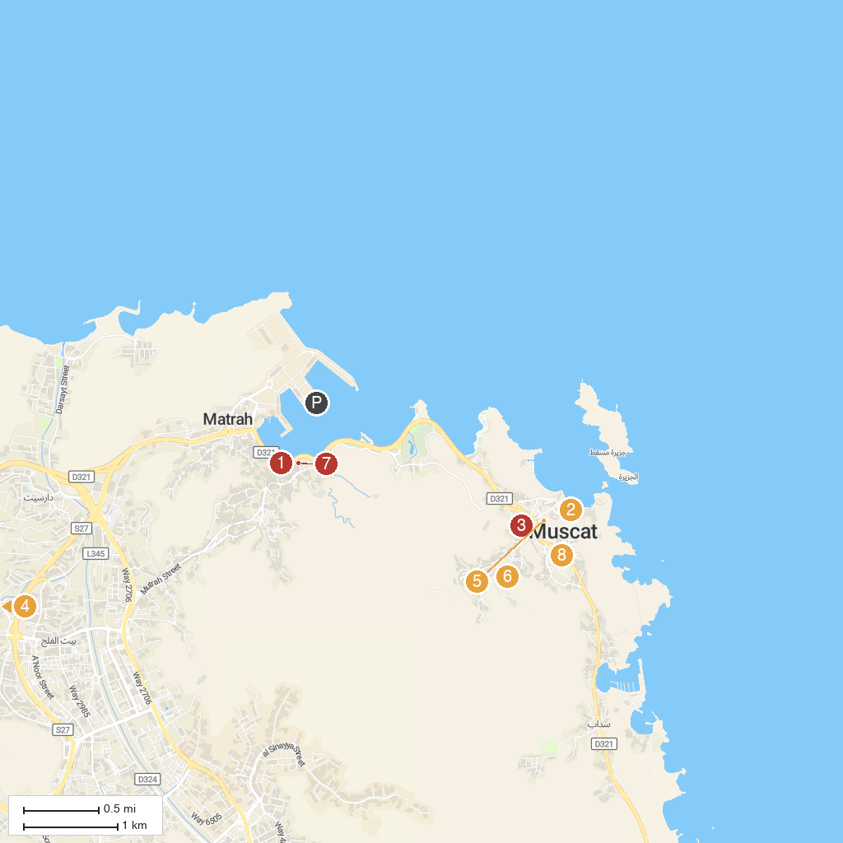
MAP KEY
1. Mutrah Souq | 5. Omani and French Museum
2. Al Alam Palace | 6. Shri Shiv Mandir
3. Bait Al Zubair Museum | 7. Mutrah Corniche
4. Sri Krishna Temple, Muscat, Oman | 8. National Museum (Oman)
P. Cruise port / terminal
Map © MapTiler © OpenStreetMap contributors · cruiseports.org

