Nafplio, Argolis, Greece
Greece's most romantic port town — a former capital where Venetian fortresses crown limestone cliffs above a harbor of bobbing caïques and bougainvillea-draped alleyways. Every step in the marble Old Town is a chapter in 3,000 years of history.
⚓ Tender port · 🕒 Typical call: 7-9 hrs · 💶 Currency: Euro (€) · 🗣️ Language: Greek (English widely spoken) · 🏛️ UNESCO sites nearby
✍️ MY DAY IN PORT (FILL IN)
Ship / Date
In port | arrive ______ · all aboard ______
Booked excursion
Notes / meeting point
GETTING ASHORE
- Docking: Tender — ships anchor in the Argolic Gulf; short 5-10 min ferry to the harbor pier
- Walk to center: Tender drops you steps from the Old Town; Syntagma Square ~5 min on foot
- Best For: History lovers, walkers, foodies, and day-trippers to Mycenae & Epidaurus
- Don't Miss: Palamidi Fortress panorama & gelato from Antica Gelateria di Roma
GETTING AROUND
- 🚕 Taxi: €5–€8 — Taxis are available near the port and at the main rank on Sigrou Street near the bus station. Short trips around the cen
- 📱 Rideshare: ✅ Uber, FreeNow
- 🚌 Hop-on hop-off: ✅
TOP THINGS TO DO
- Palamidi Fortress — The crown of Nafplio — a colossal Venetian citadel (1711-14) perched 216 m above the town.
- Ancient Mycenae — Thirty minutes by taxi, the Bronze Age citadel of Agamemnon is one of Greece's most important sites.
- Ancient Epidaurus Theatre — The 4th-century BC theatre at Epidaurus has acoustics so perfect that a coin dropped on stage is audible in the top row.
- Nafplio Old Town & Archaeological Museum — Syntagma Square, the city's Venetian-era heart, is ringed by historic mansions.
- Bourtzi Castle Boat Trip — Small wooden boats ferry passengers the short distance to Bourtzi — the iconic Venetian water fortress (begun 1471) sitting on…
BEST WALKS
- Old Town & Arvanitia Promenade: 3 km · ~1 hr · Flat to gently hilly · Paved throughout — From the tender pier, stroll into the Old Town and through Syntagma Square, pausing at the Church…
- Acronafplia Ramparts: 2 km · ~45 min · Moderate uphill · Free entry — From the Old Town, wind up past the hotels carved into the old citadel walls to reach Acronafplia's…
WEATHER · DAYLIGHT · MONEY
Month | High °F | Low °F | Rainy days
May | 79 | 60 | 5
Jul | 95 | 74 | 2
Sep | 85 | 68 | 4
Daylight: May 6:19AM–8:31PM · Jul 6:19AM–8:49PM · Sep 7:10AM–7:36PM
cruiseports.org/nafplio · Confirm terminal & all-aboard time with your ship

Nafplio, Argolis, Greece — Port Map
Red = walkable sights · Amber = excursions farther out · P = cruise terminal
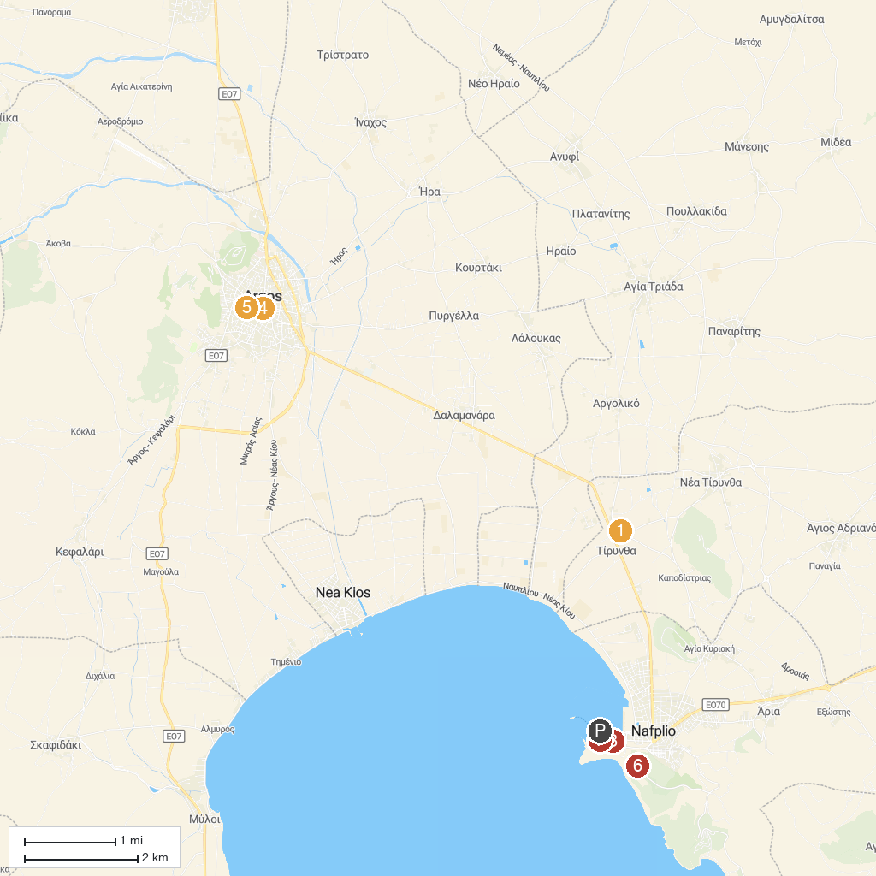
MAP KEY
1. Mycenean Acropolis of Tiryns | 5. Piazza della cattedrale di San Pietro
2. Heraion of Argos | 6. Byzantine Museum of Argolis - BYMA
3. Nafplio Port | 7. Palamidi Fortress
4. War Museum Nafplio | 8. Archaeological Museum of Nafplio
P. Cruise port / terminal
Map © MapTiler © OpenStreetMap contributors · cruiseports.org

