Nagasaki City, Nagasaki Prefecture, Japan
Few ports carry a story as heavy—or as hopeful—as Nagasaki. Its hillside streets, harbor views, and layered history of East-West exchange reward every hour you spend ashore.
⚓ Docked (Matsugae or Dejima Wharf) · 🕒 Typical call: 8-10 hrs · 💴 Currency: Japanese Yen (JPY) · 🗣️ Language: Japanese · 🚃 Trams cover most sights cheaply
✍️ MY DAY IN PORT (FILL IN)
Ship / Date
In port | arrive ______ · all aboard ______
Booked excursion
Notes / meeting point
GETTING ASHORE
- Docking: Berth at Matsugae International Cruise Terminal (most ships) or Dejima Wharf (smaller vessels); no tendering
- Walk to center: Matsugae Pier is ~1-2 km to downtown; 15-20 min walk or short tram ride
- Best For: History, culture, walking, peace memorials, Japanese-Western architecture
- Don't Miss: Atomic Bomb Museum + Peace Park, Glover Garden, Oura Church (UNESCO)
GETTING AROUND
- 🚕 Taxi: ¥800–¥1,800 to city center — Taxis queue directly at Matsugae Pier. The city center is a 3–10 minute ride. Meters are used; tipping is not customary.
- 📱 Rideshare: ✅ Uber, DiDi, GO
TOP THINGS TO DO
- Atomic Bomb Museum & Peace Memorial Park — Ground zero of August 9, 1945.
- Glover Garden & Oura Church — A hillside open-air museum showcasing the mansions of 19th-century foreign merchants, including the Former Glover House — the…
- Dejima Island — Nagasaki's fan-shaped artificial island was Japan's sole window to the West during the Edo period — a Dutch trading post from…
- Mount Inasa Night Views — Ranked among Japan's three greatest night views, Inasa's summit gives a panoramic sweep of the city and harbour glittering below.
- Shinchi Chinatown & Nagasaki Chanpon — Nagasaki Chinatown is one of Japan's three major Chinatowns.
BEST WALKS
- Waterfront to Glover Garden Walk: 3-4 km · 1.5-2 hrs · Moderate (uphill finish) — From the Matsugae pier, head south along the waterfront to Dejima Island, continue through…
- Peace Park to Urakami Cathedral: 2 km · 45 min · Easy — Start at Peace Memorial Park, visit the Atomic Bomb Museum, then walk north to the Urakami…
WEATHER · DAYLIGHT · MONEY
Month | High °F | Low °F | Rainy days
May | 73 | 61 | 11
Jul | 84 | 75 | 18
Sep | 81 | 72 | 15
Daylight: May 5:22AM–7:12PM · Jul 5:23AM–7:29PM · Sep 6:04AM–6:26PM
cruiseports.org/nagasaki-city · Confirm terminal & all-aboard time with your ship

Nagasaki City, Nagasaki Prefecture, Japan — Port Map
Red = walkable sights · Amber = excursions farther out · P = cruise terminal
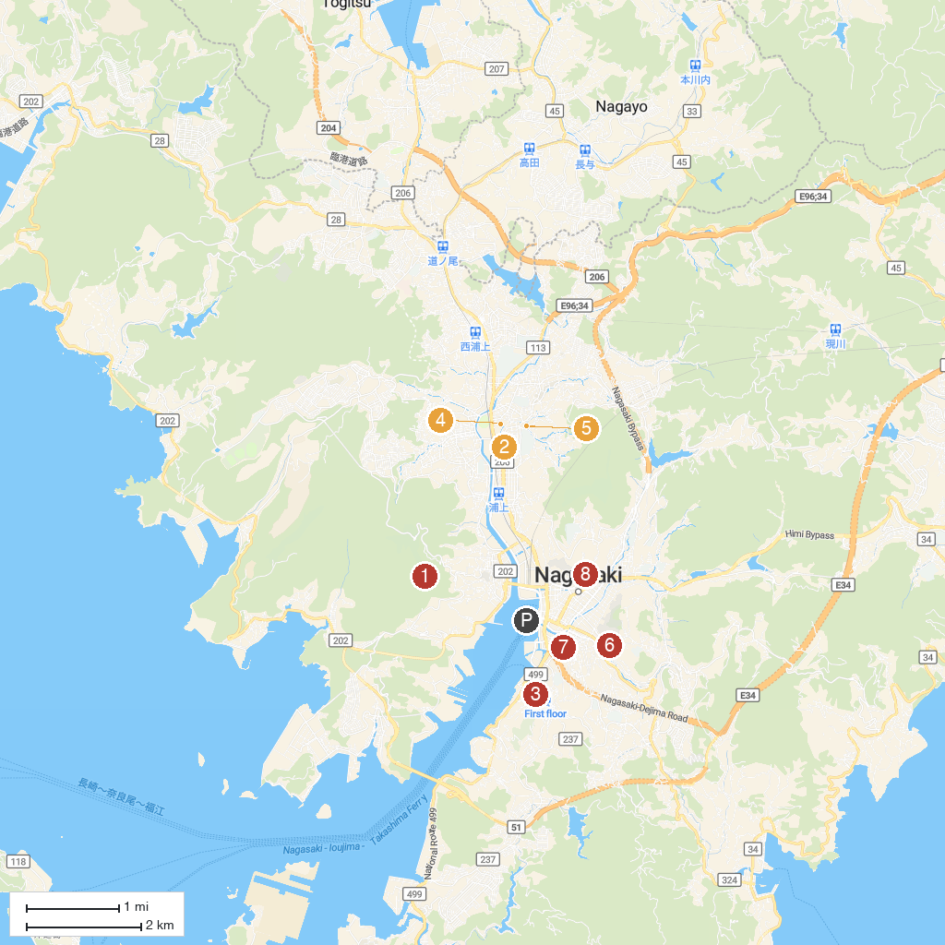
MAP KEY
1. Mt. Inasa Overlook | 5. Urakami Cathedral
2. Nagasaki Atomic Bomb Museum | 6. Yasaka Shrine
3. Ōura Cathedral | 7. Nagasaki Shinchi Chinatown
4. Peace Park Nagasaki | 8. Nagasaki Museum of History & Culture
P. Cruise port / terminal
Map © MapTiler © OpenStreetMap contributors · cruiseports.org

