Nanortalik, South Greenland, Greenland
Greenland's southernmost town, where the name means 'Place of Polar Bears' — a compact Inuit settlement framed by cathedral granite spires, drifting icebergs, and an open-air museum that brings the old colonial era to life.
⚓ Tender port (no pier) · 🕒 Typical call: 6–8 hrs · 💵 Danish Krone (DKK) · 🗣️ Greenlandic / Danish
✍️ MY DAY IN PORT (FILL IN)
Ship / Date
In port | arrive ______ · all aboard ______
Booked excursion
Notes / meeting point
GETTING ASHORE
- Docking: Tender only — no cruise pier
- Walk to center: ~5 min from tender landing
- Best For: Open-air museum · Icebergs · Fjord scenery
- Don't Miss: Nanortalik Museum open-air village
GETTING AROUND
- 📱 Rideshare: ❌ not available
TOP THINGS TO DO
- Nanortalik Open-Air Museum — A genuine highlight: preserved turf houses, old colonial wooden buildings, a peat-walled church, and a traditional umiak (skin…
- Tasermiut Fjord by Boat — The Tasermiut Fjord is one of Greenland's most spectacular landscapes — sheer granite walls rising over 1,000 m, drifting…
- Hiking the Peaks Above Town — Short hikes above Nanortalik reward with sweeping views of the harbour, offshore islands, and icebergs.
- Iceberg & Wildlife Cruise — South Greenland waters host icebergs calving from the Greenland ice sheet year-round, along with humpback whales, minke whales…
- Town Walk & Inuit Heritage — Nanortalik's colourful wooden houses, the local church, and the small harbour quarter all reflect centuries of Danish colonial…
BEST WALKS
- Harbour to Open-Air Museum: ~1 km · 30 min · easy — From the tender landing, follow the waterfront to Nanortalik Museum's open-air village of turf…
- Viewpoint above town: ~2 km · 1–1.5 hrs · moderate — A rough trail climbs the hillside above the town for panoramic views over the harbour, the offshore…
WEATHER · DAYLIGHT · MONEY
Month | High °F | Low °F | Rainy days
May | 40 | 31 | 10
Jul | 53 | 43 | 11
Sep | 46 | 38 | 12
Daylight: May 5:22AM–10:34PM · Jul 5:04AM–11:08PM · Sep 7:29AM–8:20PM
cruiseports.org/nanortalik · Confirm terminal & all-aboard time with your ship

Nanortalik, South Greenland, Greenland — Port Map
Red = walkable sights · Amber = excursions farther out · P = cruise terminal
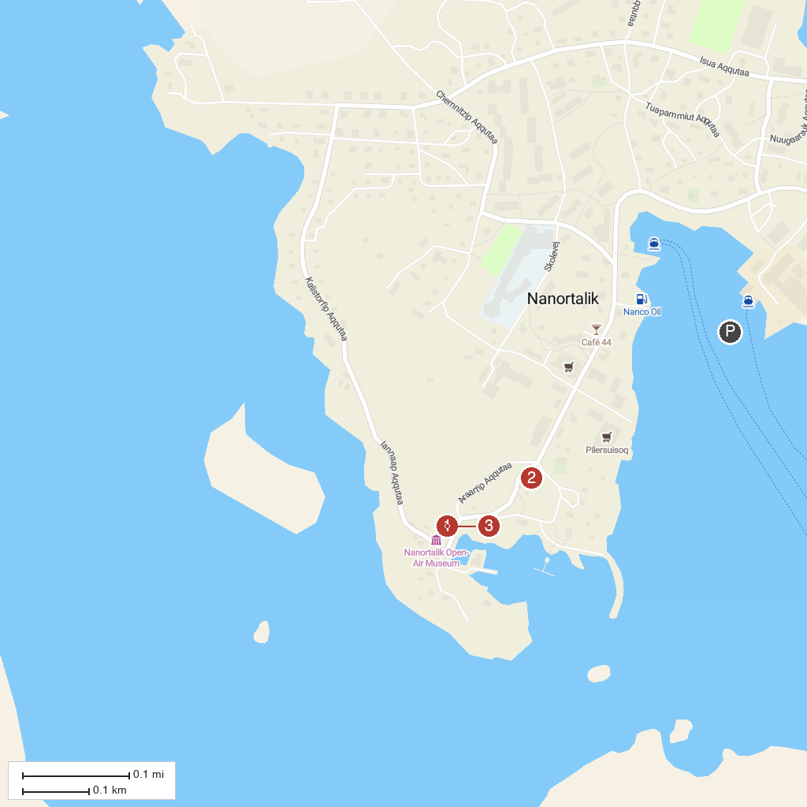
MAP KEY
1. Nanortalik Museum | 3. Qaqqarsuasik (Big Mountain)
2. Nanortalik Church | 4. Tasermiut Fjord
P. Cruise port / terminal
Map © MapTiler © OpenStreetMap contributors · cruiseports.org

