Natchez, Mississippi, USA
Perched atop 200-foot bluffs above the Mississippi, Natchez packs more antebellum mansions per square mile than anywhere in America — plus tales of pirates, plantation wealth, and a riverfront that has barely changed in 200 years.
⚓ Docked (pier/riverbank) · 🕒 Typical call: 6–10 hrs · 💵 US Dollar · 🗣️ English · 🌿 River cruise port
✍️ MY DAY IN PORT (FILL IN)
Ship / Date
In port | arrive ______ · all aboard ______
Booked excursion
Notes / meeting point
GETTING ASHORE
- Docking: Ships dock directly at the Natchez riverfront (Silver Street / Harbor View Dr) — no tender required
- Walk to center: Flat riverfront 5 min walk; steep 0.3-mile hill climb to historic downtown (shuttles provided)
- Best For: Antebellum mansion tours, Civil War history, Southern food & live music
- Don't Miss: Longwood octagonal mansion, Natchez City Cemetery Turning Angel, Fat Mama's Tamales
GETTING AROUND
- 🚕 Taxi: $10–$20 — Wynn Transportation is a local taxi service with a mobile app (Taxi Caller) for booking; they offer a price-match guaran
- 📱 Rideshare: ✅ Uber
TOP THINGS TO DO
- Antebellum Mansion Trail — Tour Longwood (the largest octagonal house in the US, frozen mid-construction since 1861), Stanton Hall (Greek Revival on a full…
- William Johnson House & NPS Sites — Explore the National Park Service–run William Johnson House, home of a free Black businessman whose diary gives a rare…
- Natchez Bluff Park Walk — Stroll the paved bluff-top paths for unobstructed panoramas of the Mississippi River.
- Natchez Trace Parkway Terminus — Natchez is the southern end of the 444-mile Natchez Trace Parkway, a historic forest corridor used by Native Americans and early…
- Southern Food & Riverfront Drinks — Hit Under-the-Hill Saloon (one of the oldest bars on the Mississippi) right near the ship, then head uptown for Fat Mama's…
BEST WALKS
- Riverfront to Downtown Natchez: 1.2 miles • Moderate (steep hill) • 25–40 min — Walk off the gangway along Silver Street, then climb the bluff road to Main Street and the historic…
- Historic Downtown Loop: 1 mile • Easy (flat on top) • 20–30 min — From the shuttle drop-off, walk along Main Street past Stanton Hall, St.
WEATHER · DAYLIGHT · MONEY
Month | High °F | Low °F | Rainy days
May | 83 | 66 | 11
Jul | 91 | 76 | 13
Sep | 88 | 71 | 9
Daylight: May 6:09AM–7:55PM · Jul 6:11AM–8:11PM · Sep 6:50AM–7:10PM
cruiseports.org/natchez-ms · Confirm terminal & all-aboard time with your ship

Natchez, Mississippi, USA — Port Map
Red = walkable sights · Amber = excursions farther out · P = cruise terminal
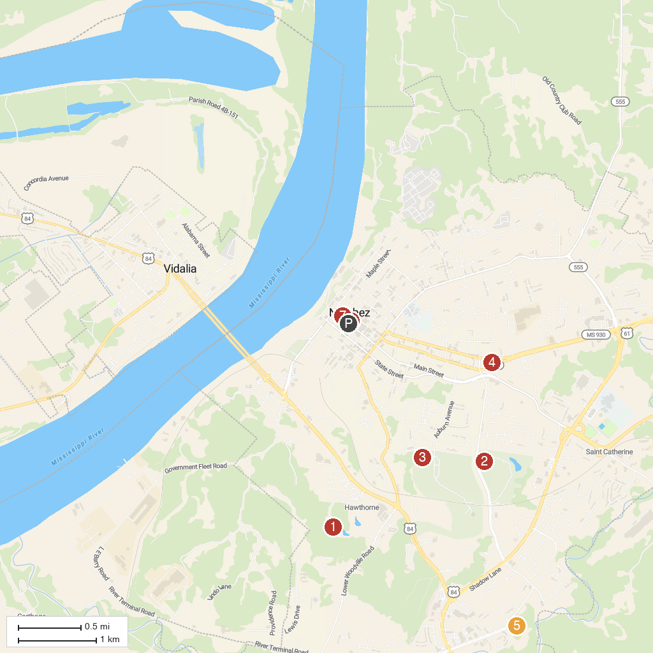
MAP KEY
1. Longwood | 5. Grand Village of the Natchez Indians
2. Natchez National Historical Park | 6. Natchez Ghost Tour
3. Historic Auburn | 7. Natchez Museum-African American Culture
4. Forks of the Road
P. Cruise port / terminal
Map © MapTiler © OpenStreetMap contributors · cruiseports.org

