Naxos Island, Cyclades, Greece
The Cyclades' best-kept secret: a lush, self-sufficient island with a 2,500-year-old marble gateway, a medieval Venetian castle, golden sand beaches, and food so good it puts Mykonos to shame.
⚓ Dockside berth (small ships) · 🕒 Typical call: 6–8 hrs · 💶 Euro (€) · 🗣️ Greek
✍️ MY DAY IN PORT (FILL IN)
Ship / Date
In port | arrive ______ · all aboard ______
Booked excursion
Notes / meeting point
GETTING ASHORE
- Docking: Dockside — small cruise ships berth at the Chora port quay; larger ships may anchor and tender
- Walk to center: 1 min to promenade; 10–12 min to Portara; 15 min to Kastro
- Best For: History, beaches, Greek food, unhurried exploration
- Don't Miss: The Portara at sunset, Kastro alleys, Naxian Graviera cheese
GETTING AROUND
- 🚕 Taxi: €2–€6 — Taxis queue at the port; metered fares to anywhere in Chora are very short and inexpensive. Most journeys within town ru
- 📱 Rideshare: ✅ Uber
TOP THINGS TO DO
- The Portara & Palatia Islet — Walk the breakwater causeway to the islet of Palatia and stand beneath the massive marble gate of an unfinished Temple of Apollo…
- Venetian Kastro & Old Town — Climb into the 13th-century Venetian citadel through the historic Trani Porta (Great Gate).
- Agios Prokopios & Agia Anna Beaches — Voted among Greece's best beaches, Agios Prokopios boasts thick golden rice-grain sand and shallow turquoise water.
- Mountain Villages & Vallindras Distillery — Take a guided tour or hire a taxi to the marble villages of Chalki and Filoti in the Tragaea valley.
- Temple of Demeter at Gyroulas — A beautifully restored 530 BC marble temple near the village of Sangri — predating the Parthenon.
BEST WALKS
- Portara Causeway Walk: 1.2 km round-trip · 25 min · Flat · Free — From the port quay, walk north along the harbor promenade to the causeway leading to Palatia islet.
- Chora to Venetian Kastro: 1 km · 20–30 min · Moderate uphill · Cobblestones — From the harbor head inland through the old market district, past boutiques and cafés, up the…
- Town to Agios Georgios Beach: 1.5 km · 20 min · Flat · Sandy finish — Head south from the port quay along the waterfront road past the town's restaurants and shops to…
WEATHER · DAYLIGHT · MONEY
Month | High °F | Low °F | Rainy days
May | 74 | 63 | 4
Jul | 84 | 74 | 0
Sep | 80 | 71 | 2
Daylight: May 6:10AM–8:19PM · Jul 6:10AM–8:37PM · Sep 7:00AM–7:25PM
cruiseports.org/naxos-island · Confirm terminal & all-aboard time with your ship

Naxos Island, Cyclades, Greece — Port Map
Red = walkable sights · Amber = excursions farther out · P = cruise terminal
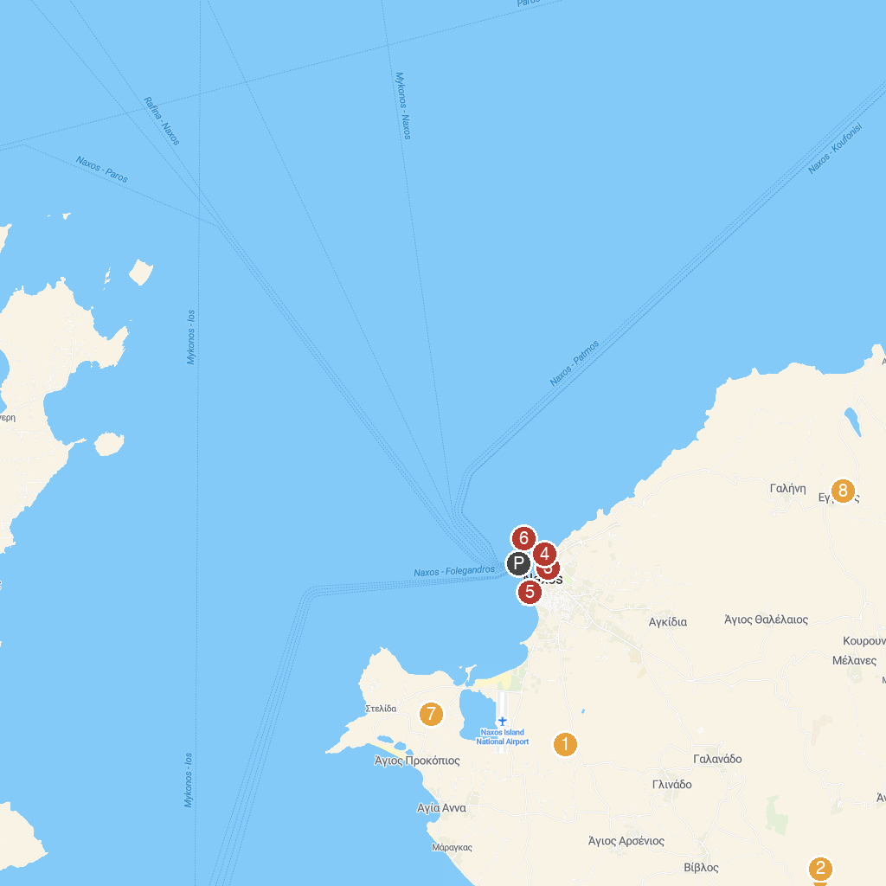
MAP KEY
1. Archaeological Site of Yria Naxos | 5. Σφίγγα των Ναξίων
2. Ancient Temple of Demeter | 6. Temple of Apollo
3. Archaeological Museum of Naxos | 7. Aqua Fun
4. Mitropolis On-site Museum | 8. Eggares Olive Oil Museum
P. Cruise port / terminal
Map © MapTiler © OpenStreetMap contributors · cruiseports.org

