New Orleans, Louisiana, USA
Where jazz spills into the street, beignets dust your shirt, and every block between the river and the Quarter tells a story 300 years in the making.
⚓ Docked (cruise terminal) · 🕒 Typical call: 8–10 hrs (often homeport) · 💵 USD · 🗣️ English (French Creole culture)
✍️ MY DAY IN PORT (FILL IN)
Ship / Date
In port | arrive ______ · all aboard ______
Booked excursion
Notes / meeting point
GETTING ASHORE
- Docking: Erato Street or Julia Street terminal, right on the Mississippi River
- Walk to French Quarter: 15–20 min on foot or 5 min on Riverfront Streetcar
- Best For: Jazz & nightlife, Creole food, history, swamp & plantation tours
- Don't Miss: Café du Monde beignets, Jackson Square, National WWII Museum
GETTING AROUND
- 🚕 Taxi: $14 min (1 person); $8 pp (2+) — Taxis are metered at $3.50 plus $2.00/mile; minimum fare is $14 for a single rider or $8 per person for two or more. The
- 📱 Rideshare: ✅ Uber, Lyft
- 🚌 Hop-on hop-off: ✅ City Sightseeing New Orleans · from 38 USD
TOP THINGS TO DO
- French Quarter Walking Tour — Explore the oldest neighborhood in New Orleans, where the city began in 1718: wrought-iron balconies, Jackson Square, St.
- Bayou & Swamp Airboat Tour — Head 30–45 minutes outside the city into Louisiana bayou country for an airboat ride through cypress swamps teeming with…
- National WWII Museum — Consistently ranked among the top museums in the USA, the National WWII Museum is an immersive, moving experience covering every…
- Plantation Tour (Oak Alley or Laura) — About an hour upriver, Oak Alley Plantation and Laura Plantation offer contrasting but equally compelling windows into antebellum…
- Creole Food & Cocktail Tour — Taste your way through the Quarter and Marigny: po'boys, gumbo, red beans and rice, charbroiled oysters, pralines, and the city's…
BEST WALKS
- Riverfront to Jackson Square Loop: 1.5 miles • Easy • 45–60 min — Walk along the Mississippi riverfront through Woldenberg Park to Jackson Square, then cut into the…
- Warehouse District Art Walk: 1 mile • Easy • 45 min — Head uptown from the terminal along Camp Street through the Warehouse Arts District — galleries…
WEATHER · DAYLIGHT · MONEY
Month | High °F | Low °F | Rainy days
May | 82 | 70 | 13
Jul | 88 | 78 | 20
Sep | 85 | 75 | 15
Daylight: May 6:06AM–7:46PM · Jul 6:09AM–8:02PM · Sep 6:45AM–7:04PM
ESSENTIAL TRAVEL QUALIFICATIONS
Julia Street: Norwegian/Royal Caribbean; Disney terminal assignment unverified—check boarding documents. No inferred Disney berth assignment.
cruiseports.org/new-orleans · Confirm terminal & all-aboard time with your ship

New Orleans, Louisiana, USA — Port Map
Red = walkable sights · Amber = excursions farther out · P = cruise terminal
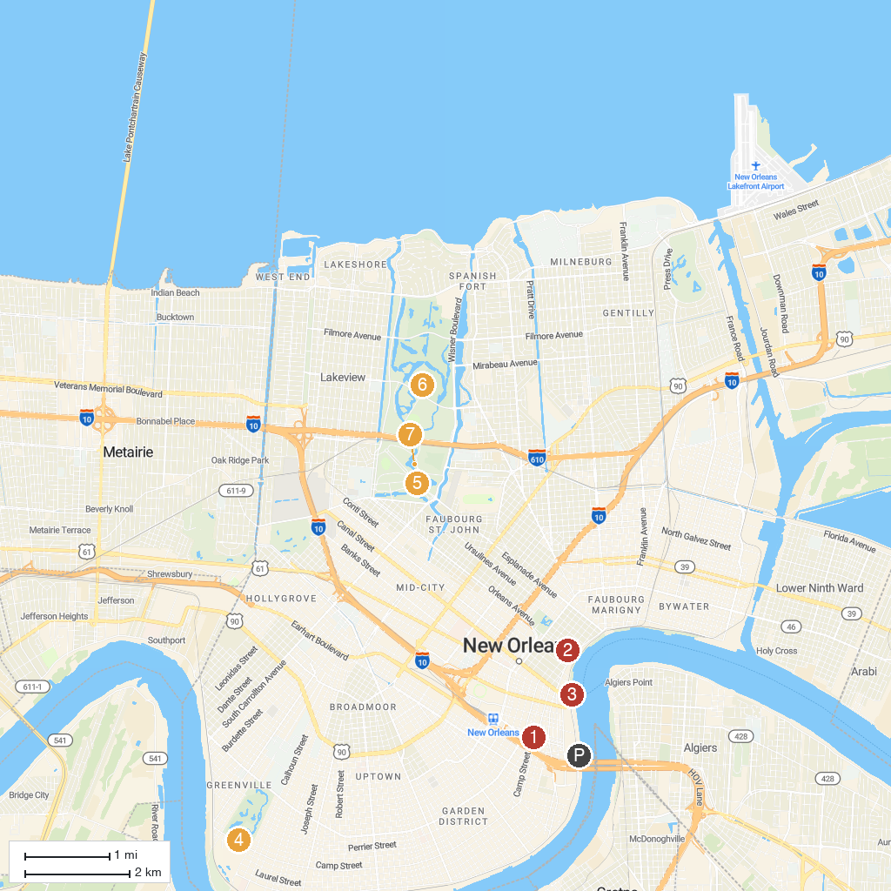
MAP KEY
1. The National WWII Museum | 5. New Orleans Museum of Art
2. St. Louis Cathedral | 6. New Orleans City Park
3. Audubon Aquarium | 7. Louisiana Children's Museum
4. Audubon Park
P. Cruise port / terminal
Map © MapTiler © OpenStreetMap contributors · cruiseports.org

