Niebla-Valdivia, Los Ríos, Chile
Ships anchor off Niebla where a 17th-century Spanish fort guards the river mouth — from here, Valdivia's vibrant fish market, sea lion docks, and craft-beer scene await just 18 km upriver.
⚓ Tender port · 🕒 Typical call: 8-10 hrs · 💵 Chilean Peso (CLP) · 🗣️ Spanish
✍️ MY DAY IN PORT (FILL IN)
Ship / Date
In port | arrive ______ · all aboard ______
Booked excursion
Notes / meeting point
GETTING ASHORE
- Docking: Tender to Muelle de Niebla pier
- Walk to Niebla Fort: 10-15 min from tender pier
- Best For: History, craft beer, sea lions, river cruises
- Don't Miss: Mercado Fluvial sea lions & Cervecería Kunstmann
GETTING AROUND
- 🚕 Taxi: ~800–1,000 CLP per person — Fixed-route shared taxis run between Niebla and Valdivia. Faster than the bus and cheaper than a private taxi; cash only
- 📱 Rideshare: ✅ Uber, Cabify, DiDi
TOP THINGS TO DO
- Niebla Fort & Corral Fortress Circuit — The Castillo de la Pura y Limpia Concepción de Monforte de Lemos (1645) sits just uphill from the tender pier with original…
- Mercado Fluvial & Sea Lions — Valdivia's waterfront fish market is where local fishermen and enormous South American sea lions compete for the same catch.
- Cervecería Kunstmann Brewery Visit — Chile's craft beer capital owes its roots to 19th-century German settlers.
- Carlos Anwandter Nature Sanctuary Boat Trip — The 1960 earthquake — the strongest ever recorded — caused land to sink and forests to flood, creating vast wetlands now home to…
- Isla Teja Museums & Botanical Garden — Cross the pedestrian bridge to Isla Teja for the Museo Histórico y Antropológico Maurice van de Maele (Mapuche artifacts…
BEST WALKS
- Niebla Fort & Coastal Walk: 1.5 km · 30-40 min · Easy — From the tender pier, walk uphill 10 minutes to the Niebla Fort, explore the ramparts and cannon…
- Valdivia Riverfront & Fish Market: 2 km · 45 min · Easy — From the bus/taxi drop at the Costanera, stroll south past the river promenade to the Mercado…
WEATHER · DAYLIGHT · MONEY
Month | High °F | Low °F | Rainy days
May | 56 | 45 | 15
Jul | 51 | 40 | 19
Sep | 55 | 41 | 13
Daylight: May 7:51AM–5:46PM · Jul 8:10AM–5:47PM · Sep 7:53AM–7:43PM
cruiseports.org/niebla-valdivia · Confirm terminal & all-aboard time with your ship

Niebla-Valdivia, Los Ríos, Chile — Port Map
Red = walkable sights · Amber = excursions farther out · P = cruise terminal
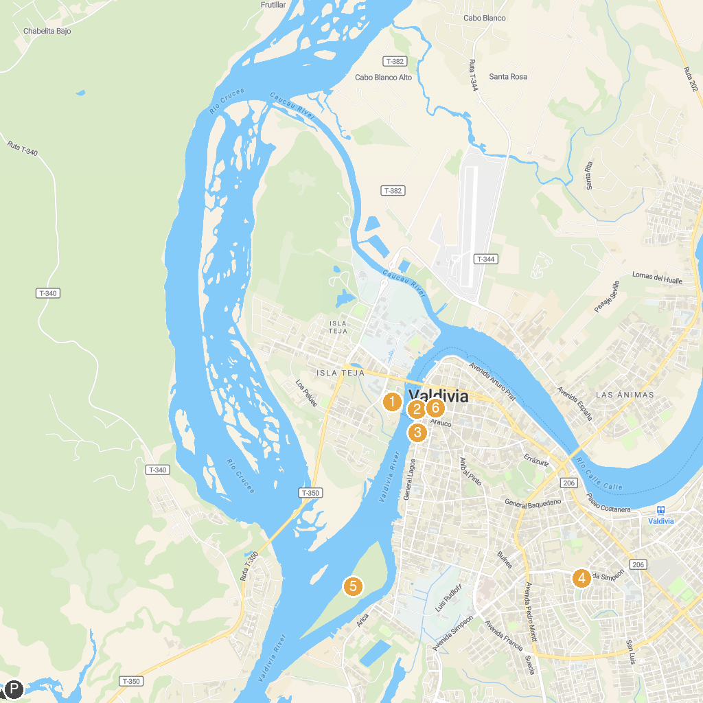
MAP KEY
1. Museo de la Exploración Rudolph Amandus Philippi | 5. Playa Los Molinos
2. Pendulo de Foucault | 6. Islote Haverbeck
3. Centro Cultural El Austral | 7. Our Lady of the Rosary Cathedral, Valdivia
4. Parque Krahmer
P. Cruise port / terminal
Map © MapTiler © OpenStreetMap contributors · cruiseports.org

