Nienburg/Weser, Lower Saxony, Germany
A fairy-tale river town where 500 bronze bear paws lead you through cobblestone streets lined with half-timbered gems — and white asparagus is practically a religion.
⚓ Docked (riverbank pier) · 🕒 Typical call: 6-8 hrs · 💶 Euro (€) · 🗣️ German · 🌿 Asparagus season: mid-Apr – Jun 24
✍️ MY DAY IN PORT (FILL IN)
Ship / Date
In port | arrive ______ · all aboard ______
Booked excursion
Notes / meeting point
GETTING ASHORE
- Docking: Direct berth on the Weserpromenade riverbank — no tender
- Walk to center: 2-5 min (150–300 m) from gangway to the Altstadt
- Best For: History walk, asparagus dining, traditional German market
- Don't Miss: Follow the 500 painted bear paws through the old town
GETTING AROUND
- 🚕 Taxi: €8 base + €2.80/km — Local taxis start at €8 base fare (up to 4 passengers) covering the first kilometer; rarely needed given the walkable to
- 📱 Rideshare: ✅ Uber
TOP THINGS TO DO
- Bear Paw Trail (Bärentatzen-Weg) — Follow roughly 500 white bear paws painted into the cobblestones on a 3.6 km self-guided loop past 32 of the town's most…
- St. Martin's Church & Tower — The town's defining landmark — a 72-metre Gothic brick tower rising above half-timbered rooftops.
- Lower Saxony Asparagus Museum (Niedersächsisches Spargelmuseum) — Housed in a nearly 400-year-old Low German hall house in the garden of the Quaet-Faslem-Haus, this quirky museum is dedicated…
- Museum Nienburg/Weser — The region's history and archaeology museum, set across three historic exhibition houses.
- Weser-Radweg Bike Ride — Rent a bicycle and pedal the legendary Weser-Radweg — one of Germany's most popular river cycling paths.
BEST WALKS
- Bear Paw Old Town Loop: 1.5 km · 40-60 min · Flat · Free — Follow the painted white bear paws from the pier through the pedestrian zone, past St.
- Weserpromenade Stroll: 1 km · 20 min · Flat · Free — A pleasant out-and-back walk along the grassy Weser riverbank south of the pier.
cruiseports.org/nienburg-weser · Confirm terminal & all-aboard time with your ship

Nienburg/Weser, Lower Saxony, Germany — Port Map
Red = walkable sights · Amber = excursions farther out · P = cruise terminal
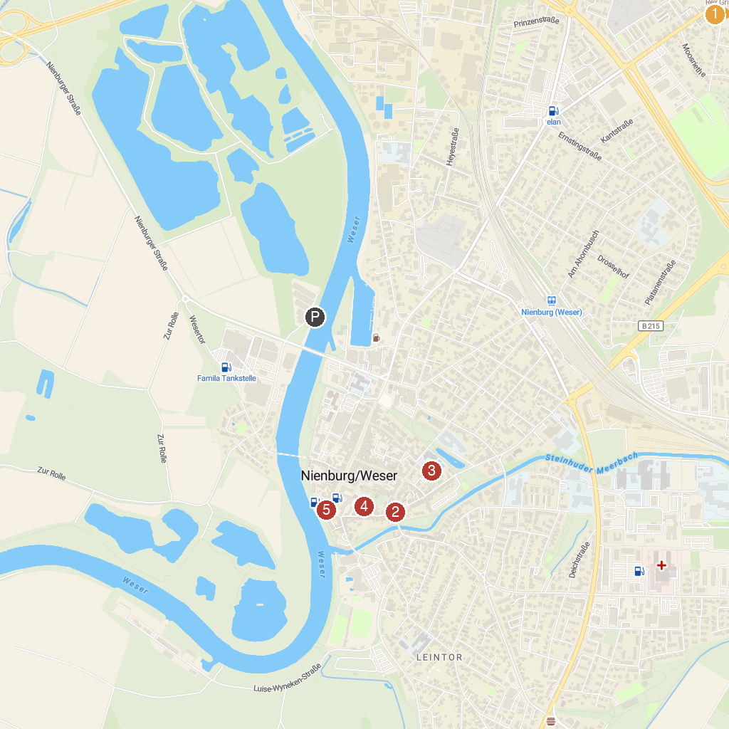
MAP KEY
1. Kräher Höhe | 4. Nienburg Altstadt
2. Museum Nienburg, Quaet-Faslem-Haus | 5. Spargelbrunnen
3. Museum Nienburg, Fresenhof
P. Cruise port / terminal
Map © MapTiler © OpenStreetMap contributors · cruiseports.org

