Nijmegen, Gelderland, Netherlands
Founded by the Romans in the 1st century BC, Nijmegen sits on one of the few hills in the otherwise flat Netherlands. Ships tie up right on the Waalkade promenade — step off and you're already in the city.
⚓ Docked (Waalkade quay) · 🕒 Typical call: 8–10 hrs · 💶 Euro · 🗣️ Dutch (English universally spoken)
✍️ MY DAY IN PORT (FILL IN)
Ship / Date
In port | arrive ______ · all aboard ______
Booked excursion
Notes / meeting point
GETTING ASHORE
- Docking: Pier — river ships dock along the Waalkade quay; no tender
- Walk to center: 5–10 min uphill to Grote Markt (~500 m)
- Best For: Roman history, medieval old town, riverside cycling
- Don't Miss: Valkhof Park ruins & De Oversteek bridge sunset tribute
GETTING AROUND
- 🚕 Taxi: €5–€10 — Standard taxis charge a base fare of ~€3.19 plus ~€2.35/km. For the short hop from the pier to city center the total is
- 📱 Rideshare: ✅ Uber, Bolt
TOP THINGS TO DO
- Roman Nijmegen & Valkhof Ruins — Walk through Valkhof Park to see the 11th-century St.
- Old Town Walk: Grote Markt & Sint-Stevenskerk — Explore the main market square with its 17th-century Boterwaag, climb the tower of the Gothic St.
- Waal Riverside Cycling — Rent a bike on the Waalkade and follow the dike paths east into the Ooijpolder nature reserve, where wild Konik horses and…
- WWII Liberation: National Liberation Museum, Groesbeek — A short taxi or bus ride from the dock, this museum near the German border tells the full story of Operation Market Garden and…
- Veur-Lent River Beach & Spiegelwaal — Cross De Oversteek bridge to the Veur-Lent island for sandy river swimming beaches along the Spiegelwaal bypass channel — calm…
BEST WALKS
- Waalkade to Grote Markt & Valkhof Park: 1.5 km | 25–35 min | easy–moderate (uphill sections) — From the dock, walk along the Waalkade to the Velorama bicycle museum, then head up Burchtstraat…
- De Oversteek Bridge & Veur-Lent: 3 km round trip | 40–50 min | easy — Walk west along the Waalkade to the De Oversteek bridge, where 48 lamp pairs light up one by one…
- Kronenburgerpark & Medieval Walls: 1 km | 20 min | easy — Head west from Grote Markt to Kronenburgerpark, a landscaped English-style park with a pond…
WEATHER · DAYLIGHT · MONEY
Month | High °F | Low °F | Rainy days
May | 64 | 49 | 12
Jul | 73 | 59 | 13
Sep | 68 | 54 | 11
Daylight: May 5:43AM–9:23PM · Jul 5:35AM–9:48PM · Sep 7:11AM–7:50PM
cruiseports.org/nijmegen · Confirm terminal & all-aboard time with your ship

Nijmegen, Gelderland, Netherlands — Port Map
Red = walkable sights · Amber = excursions farther out · P = cruise terminal
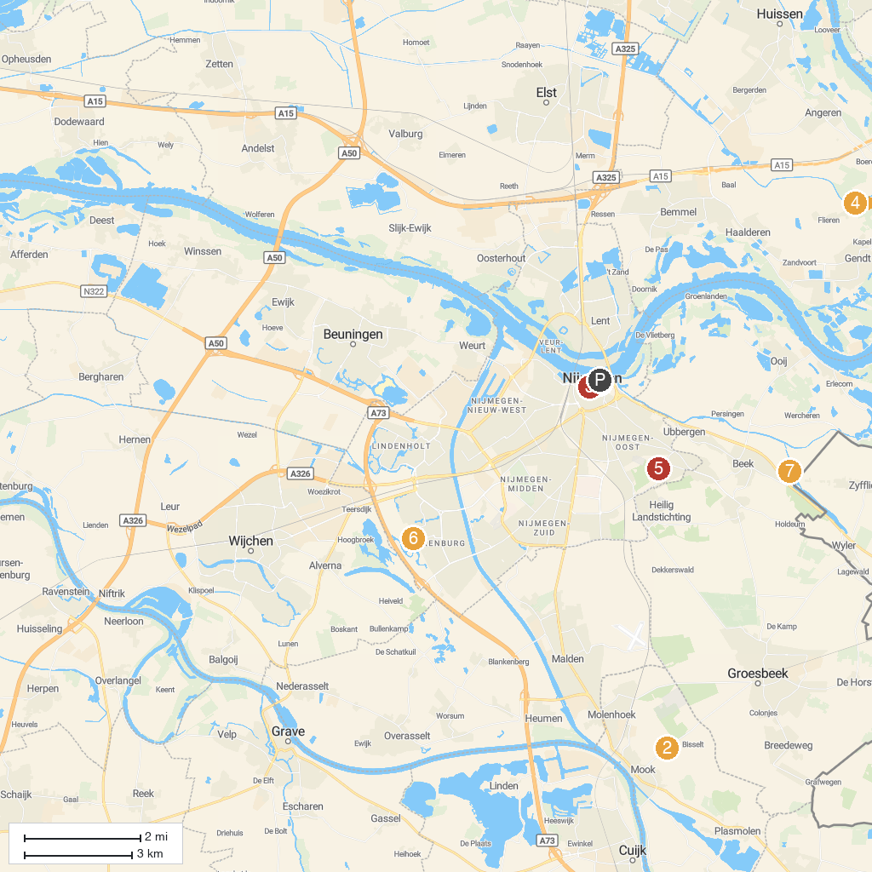
MAP KEY
1. Besiendershuis | 5. Playground The Leemkuil
2. Mookerheide | 6. Grenzland-Draisine GmbH
3. Saint Stephen's Church | 7. Staddijk
4. Doornenburg Castle | 8. Wylerbergmeer
P. Cruise port / terminal
Map © MapTiler © OpenStreetMap contributors · cruiseports.org

