Nikopol, Pleven Province, Bulgaria
A quiet Danube town below a fortress hill, Nikopol was a key medieval stronghold of the Second Bulgarian Empire and the site of the 1396 Battle of Nicopolis — today a tranquil river-cruise call into the heart of rural northern Bulgaria.
⚓ River quay (no tender) · 🕒 Typical call: 4–6 hrs · 💵 Bulgarian Lev (BGN) · 🗣️ Bulgarian · 🏰 Medieval fortress & churches
✍️ MY DAY IN PORT (FILL IN)
Ship / Date
In port | arrive ______ · all aboard ______
Booked excursion
Notes / meeting point
GETTING ASHORE
- Docking: River quay on the Danube waterfront — ships dock directly alongside, no tender required
- Walk to center: Town center is a few minutes' flat walk from the quay; the fortress is a steep climb above town
- Best For: Medieval history, Danube fortress views, day trips to Pleven & Veliko Tarnovo
- Don't Miss: Kaleto / Shishman's Fortress ruins above town and the riverfront Danube views toward Romania
GETTING AROUND
- 🚕 Taxi: ~BGN 5–15 (~€2.50–€8) within town — Local taxis are available in Nikopol for trips around town or to nearby areas. Private transfers to Pleven (45 km) cost
TOP THINGS TO DO
- Kaleto — Shishman's Fortress — Climb to the ruins of the medieval fortress on the hill above town, built on a Roman and Byzantine core.
- Battle of Nicopolis Heritage — Nikopol is famous as the site of the 1396 Battle of Nicopolis, where Sultan Bayezid I's Ottoman army defeated a large European…
- Day Trip to Veliko Tarnovo — A longer inland excursion (~100 km) to Veliko Tarnovo, the medieval capital of the Second Bulgarian Empire, crowned by the…
- Town Churches & Riverfront — Explore Nikopol's compact center on foot: medieval and Revival-era Orthodox churches, the small historical museum with finds from…
BEST WALKS
- Riverfront to Town Center: 0.8 km · 12 min · Easy — From the quay, follow the Danube waterfront into the compact town center, passing the main square…
- Climb to Kaleto Fortress: 1.5 km · 25 min · Moderate (uphill) — A steeper walk up from town to the Kaleto / Shishman's Fortress ruins on the hill, rewarded with…
WEATHER · DAYLIGHT · MONEY
Month | High °F | Low °F | Rainy days
May | 73 | 55 | 10
Jul | 86 | 67 | 6
Sep | 79 | 60 | 5
Daylight: May 5:55AM–8:38PM · Jul 5:52AM–9:00PM · Sep 6:59AM–7:32PM
cruiseports.org/nikopol · Confirm terminal & all-aboard time with your ship

Nikopol, Pleven Province, Bulgaria — Port Map
Red = walkable sights · Amber = excursions farther out · P = cruise terminal
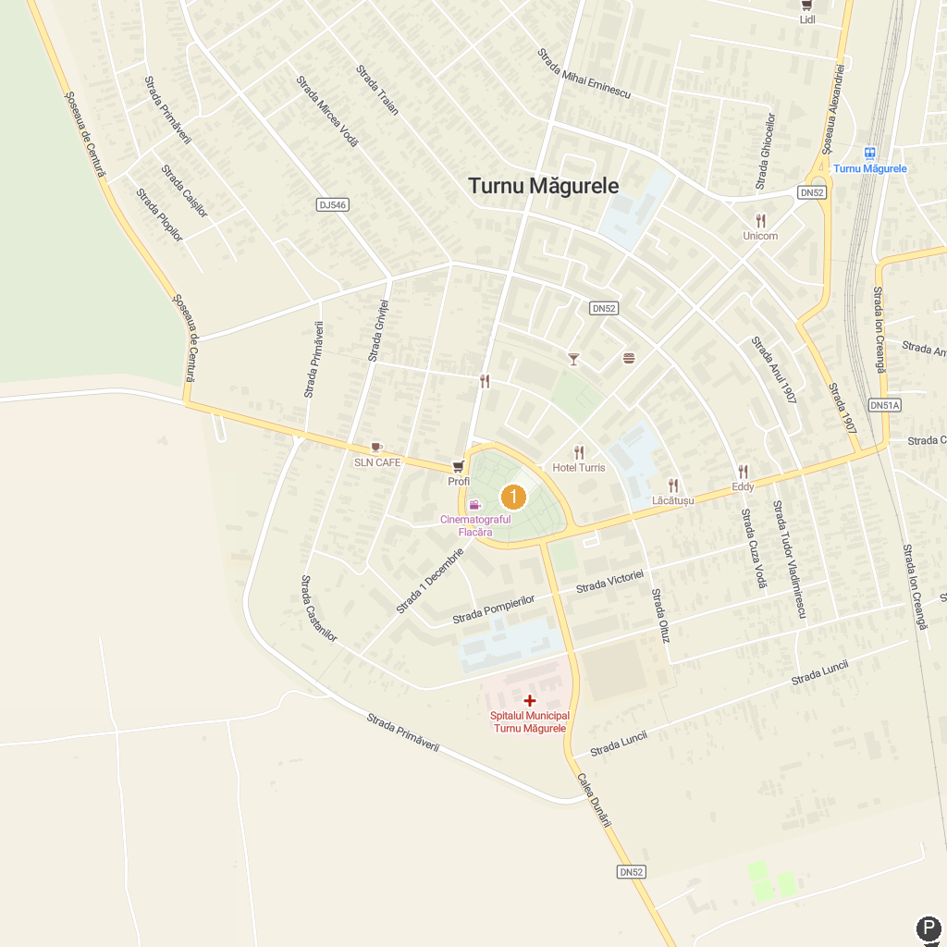
MAP KEY
1. Persina Nature Park | 2. Central Park Turnu Magurele
P. Cruise port / terminal
Map © MapTiler © OpenStreetMap contributors · cruiseports.org

