Nordkapp (North Cape), Finnmark, Norway
Stand at the edge of Europe. At 71°N, the Nordkapp plateau juts into the Arctic Ocean with nothing between you and the North Pole — and from mid-May to late July, the sun never sets.
⚓ Mostly pier (some tender for large ships) · 🕒 Typical call: 6-10 hrs (often midnight-sun evening calls) · 💵 Norwegian Krone (NOK) — nearly cashless · 🗣️ Norwegian (English widely spoken) · ❄️ Arctic weather year-round — always pack layers
✍️ MY DAY IN PORT (FILL IN)
Ship / Date
In port | arrive ______ · all aboard ______
Booked excursion
Notes / meeting point
GETTING ASHORE
- Docking: Pier in Honningsvåg town center; very large ships may tender
- Walk to center: 2-5 min from pier to town shops and tour buses
- Best For: Midnight Sun, the Globe Monument, King Crab dining, Arctic scenery
- Don't Miss: Nordkapphallen panorama cinema and mailing a postcard with the Nordkapp stamp
GETTING AROUND
- 🚕 Taxi: NOK 1,600 round-trip (up to 4 people) — Taxis wait at the main parking lot in front of the cruise docks. A round trip for up to four passengers to the North Cap
- 📱 Rideshare: ❌ not available
TOP THINGS TO DO
- North Cape Plateau & Globe Monument — The essential Nordkapp experience.
- King Crab Safari — Boat out to where giant King Crabs are caught in the cold Barents Sea, then cook and eat them fresh on board or at a crab house.
- Midnight Sun at the Cape — If your ship calls between May 14 and July 29, the sun never sets.
- Honningsvåg & WWII History — The North Cape Museum (Nordkappmuseet) near the pier tells the story of Magerøya island, the fishing heritage, and the German…
- Arctic Seabird & Fjord Cruise — RIB or zodiac boat tours along the Magerøya coastline to spot puffins, white-tailed eagles, and other Arctic seabirds on the…
BEST WALKS
- Honningsvåg Harborfront Stroll: 1 km · 20 min · Easy · Walkable from pier — From the pier, walk along the harborfront past colorful wooden buildings to Honningsvåg Church…
- Nordkapp Plateau Walk: 1-2 km on plateau · Easy · Incredible views — Once you've taken the bus to the plateau, explore the perimeter path along the cliff edge with…
WEATHER · DAYLIGHT · MONEY
Month | High °F | Low °F | Rainy days
May | 42 | 35 | 16
Jul | 55 | 48 | 12
Sep | 49 | 43 | 15
Daylight: Sep 5:27AM–6:52PM
cruiseports.org/nordkapp-north-cape · Confirm terminal & all-aboard time with your ship

Nordkapp (North Cape), Finnmark, Norway — Port Map
Red = walkable sights · Amber = excursions farther out · P = cruise terminal
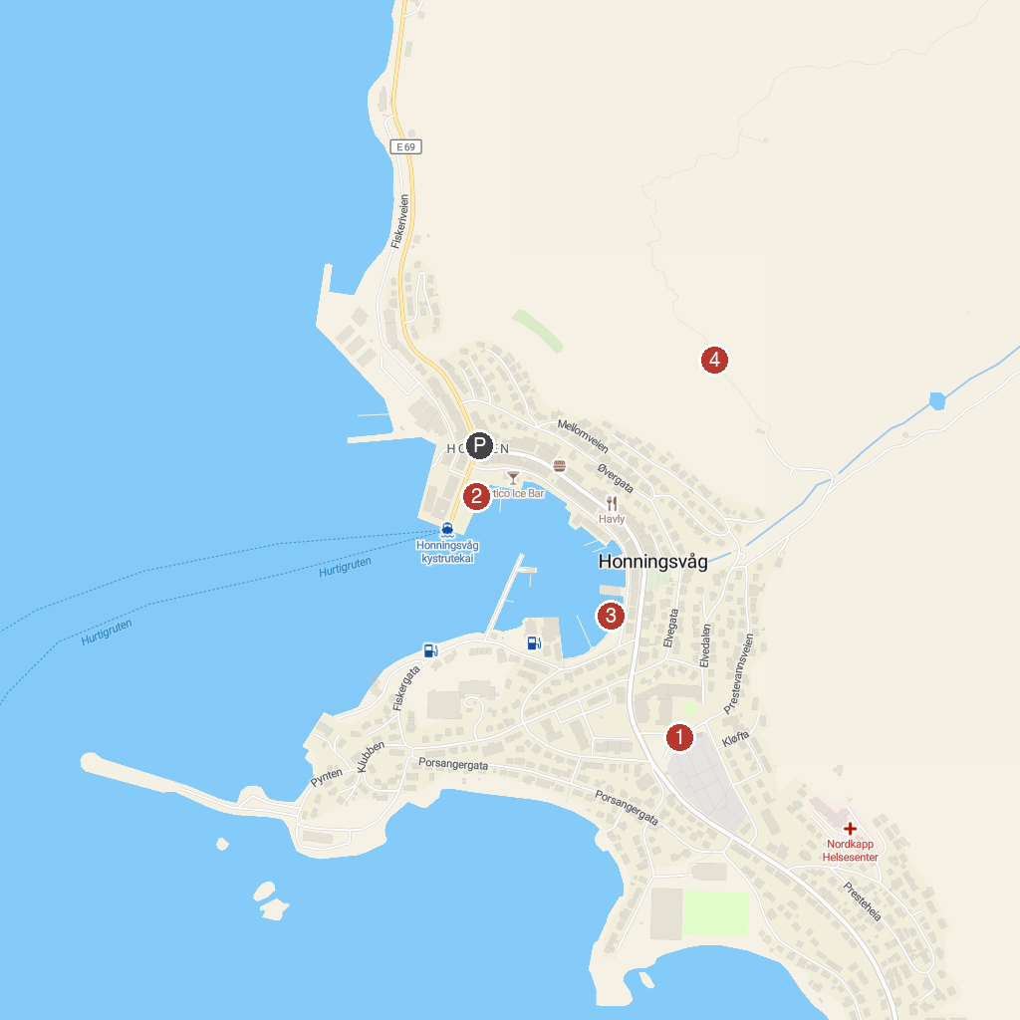
MAP KEY
1. Honningsvåg Church | 3. North Cape Experience
2. Nordkappmuseet | 4. Nordkapin portaat
P. Cruise port / terminal
Map © MapTiler © OpenStreetMap contributors · cruiseports.org

