Norman Island, British Virgin Islands
The real-life Treasure Island: an uninhabited BVI gem where pirate caves, turquoise-lit snorkeling, and a floating party boat share the same postcard-perfect anchorage.
⚓ Tender only (no pier) · 🕒 Typical call: 5–8 hrs · 💵 USD · 🗣️ English · 🤿 World-class snorkeling
✍️ MY DAY IN PORT (FILL IN)
Ship / Date
In port | arrive ______ · all aboard ______
Booked excursion
Notes / meeting point
GETTING ASHORE
- Docking: Tender into The Bight beach/dinghy dock — no cruise pier on island
- Walk to center: 0 min — tender drops you on The Bight beach; Pirates Bight restaurant 2 min
- Best For: Snorkeling, pirate history, hiking, floating bar experience
- Don't Miss: Swimming the three sea caves at Treasure Point and a painkiller on the Willy T
GETTING AROUND
- 🚕 Taxi: $1,200–$2,350/boat (half-day) — Private powerboat charters from operators like Chillout Charters can bring you to Norman Island from Tortola or other BV
- 📱 Rideshare: ❌ not available
TOP THINGS TO DO
- The Caves Snorkel (Treasure Point) — Three semi-submerged sea caves cut into the cliffs at the western edge of The Bight.
- The Indians Snorkel & Dive — Four jagged rock pinnacles off Pelican Island, just northwest of Norman Island, rise from the seabed and plunge to about 40 feet…
- Spyglass Hill Hike — Follow the dirt trail from The Bight beach up to the ridge where pirates once scanned for incoming Spanish galleons.
- The Willy T Floating Bar — A roughly 100-foot former steel supply ship permanently anchored in The Bight, converted into a rowdy floating bar and restaurant…
- Pirates Bight Beach Day — The beachfront restaurant right on The Bight offers lounge chairs (for rent), Caribbean and international cuisine — fresh…
BEST WALKS
- The Bight Beach Stroll: 0.5 km · Flat · 10 min — Walk the crescent of white sand from the tender dock west to the base of the Spyglass Hill trail.
- Spyglass Hill Trail: ~1.5 km round trip · Moderate · 50 min — From Pirates Bight restaurant, pick up the trail heading uphill through dry scrub.
WEATHER · DAYLIGHT · MONEY
Month | High °F | Low °F | Rainy days
May | 80 | 78 | 11
Jul | 82 | 79 | 15
Sep | 83 | 80 | 17
Daylight: May 5:44AM–6:44PM · Jul 5:50AM–6:57PM · Sep 6:06AM–6:20PM
cruiseports.org/norman-island-bvi · Confirm terminal & all-aboard time with your ship

Norman Island, British Virgin Islands — Port Map
Red = walkable sights · Amber = excursions farther out · P = cruise terminal
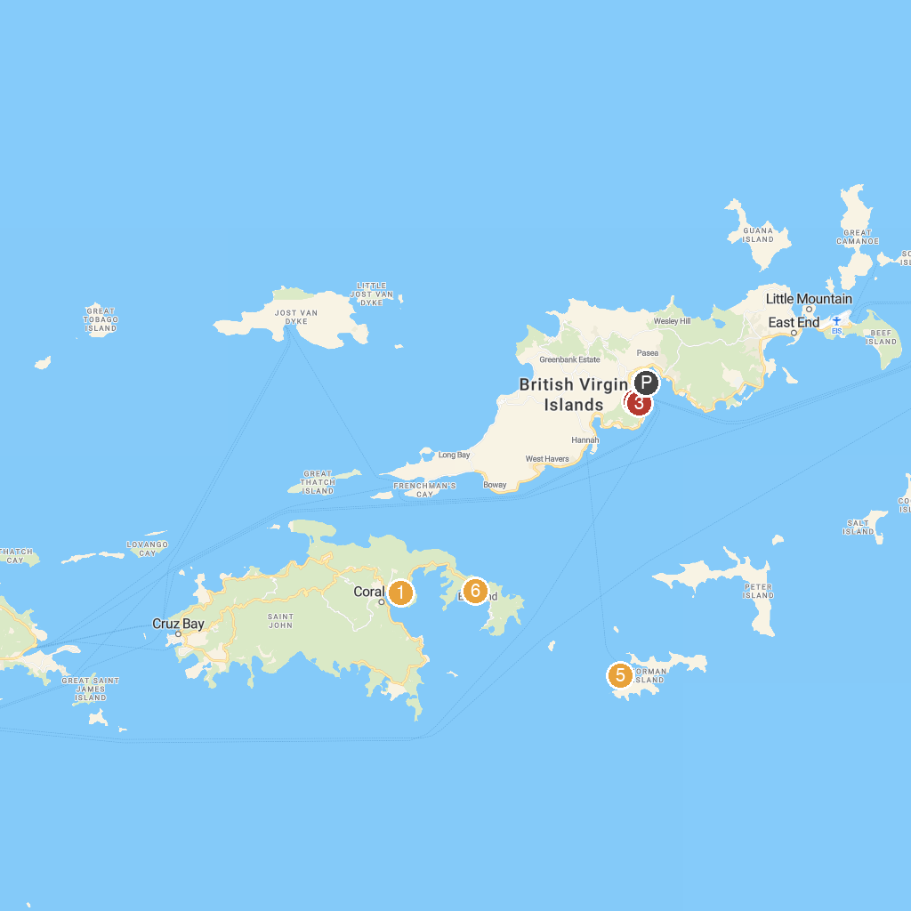
MAP KEY
1. Carolina Corral | 5. Annaberg Sugar Plantation
2. Old Government House Museum | 6. Treasure Point
3. Queen Elizabeth II National Park | 7. South Haulover Beach
4. Cyril B. Romney Tortola Pier Park
P. Cruise port / terminal
Map © MapTiler © OpenStreetMap contributors · cruiseports.org

