Noumea, Grande Terre, New Caledonia
France in the South Pacific — a city of baguettes and coral reefs, where Renzo Piano's Kanak cultural centre meets turquoise lagoon waters and one of the world's great UNESCO marine ecosystems.
⚓ Docked (Gare Maritime, central) · 🕒 Typical call: 8–10 hrs · 💵 CFP Franc (XPF) · 🗣️ French
✍️ MY DAY IN PORT (FILL IN)
Ship / Date
In port | arrive ______ · all aboard ______
Booked excursion
Notes / meeting point
GETTING ASHORE
- Docking: Gare Maritime (Quai Ferry, central waterfront)
- Walk to center: 5 min to Place des Cocotiers
- Best For: Culture · Beaches · Lagoon
- Don't Miss: Tjibaou Cultural Centre
GETTING AROUND
- 🚕 Taxi: ~555 XPF base + 123 XPF/km — Metered taxis are available at the terminal. A short city-center ride runs roughly 1,000–1,500 XPF. Ask the driver for a
- 📱 Rideshare: ❌ not available
- 🚌 Hop-on hop-off: ✅
TOP THINGS TO DO
- Tjibaou Cultural Centre — Renzo Piano's iconic Kanak cultural centre on the Tina peninsula — ten soaring wooden 'cases' housing Kanak art, history, and…
- Amédée Island Lighthouse Day Trip — A classic South Pacific excursion: boat out to tiny Amédée Island with its 19th-century lighthouse, snorkel the coral reef, lunch…
- Anse Vata & Baie des Citrons — Noumea's two most popular swimming beaches, lined with cafés, restaurants, and watersports.
- UNESCO Lagoon Sailing or Snorkeling — New Caledonia's lagoon is a UNESCO World Heritage Site — one of the largest coral reef systems on Earth.
- Aquarium des Lagons & City Walk — The Aquarium des Lagons showcases the extraordinary marine biodiversity of New Caledonia's reef, including nautiluses and local…
BEST WALKS
- Waterfront to Place des Cocotiers: ~1.5 km · 30 min · easy — Walk from the Gare Maritime along the waterfront esplanade, past the Aquarium des Lagons, and into…
- Mont Coffyn Lookout: ~3 km · 1 hr · moderate — A short uphill walk or taxi ride to the Mont Coffyn lookout delivers panoramic views over Noumea…
WEATHER · DAYLIGHT · MONEY
Month | High °F | Low °F | Rainy days
May | 76 | 69 | 14
Jul | 72 | 64 | 9
Sep | 74 | 64 | 10
Daylight: May 6:19AM–5:21PM · Jul 6:33AM–5:26PM · Sep 5:51AM–5:48PM
cruiseports.org/noumea · Confirm terminal & all-aboard time with your ship

Noumea, Grande Terre, New Caledonia — Port Map
Red = walkable sights · Amber = excursions farther out · P = cruise terminal
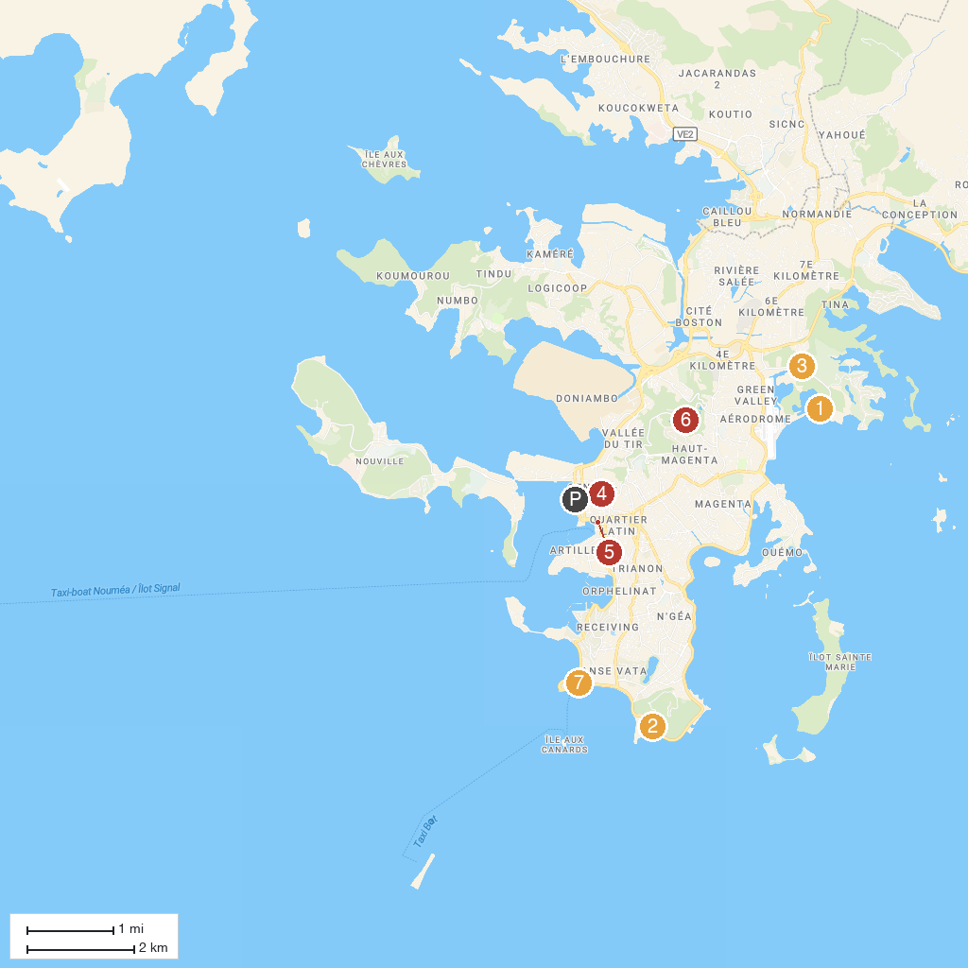
MAP KEY
1. Tjibaou Cultural Centre | 5. KOGHI PARC AVENTURE
2. Grand Casino | 6. Noumea City Market
3. Les Boucles de Tina | 7. Parc Zoologique Et Forestier Michel Corbasson
4. Musée de la Ville de Nouméa | 8. Lagoon Aquarium
P. Cruise port / terminal
Map © MapTiler © OpenStreetMap contributors · cruiseports.org

