Nuku'alofa, Tongatapu, Tonga
Capital of the world's last Polynesian Kingdom, Nuku'alofa moves at pure island pace — free-roaming pigs, a Victorian royal palace, and volcanic blowholes shooting plumes 30 metres into the air await just minutes from the pier.
⚓ Docked — Vuna Wharf (city-centre pier) · 🕒 Typical call: 7–9 hrs · 💵 Tongan Pa'anga (TOP); AUD/USD sometimes accepted · 🗣️ Tongan & English · ⚠️ Everything closes on Sundays by law
✍️ MY DAY IN PORT (FILL IN)
Ship / Date
In port | arrive ______ · all aboard ______
Booked excursion
Notes / meeting point
GETTING ASHORE
- Docking: Vuna Wharf — docked, steps from city centre
- Walk to centre: 5 min to Royal Palace; 10 min to Talamahu Market
- Best For: Polynesian culture, royal history, blowholes, island day-trips
- Don't Miss: Mapu 'a Vaea Blowholes on the south coast
GETTING AROUND
- 🚕 Taxi: TOP $5–20 (city); TOP $350 for 4–5 hr island tour — Taxis queue at the pier when ships are in. No meters — always agree on the fare before you go. Half-day island tours run
- 📱 Rideshare: ❌ not available
TOP THINGS TO DO
- Mapu 'a Vaea Blowholes — Miles of lava coastline at Houma village where waves force plumes of water up to 30 metres into the air through natural volcanic…
- Ha'amonga 'a Maui Trilithon — Tonga's 'Stonehenge' — a massive three-slab stone archway erected in the 13th century as a royal gateway or astronomical marker…
- Anahulu Cave Swim — Descend into a limestone cavern of stalactites and stalagmites, then swim in the cool freshwater pool inside.
- Pangaimotu Island Day Trip — A 10–15 minute water taxi from Faua Jetty lands you on a classic South Pacific island with white sand, snorkeling around a sunken…
- Talamahu Market & Town Walk — Wander Nuku'alofa's main market for taro, tropical fruit, woven mats, and wood carvings — then visit the Royal Palace fence and…
BEST WALKS
- Waterfront to Market Loop: 2.5 km · 30–40 min · Flat — A simple loop taking in all of walkable Nuku'alofa: head right from the pier along the waterfront…
WEATHER · DAYLIGHT · MONEY
Month | High °F | Low °F | Rainy days
May | 77 | 74 | 12
Jul | 74 | 70 | 9
Sep | 75 | 70 | 12
Daylight: May 7:03AM–6:10PM · Jul 7:18AM–6:15PM · Sep 6:37AM–6:34PM
cruiseports.org/nukualofa · Confirm terminal & all-aboard time with your ship

Nuku'alofa, Tongatapu, Tonga — Port Map
Red = walkable sights · Amber = excursions farther out · P = cruise terminal
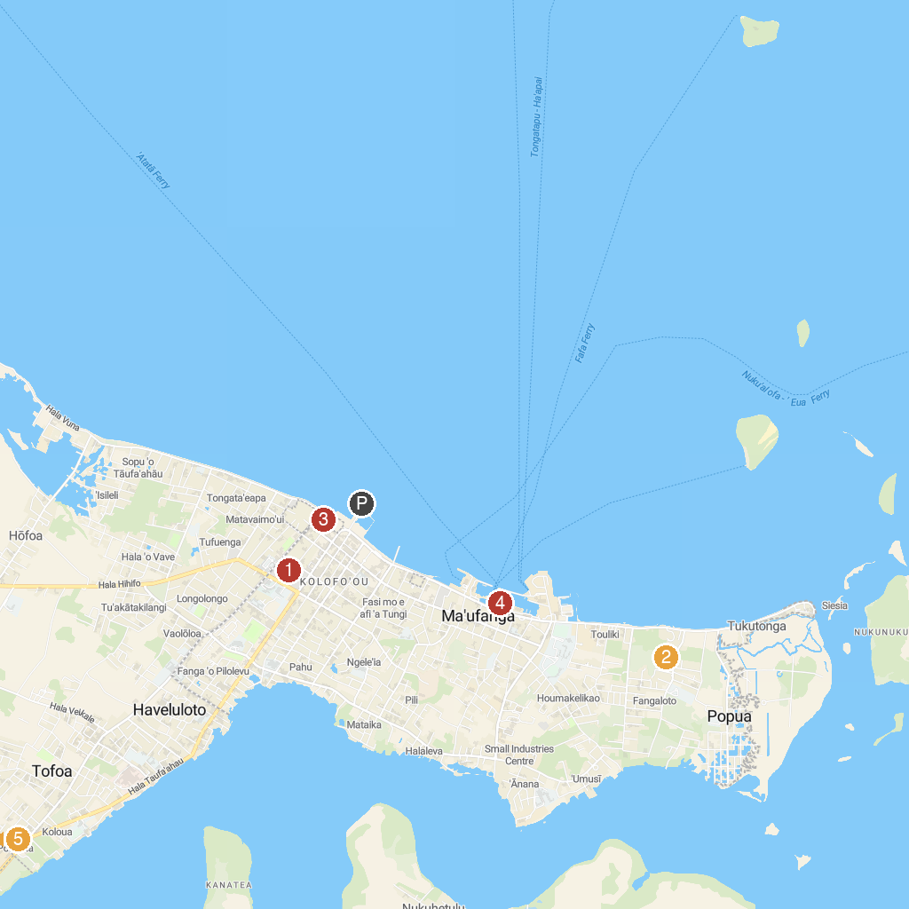
MAP KEY
1. Royal Tombs | 5. Tahi Tonga
2. Ancient Tonga | 6. 3 Headed Coconut
3. Anahulu Cave | 7. Tsunami Rock
4. Royal Palace Of Tonga
P. Cruise port / terminal
Map © MapTiler © OpenStreetMap contributors · cruiseports.org

