Nyborg, Funen, Denmark
Denmark's first capital sits at the foot of the Great Belt Bridge — a medieval gem of ramparts, a royal castle, and cobblestone streets just 10 minutes from the pier.
⚓ Pier (no tender) · 🕒 Typical call: 6-8 hrs · 💵 Danish Krone (DKK) — cards accepted everywhere · 🗣️ Danish (English spoken fluently) · 🚲 Very bike-friendly
✍️ MY DAY IN PORT (FILL IN)
Ship / Date
In port | arrive ______ · all aboard ______
Booked excursion
Notes / meeting point
GETTING ASHORE
- Docking: Pier — Cruise Quay, Nyborg Havn (~1 km to town center)
- Walk to center: 10-15 min (flat, scenic harbor walk)
- Best For: Medieval history, Danish architecture, cycling, the Great Belt Bridge
- Don't Miss: Brunsviger cake from a local bakery — Funen's signature sugar-glazed pastry
GETTING AROUND
- 🚕 Taxi: 100–130 DKK (€13–17) — Taxis are available at the terminal taxi rank. Base fare is around 66 DKK plus 20 DKK/km; the short ride to the center t
- 📱 Rideshare: ✅ Uber
TOP THINGS TO DO
- Nyborg Castle & Ramparts — Walk to Denmark's oldest royal castle (12th century) where the Danehof — medieval parliament — met from the mid-13th century…
- Borgmestergården Museum — A beautifully preserved 17th-century half-timbered merchant's house in the heart of town, now a local history museum.
- Nyborg Destilleri Tour & Tasting — Denmark's largest craft distillery occupies a restored railway workshop near the harbor.
- Day Trip to Odense — The birthplace of Hans Christian Andersen is a direct 15-minute train ride from Nyborg Station (15-min walk from pier).
- Great Belt Bridge Viewpoint & Beach — Cycle or walk east along the coast to Fyns Badestrand, a Blue Flag sandy beach right beside the Great Belt Bridge.
BEST WALKS
- Harbor to Castle & Ramparts: 1.5 km · 20-25 min · Easy — Walk north from the cruise quay along the harbor promenade, turn into the old town via Kongegade…
- Coastal Walk to Great Belt Beach: 2.5 km each way · 30 min · Easy (flat coastal path) — Head east from the harbor along the coastal path to Fyns Badestrand, a Blue Flag beach at the foot…
WEATHER · DAYLIGHT · MONEY
Month | High °F | Low °F | Rainy days
May | 60 | 47 | 11
Jul | 70 | 57 | 13
Sep | 65 | 54 | 11
Daylight: May 5:07AM–9:19PM · Jul 4:56AM–9:48PM · Sep 6:49AM–7:33PM
cruiseports.org/nyborg · Confirm terminal & all-aboard time with your ship

Nyborg, Funen, Denmark — Port Map
Red = walkable sights · Amber = excursions farther out · P = cruise terminal
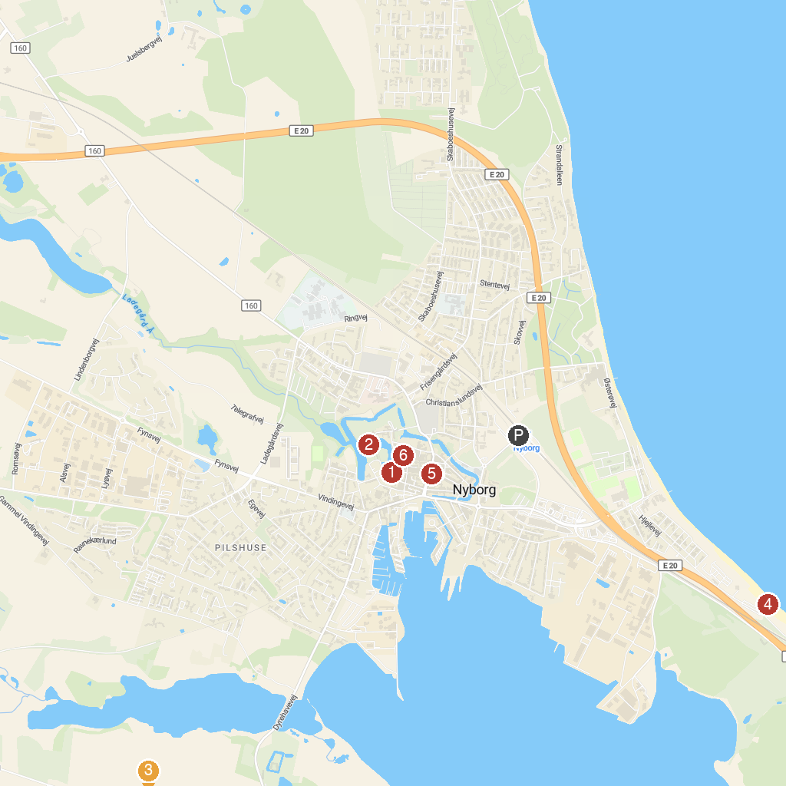
MAP KEY
1. Borgmestergården | 5. Nyborg Badestrand
2. Nyborg Fortress | 6. Church of Our Lady
3. Kongshøj Møllesø | 7. Nyborg torv
4. Damestenen (Danmarks største sten)
P. Cruise port / terminal
Map © MapTiler © OpenStreetMap contributors · cruiseports.org

