Nynäshamn, Stockholm Archipelago, Sweden
Stockholm's front door and a charming Baltic coastal town in its own right. A 60-minute commuter train links the pier to the Swedish capital — but the smoked shrimp at the fishing harbor might convince you to stay.
⚓ Docked (Seawalk floating pier) · 🕒 Typical call: 8–10 hrs · 💵 Swedish Krona (SEK) — card strongly preferred · 🗣️ Swedish (English near-universal) · 🚂 Stockholm 60 min by train
✍️ MY DAY IN PORT (FILL IN)
Ship / Date
In port | arrive ______ · all aboard ______
Booked excursion
Notes / meeting point
GETTING ASHORE
- Docking: Pier — 260 m Seawalk floating walkway; some smaller ships use guest harbor pontoons
- Walk to center: 10–15 min to train station and town (1.3 km, signposted path)
- Best For: Stockholm day trip, archipelago scenery, fresh seafood, low-key coastal wandering
- Don't Miss: Smoked shrimp at Nynäs Rökeri in the fishing harbor
GETTING AROUND
- 🚕 Taxi: 900–1,100 SEK (~$85–105) — Metered taxis and pre-booked private transfers take about 45 minutes to central Stockholm. Pre-booking typically saves v
- 📱 Rideshare: ✅ Uber
- 🚌 Hop-on hop-off: ✅
TOP THINGS TO DO
- Stockholm Self-Guided Day Trip — Hop the commuter train to Sweden's capital and pack in Gamla Stan's cobbled lanes, the spectacular Vasa Museum warship, and…
- Archipelago Boat Trip — Short island-hop cruises depart the guest harbor, weaving through granite skerries and pine-covered islets of the inner Stockholm…
- Gamla Stan & Royal Palace, Stockholm — Medieval old town with the Royal Palace, Stockholm Cathedral, Nobel Museum and narrow alleys unchanged since the 17th century.
- Nynäshamn Railway Museum — A gem for train enthusiasts: restored vintage locomotives, volunteer-run workshops and displays tracing Sweden's railway heritage.
- Nickstabadet Beach — Sandy beach in central Nynäshamn, a 20-minute walk from the pier.
BEST WALKS
- Pier to Fishing Harbor Loop: 1.5 km · ~30 min · Easy — Walk from the cruise pier along the waterfront to the fishing harbor (Fiskehamnen), sample smoked…
- Coastal Path to Nickstabadet: 2 km · ~25 min · Easy — Follow the coastal promenade south from the guest harbor past the marina and the 1912 Olympics pier…
WEATHER · DAYLIGHT · MONEY
Month | High °F | Low °F | Rainy days
May | 55 | 44 | 10
Jul | 69 | 58 | 10
Sep | 61 | 52 | 10
Daylight: May 4:18AM–9:12PM · Jul 4:02AM–9:44PM · Sep 6:17AM–7:07PM
cruiseports.org/nynashamn · Confirm terminal & all-aboard time with your ship

Nynäshamn, Stockholm Archipelago, Sweden — Port Map
Red = walkable sights · Amber = excursions farther out · P = cruise terminal
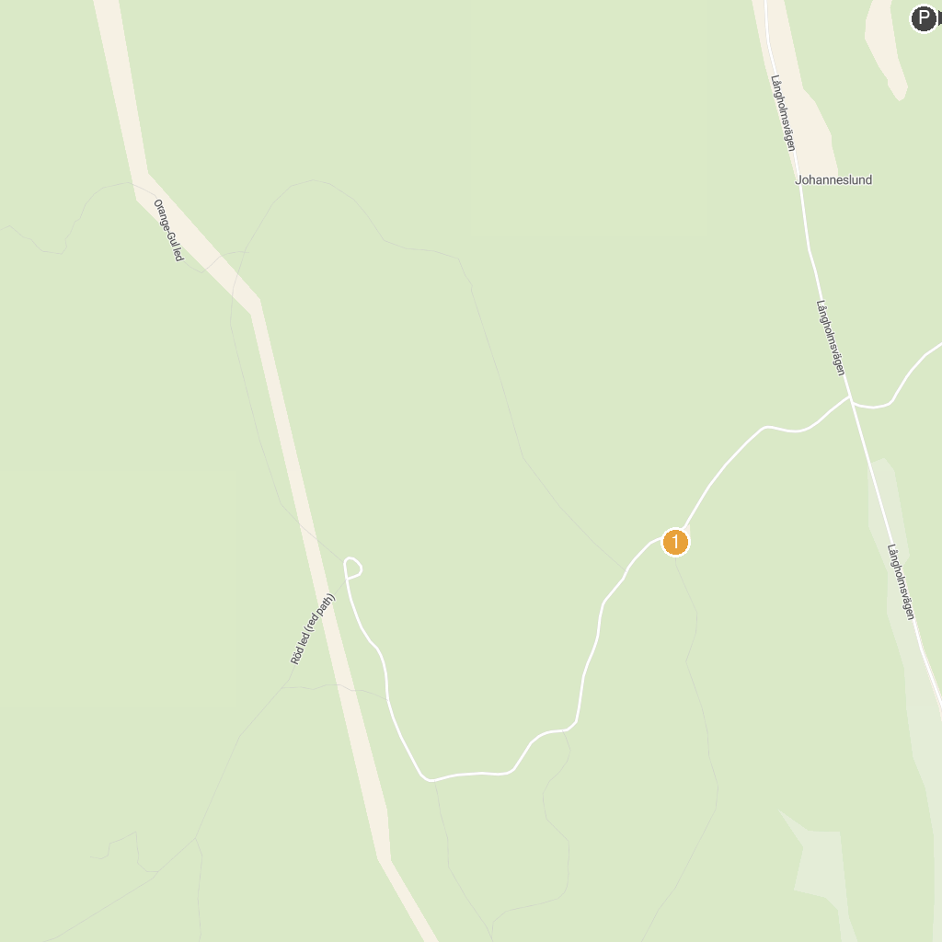
MAP KEY
1. Landsort Heavy Artillery Battery | 4. Gålöbasen
2. Landsorts fyr | 5. Medley Safiren
3. Garvaregården Trosa hembygdsgård | 6. Käringboda
P. Cruise port / terminal
Map © MapTiler © OpenStreetMap contributors · cruiseports.org

