Oarai, Ibaraki, Japan
A Pacific coast gem where an ancient torii gate rises from crashing waves, one of Japan's best aquariums awaits, and the seafood is legendary — all walkable from the pier.
⚓ Pier (docked) · 🕒 Typical call: 8-10 hrs · 💴 Japanese Yen (JPY) · 🗣️ Japanese · 🎌 Anime town
✍️ MY DAY IN PORT (FILL IN)
Ship / Date
In port | arrive ______ · all aboard ______
Booked excursion
Notes / meeting point
GETTING ASHORE
- Docking: Pier docked — Wharf No. 4, no tender needed
- Walk to center: Oarai Seaside Station ~10-15 min; Isosaki Shrine ~30 min
- Best For: Seafood lovers, culture fans, aquarium visits
- Don't Miss: Kamiiso-no-Torii gate at Oarai Isosaki Shrine
GETTING AROUND
- 🚕 Taxi: ¥1,000–¥2,000 (Oarai town); ¥5,000–¥6,500 (to Mito) — Taxis are readily available at the port. Short rides within Oarai town are inexpensive; the 15-minute ride to Mito Stati
- 📱 Rideshare: ✅ Uber
- 🚌 Hop-on hop-off: ✅
TOP THINGS TO DO
- Oarai Isosaki Shrine & Kamiiso Torii Gate — The ancient Shinto shrine (founded 856 AD) crowns a headland above the Pacific, but the real drama is the white torii gate…
- Aqua World Oarai Aquarium — One of Japan's largest aquariums, housing over 580 species including 60+ shark species — the most in Japan.
- Oarai Seafood Market & Kaisen-don — The Oarai Kaisen Ichiba seafood market near the port is the place for fresh oysters, grilled clams, and bowls piled high with…
- Mentai Park Oarai — A free theme park dedicated to mentaiko (spicy cod roe) run by Kanefuku, one of Japan's top producers.
- Mito City Day Trip — Kairakuen Garden & Mito Castle — A 15-minute train ride from Oarai brings you to Mito, home to Kairakuen — one of Japan's Three Great Gardens — and the ruins of…
BEST WALKS
- Pier to Seaside Station & Mentai Park Loop: ~2 km | 30-40 min | Easy | Flat — A gentle flat walk through the port area, past the Marine Tower observation deck, into the Oarai…
- Isosaki Shrine & Torii Gate Walk: ~3 km one way | 30-35 min | Moderate | Stairs at shrine — Follow the coastal road north from the port to Oarai Isosaki Shrine.
WEATHER · DAYLIGHT · MONEY
Month | High °F | Low °F | Rainy days
May | 69 | 57 | 12
Jul | 80 | 71 | 15
Sep | 77 | 69 | 16
Daylight: May 4:31AM–6:36PM · Jul 4:31AM–6:55PM · Sep 5:20AM–5:45PM
cruiseports.org/oarai · Confirm terminal & all-aboard time with your ship

Oarai, Ibaraki, Japan — Port Map
Red = walkable sights · Amber = excursions farther out · P = cruise terminal
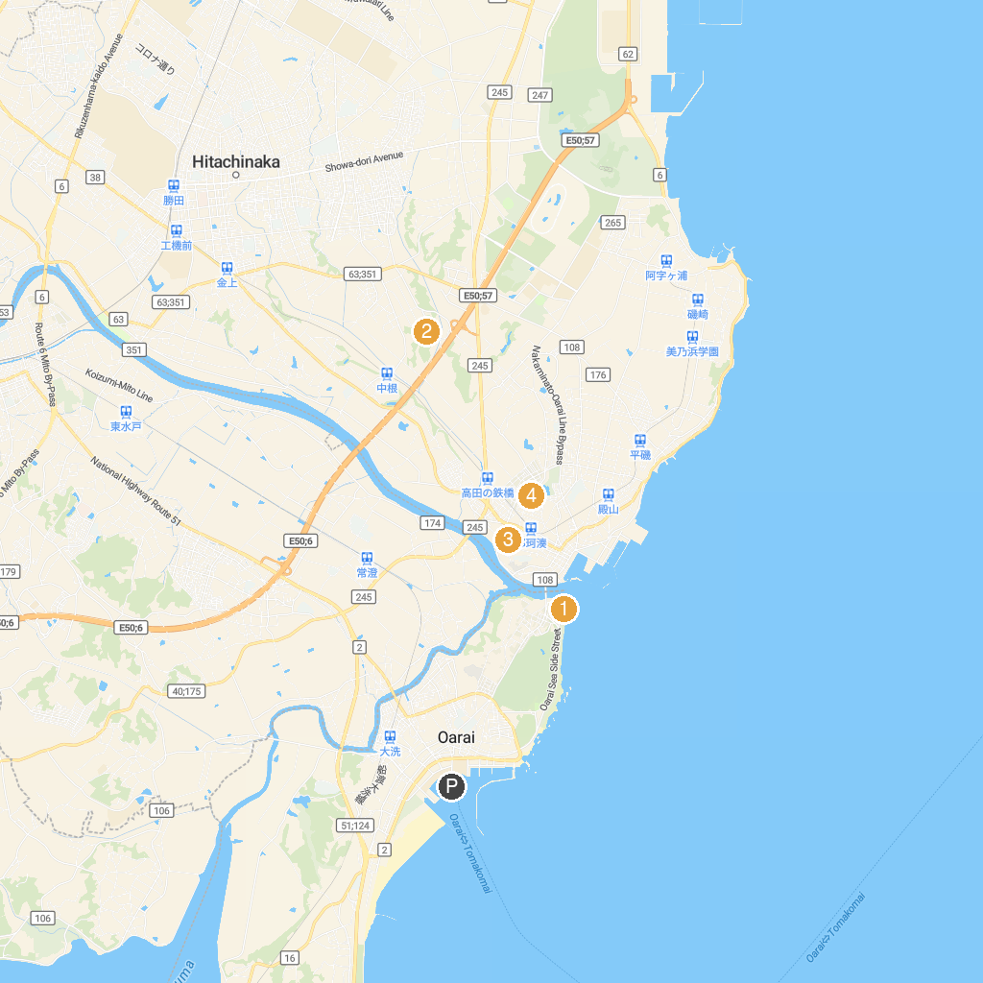
MAP KEY
1. Aqua World Ibaraki Oarai Aquarium | 5. Mito City Museum
2. Torazuka Mounded Tomb | 6. Kairakuen
3. Nakaminato Reverberatory Furnace Ruin | 7. Giretsu kan
4. Art Tower Mito | 8. Jokoji
P. Cruise port / terminal
Map © MapTiler © OpenStreetMap contributors · cruiseports.org

