Olbia, Sardinia, Italy
Sardinia's northeast gateway mixes Bronze Age nuraghi, Roman shipwrecks, and some of the Mediterranean's most dazzling turquoise water — all within reach of a single shore day.
⚓ Pier (Isola Bianca) · 🕒 Typical call: 8-10 hrs · 💶 Currency: Euro (€) · 🗣️ Language: Italian / Sardinian · 🏖️ Beach day possible
✍️ MY DAY IN PORT (FILL IN)
Ship / Date
In port | arrive ______ · all aboard ______
Booked excursion
Notes / meeting point
GETTING ASHORE
- Docking: Pier — Isola Bianca Cruise Terminal, ~2 km from town center
- Walk to center: 25 min on foot; free shuttle every 10 min to Piazza Regina Margherita
- Best For: Beaches, history, Costa Smeralda day trip, Sardinian food
- Don't Miss: Basilica di San Simplicio, Pittulongu Beach, Olbia mussels
GETTING AROUND
- 🚕 Taxi: €9–€14 — Metered taxis are available at the terminal. The ride to the city center takes roughly 5–10 minutes; fares vary by time
- 📱 Rideshare: ✅ Uber
TOP THINGS TO DO
- Pittulongu Beach by Bus — Olbia's most popular beach with pale sand and transparent turquoise water.
- Costa Smeralda & Porto Cervo — Drive or join a shore excursion to the famous Emerald Coast — mega-yachts, designer boutiques, and some of Italy's most…
- Nuragic Sites: Cabu Abbas & Sa Testa — Cabu Abbas is a Bronze Age nuraghe fortress on a hill with sweeping Gulf of Olbia panoramas; Sa Testa is a Nuragic sacred well…
- Tavolara Island Boat Trip — From nearby Porto San Paolo (15 min south), boats ferry visitors to the dramatic limestone monolith of Tavolara and the…
- Olbia Old Town & Archaeological Museum — Walk Corso Umberto I, admire the majolica-tiled dome of Chiesa di San Paolo, and visit the free Archaeological Museum on its own…
BEST WALKS
- Historic Center Stroll: 45 min · Easy · Free — From Piazza Regina Margherita, walk up Corso Umberto I past boutiques and cafés.
- Museum & Ancient Walls Walk: 30 min · Easy · Mostly free — From the town center, cross the small bridge to the Archaeological Museum of Olbia (free entry)…
WEATHER · DAYLIGHT · MONEY
Month | High °F | Low °F | Rainy days
May | 72 | 57 | 8
Jul | 89 | 71 | 1
Sep | 81 | 66 | 6
Daylight: May 6:04AM–8:32PM · Jul 6:03AM–8:52PM · Sep 7:02AM–7:30PM
cruiseports.org/olbia · Confirm terminal & all-aboard time with your ship

Olbia, Sardinia, Italy — Port Map
Red = walkable sights · Amber = excursions farther out · P = cruise terminal
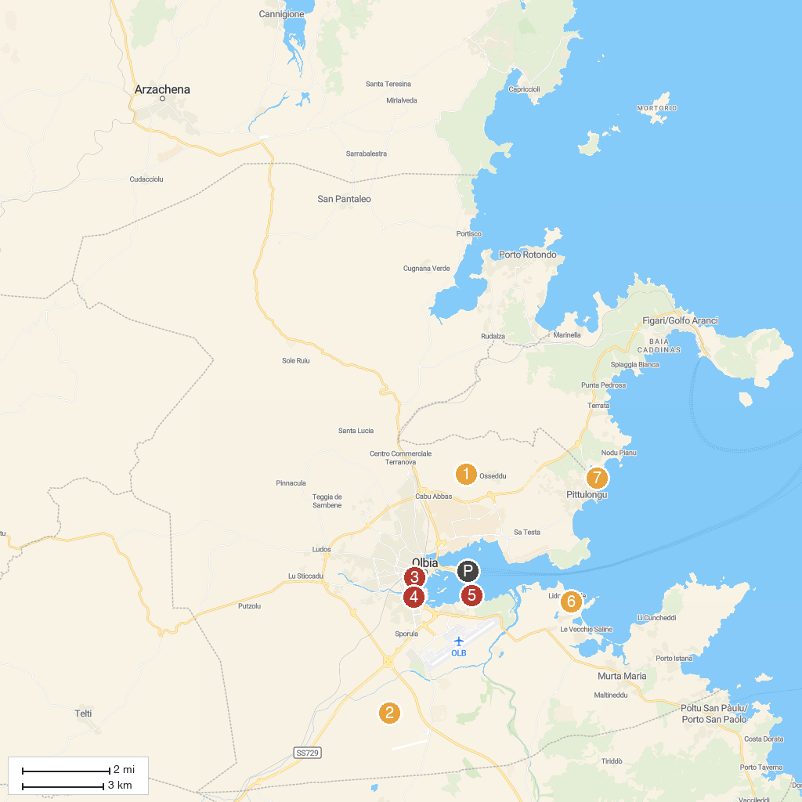
MAP KEY
1. Nuraghe Riu Mulinu Cabu Abbas | 5. BlueSea Charter Noleggio Gommoni con Skipper Olbia e Escursioni a Tavolara
2. Castle of Pedres (ruins) | 6. Beach Lido del Sole
3. Rovine delle mura puniche | 7. Spiaggia di Bados
4. Archivio Mario Cervo | 8. San Lorenzo Church
P. Cruise port / terminal
Map © MapTiler © OpenStreetMap contributors · cruiseports.org

