Olden, Vestland, Norway
A tiny village at the foot of Europe's largest mainland glacier. Olden punches far above its weight — world-class glacier hikes, a record-breaking cable car, and milky-turquoise fjord water await just steps from the pier.
⚓ Pier (walk-off) · 🕒 Typical call: 7-9 hrs · 💵 NOK — card accepted everywhere · 🗣️ Norwegian (English widely spoken) · 🏔️ Glacier & fjord country
✍️ MY DAY IN PORT (FILL IN)
Ship / Date
In port | arrive ______ · all aboard ______
Booked excursion
Notes / meeting point
GETTING ASHORE
- Docking: Deep-water cruise pier — walk off directly; tendering very rare
- Walk to village: 5 min flat walk from pier to Olden center
- Best For: Glacier hikes, cable cars, fjord scenery, photography
- Don't Miss: Briksdal Glacier hike or Loen Skylift cable car
GETTING AROUND
- 🚕 Taxi: ~100–200 NOK / ~$10–20 USD (short trips) — Taxis are very limited in Olden; advance booking is strongly recommended. Starting fare ~100 NOK plus ~14.5 NOK/km.
- 📱 Rideshare: ❌ not available
- 🚌 Hop-on hop-off: ✅
TOP THINGS TO DO
- Briksdal Glacier Hike — The crown jewel of Olden.
- Loen Skylift — One of the world's steepest cable cars, ascending from sea level to 1,011 m atop Mount Hoven in just 5 minutes.
- Kjenndal Glacier & Lovatnet Lake — A quieter alternative to Briksdal.
- Fjord RIB Boat Tour — High-speed rigid inflatable boat tours depart directly from the pier area, giving you a fast-paced perspective of the inner…
- Olden Village Walk & Old Church — Explore Olden on foot: the 1759 Olden Gamle Kyrkje (old white wooden church), the 1934 red church by the waterfront, the Oldeelva…
BEST WALKS
- Pier to Olden Village & Churches: 1 km · ~15 min · Flat · Free — A leisurely stroll from the cruise pier along the fjord into the heart of Olden.
- Huaren Viewpoint Hike: ~4 km return · 1.5-2 hrs · Steep · Free — A challenging but free hike starting near Olden School (look for the trailhead info board) that…
WEATHER · DAYLIGHT · MONEY
Month | High °F | Low °F | Rainy days
May | 56 | 42 | 16
Jul | 68 | 54 | 20
Sep | 61 | 48 | 18
Daylight: May 4:42AM–10:15PM · Jul 4:14AM–11:02PM · Sep 6:55AM–8:00PM
cruiseports.org/olden · Confirm terminal & all-aboard time with your ship

Olden, Vestland, Norway — Port Map
Red = walkable sights · Amber = excursions farther out · P = cruise terminal
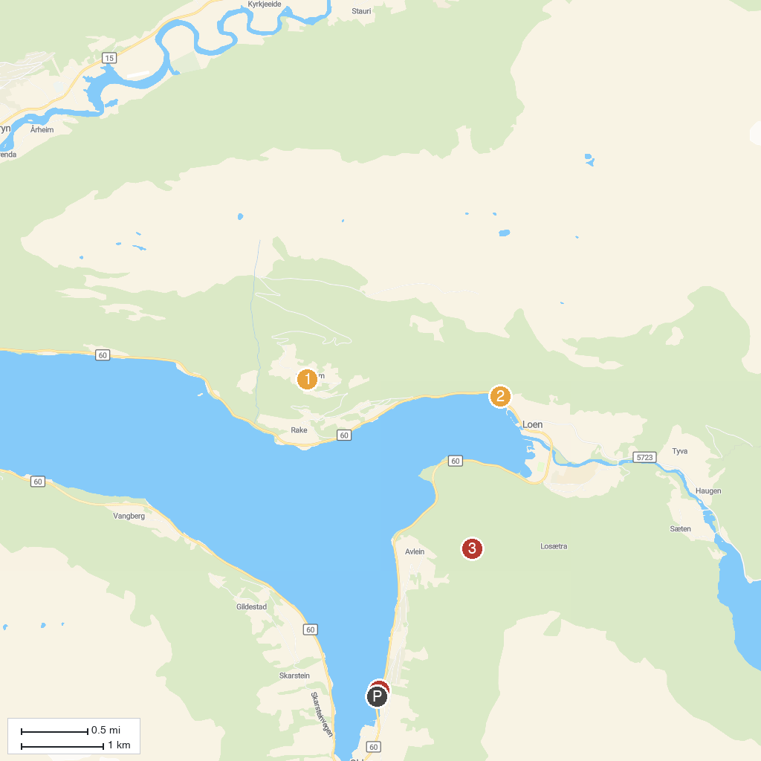
MAP KEY
1. Oppheim | 3. Huaren Viewpoint
2. LOEN Skylift | 4. Olden
P. Cruise port / terminal
Map © MapTiler © OpenStreetMap contributors · cruiseports.org

