Oltenița, Călărași County, Romania
A sleepy Danube river town that punches above its weight as Bucharest's cruise gateway — and hides a surprisingly rich Neolithic past in its local museum.
⚓ Pier (river pontoon) · 🕒 Typical call: 8-10 hrs · 💵 Currency: Romanian Leu (RON) · 🗣️ Language: Romanian · 🏙️ Gateway to Bucharest
✍️ MY DAY IN PORT (FILL IN)
Ship / Date
In port | arrive ______ · all aboard ______
Booked excursion
Notes / meeting point
GETTING ASHORE
- Docking: River pontoon pier — no tendering required
- Walk to center: ~1.5–2 km (20–25 min, flat)
- Best For: Day trips to Bucharest; Neolithic archaeology
- Don't Miss: Gumelnița Museum & the Palace of Parliament in Bucharest
GETTING AROUND
- 🚕 Taxi: $5–$10 — Taxis are available in Oltenița for short rides around town. Meters are standard; confirm the rate before departure.
TOP THINGS TO DO
- Bucharest Full-Day City Tour — The reason most passengers book this port.
- Gumelnița Archaeology Museum (Local Stay) — The crown jewel for those staying in Oltenița.
- Oltenița Town Walk & St. Nicholas Cathedral — Walk the flat streets to the town center, visit the traditional Romanian Orthodox St.
- Romanian Lunch in Town — Sample authentic Romanian cuisine at local restaurants near Republicii Boulevard.
BEST WALKS
- Pier to Museum & Cathedral Walk: 3.5 km round trip · ~50 min walk · Flat — Head from the river pier along the main road into town, pass the distinctive early-20th-century…
WEATHER · DAYLIGHT · MONEY
Month | High °F | Low °F | Rainy days
May | 72 | 54 | 10
Jul | 85 | 66 | 8
Sep | 78 | 59 | 4
Daylight: May 5:47AM–8:32PM · Jul 5:44AM–8:53PM · Sep 6:52AM–7:23PM
cruiseports.org/oltenita · Confirm terminal & all-aboard time with your ship

Oltenița, Călărași County, Romania — Port Map
Red = walkable sights · Amber = excursions farther out · P = cruise terminal
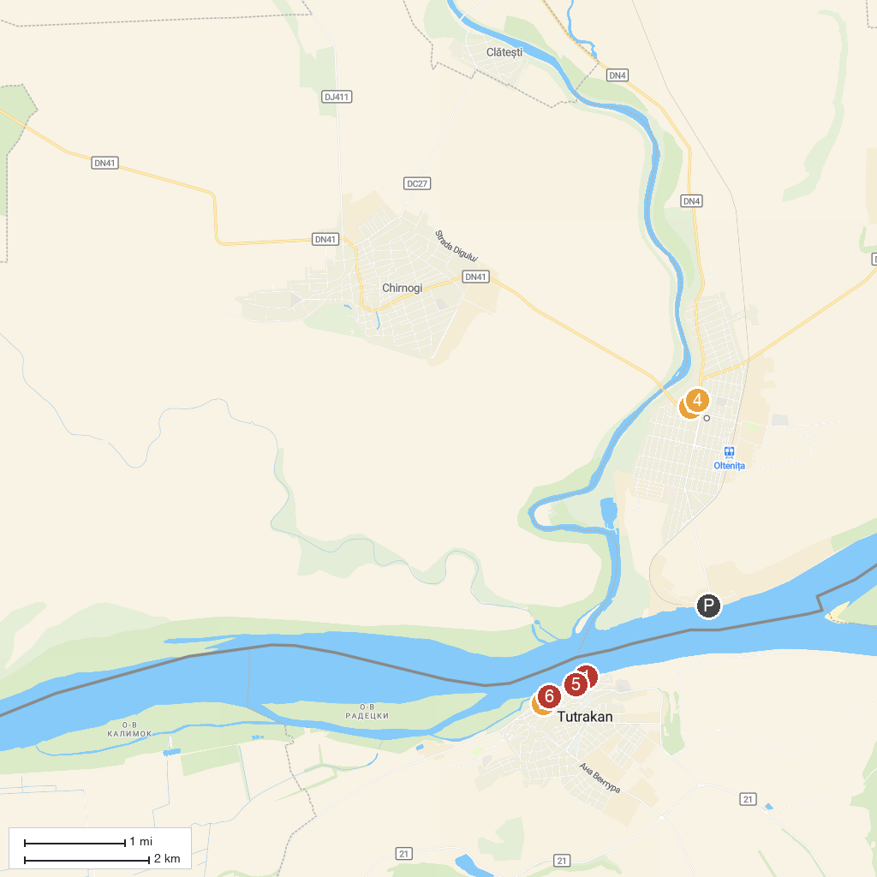
MAP KEY
1. Danube river park | 4. Water tower
2. Museum Of Danube Fishing & Boatbuilding | 5. Ribarska mahala - Posetitelski centar
3. Great Park Olteniţa | 6. History Museum of Tutrakan
P. Cruise port / terminal
Map © MapTiler © OpenStreetMap contributors · cruiseports.org

