Oristano, Sardinia, Italy
Few Mediterranean ports feel this untouched. Oristano delivers Phoenician ruins at the sea's edge, flamingo-rimmed lagoons, and a quartz-grain beach unlike anything else in Europe — all without the cruise-ship crowds.
⚓ Pier (industrial port) · 🕒 Typical call: 8-10 hrs · 💶 Euro (€) · 🗣️ Italian / Sardinian · 🦩 Flamingos year-round
✍️ MY DAY IN PORT (FILL IN)
Ship / Date
In port | arrive ______ · all aboard ______
Booked excursion
Notes / meeting point
GETTING ASHORE
- Docking: Pier at Porto Industriale di Santa Giusta (~5.5 km south of center)
- Walk to Center: Not walkable — shuttle bus or taxi required (10–15 min ride)
- Best For: History lovers, beach seekers, authentic Sardinian food and wine
- Don't Miss: Tharros archaeological site and the Giants of Mont'e Prama in Cabras
GETTING AROUND
- 🚕 Taxi: €10–€15 one way — Taxis are available at the port and in the city center. Metered fares start at €3.50 with a €2.60/km rate; minimum fare
- 📱 Rideshare: ✅ Uber
TOP THINGS TO DO
- Tharros Ancient City — Founded by the Phoenicians in the 8th century BC, Tharros sits dramatically on a narrow peninsula above turquoise water.
- Giants of Mont'e Prama (Cabras Museum) — The Civic Museum in Cabras houses massive Nuragic stone statues — roughly 3,000-year-old giants considered among the oldest…
- Is Arutas Quartz Beach — The sand here is actually tiny quartz grains — translucent, sparkling pink, green, and white — making this one of the most…
- Flamingo Lagoon Walk — The Stagno di Santa Giusta lagoon (visible as you dock) and Stagno di Cabras host thousands of pink flamingos year-round.
- Oristano Food & Wine Tasting — Sample bottarga (cured mullet roe — Sardinia's 'black gold'), malloreddus pasta with saffron, and Vernaccia di Oristano, the…
BEST WALKS
- Oristano Historic Center Loop: ⏱ 45–60 min · 🚶 Easy · 📍 Flat cobblestone streets — From the shuttle drop-off at Piazza Roma, walk to the 13th-century Torre di Mariano II, then along…
WEATHER · DAYLIGHT · MONEY
Month | High °F | Low °F | Rainy days
May | 73 | 57 | 9
Jul | 89 | 70 | 1
Sep | 82 | 66 | 6
Daylight: May 6:10AM–8:33PM · Jul 6:10AM–8:52PM · Sep 7:06AM–7:33PM
cruiseports.org/oristano · Confirm terminal & all-aboard time with your ship

Oristano, Sardinia, Italy — Port Map
Red = walkable sights · Amber = excursions farther out · P = cruise terminal
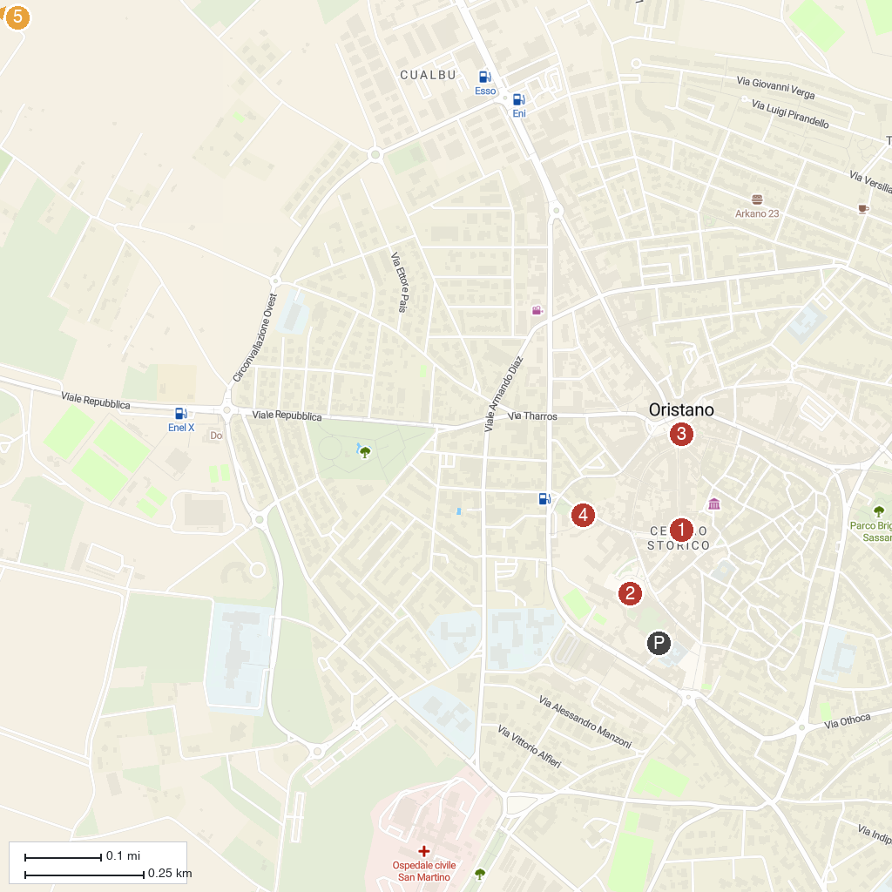
MAP KEY
1. Palazzo Corrias Carta | 5. Giovanni Marongiu City Museum
2. Cattedrale di Santa Maria Assunta | 6. Chiesa e Ipogeo di San Salvatore di Sinis
3. Tower of Mariano II | 7. Torre spagnola di San Giovanni di Sinis
4. Carlo Contini Council Picture Gallery
P. Cruise port / terminal
Map © MapTiler © OpenStreetMap contributors · cruiseports.org

