Ostend, Flanders, Belgium
Belgium's seaside queen pairs a windswept North Sea beach with Marvin Gaye history, surrealist art, and the freshest shrimp croquettes on the coast — or a 14-minute train ride to Bruges.
⚓ Pier (no tender) · 🕒 Typical call: 7-9 hrs · 💶 Currency: Euro (€) · 🗣️ Language: Dutch (Flemish) / English widely spoken
✍️ MY DAY IN PORT (FILL IN)
Ship / Date
In port | arrive ______ · all aboard ______
Booked excursion
Notes / meeting point
GETTING ASHORE
- Docking: Pier at Cruisekaai, east bank of harbor
- Walk to center: Free 5-min ferry or shuttle to train station, then 5-10 min on foot
- Best For: Beach, street art, seafood, day trip to Bruges
- Don't Miss: Shrimp croquettes at Visserskaai, The Crystal Ship murals
GETTING AROUND
- 🚕 Taxi: €5–€15 — Taxis queue near the terminal. Base fare is ~€5; short city-center hops cost €5–€10. Longer rides (e.g., to Bruges, ~25
- 📱 Rideshare: ✅ Uber
TOP THINGS TO DO
- Day Trip to Bruges — Skip the pricey cruise excursion: walk to the train station and take the 14-minute train to Bruges, one of Europe's…
- The Crystal Ship Street Art Walk — Ostend hosts one of Europe's finest street art festivals, covering entire building facades with world-class murals.
- Mu.ZEE & James Ensor House — Explore the life of Belgium's expressionist master, James Ensor, a pioneer of modern art who was born and lived here.
- Fort Napoleon & Atlantic Wall Museum — Fort Napoleon, built in 1811 on Napoleon's orders to repel a British invasion, sits in the dunes near the cruise dock.
- Ostend Beach & Albert I Promenade — Ostend's main beach is wide, sandy, and clean, backed by the grand Albert I Promenade lined with cafes and shops.
BEST WALKS
- City Center & Promenade Loop: 2-3 km · 45-60 min · Easy / flat — From the Visserskaai ferry dock, stroll along the Albert I Promenade past the Royal Galleries and…
- Mercator & Lighthouse East Bank Walk: 1-2 km · 30 min · Easy — From the ferry on the east bank, walk through the dunes to Fort Napoleon and the Oosteroever beach…
WEATHER · DAYLIGHT · MONEY
Month | High °F | Low °F | Rainy days
May | 61 | 50 | 11
Jul | 70 | 59 | 12
Sep | 67 | 56 | 11
Daylight: May 5:57AM–9:32PM · Jul 5:50AM–9:57PM · Sep 7:23AM–8:01PM
cruiseports.org/ostend · Confirm terminal & all-aboard time with your ship

Ostend, Flanders, Belgium — Port Map
Red = walkable sights · Amber = excursions farther out · P = cruise terminal
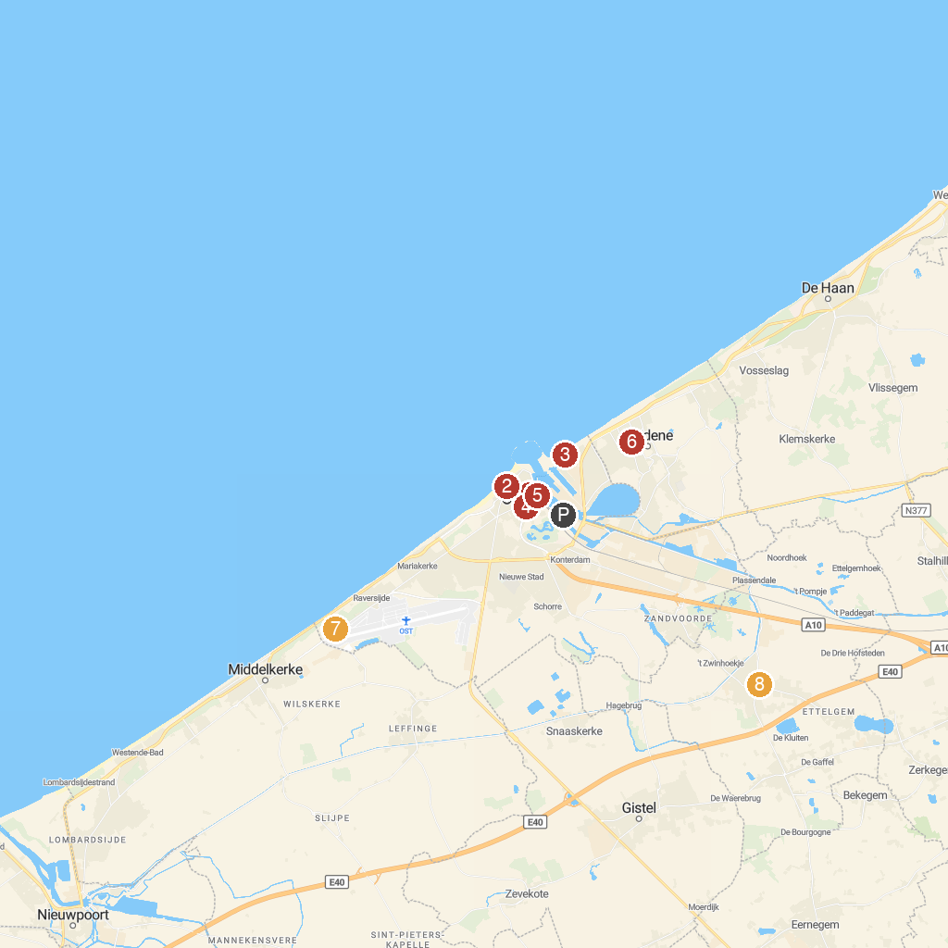
MAP KEY
1. Church of Saint Peter and Saint Paul | 5. IJslandvaarder Amandine
2. Casino Oostende | 6. Turkeyenhof
3. Fort Napoleon | 7. Atlantikwall Raversyde
4. Mercator | 8. Roman Archaeological Museum (RAM)
P. Cruise port / terminal
Map © MapTiler © OpenStreetMap contributors · cruiseports.org

