Ostiglia, Lombardy, Italy
A sleepy Lombard river town on the Po, Ostiglia trades cruise-ship crowds for medieval towers, vast cycling paths, and the wetland reserve beloved by herons and birders.
⚓ River pier (walk-off) · 🕒 Typical call: 6-8 hrs · 💶 Currency: Euro (€) · 🗣️ Language: Italian · 🚲 Great for cycling
✍️ MY DAY IN PORT (FILL IN)
Ship / Date
In port | arrive ______ · all aboard ______
Booked excursion
Notes / meeting point
GETTING ASHORE
- Docking: River pier walk-off — no tender required
- Walk to center: 5–10 min (300–500 m) flat walk along the embankment
- Best For: Cycling, birdwatching, Mantuan cuisine, day trips to Mantua or Verona
- Don't Miss: Riserva Naturale Paludi di Ostiglia and the medieval towers
GETTING AROUND
- 🚕 Taxi: ~€65–80 to Mantua (~32 km) — Local taxis serve Ostiglia but must be pre-booked — there is no taxi rank at the pier. A ride to Mantua (the main nearby
- 📱 Rideshare: ❌ not available
TOP THINGS TO DO
- Riserva Naturale Paludi di Ostiglia — A Ramsar-listed wetland reserve managed by LIPU (Italian birdlife org).
- Medieval Towers & Piazza Cornelio Nepote — Three towers survive from Ostiglia's medieval castle — the Torre Campanaria, Torre dell'Orologio, and Torre delle Prigioni — the…
- Day Trip to Mantua (Mantova) — UNESCO World Heritage city about 35 km away.
- Day Trip to Verona — Shakespeare's city of Romeo and Juliet, 45 km away.
- Cycling the Po Embankment — Ostiglia sits on EuroVelo 8 and VenTo, two of Italy's major cycling routes.
BEST WALKS
- Riverfront to Medieval Towers Loop: 45 min · 2 km · flat — Start at the river pier, walk along the Po embankment promenade northward, then cut into the town…
- Po Embankment Cycling or Walking Path: As long as you like · flat paved path — Head south or north from the dock along the Argine Po (river levee road).
WEATHER · DAYLIGHT · MONEY
Month | High °F | Low °F | Rainy days
May | 73 | 56 | 14
Jul | 88 | 69 | 9
Sep | 78 | 61 | 8
Daylight: May 5:46AM–8:37PM · Jul 5:43AM–8:59PM · Sep 6:54AM–7:25PM
cruiseports.org/ostiglia · Confirm terminal & all-aboard time with your ship

Ostiglia, Lombardy, Italy — Port Map
Red = walkable sights · Amber = excursions farther out · P = cruise terminal
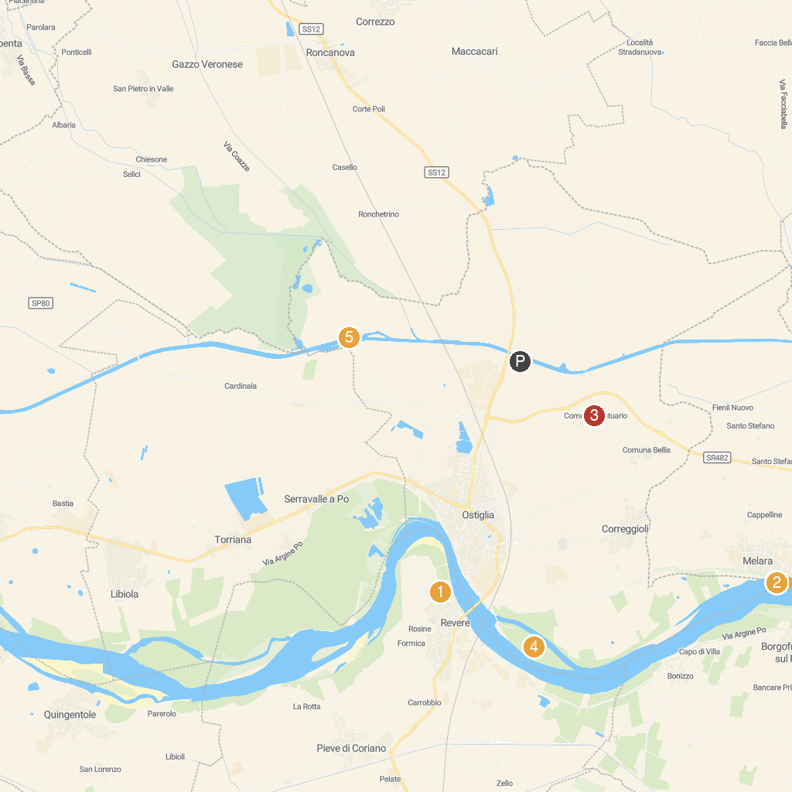
MAP KEY
1. Torre di Revere | 5. Santuario della Beata Vergine della Comuna
2. Museo Storico della Giostra e dello Spettacolo Popolare | 6. Riserva Naturale Isola Boschina
3. Parrocchia di Santo Stefano | 7. Riserva Naturale Paludi di Ostiglia
4. "Le Vallette" Park
P. Cruise port / terminal
Map © MapTiler © OpenStreetMap contributors · cruiseports.org

