Otranto, Puglia, Italy
Italy's heel tip faces Albania across the Adriatic — Otranto's medieval walls, a floor-to-ceiling mosaic that rewrites the Middle Ages, and impossibly blue water make this one of the Mediterranean's most rewarding small-ship stops.
⚓ Tender (large ships) / Pier (small ships) · 🕒 Typical call: 6–8 hrs · 💶 Currency: Euro (€) · 🗣️ Language: Italian
✍️ MY DAY IN PORT (FILL IN)
Ship / Date
In port | arrive ______ · all aboard ______
Booked excursion
Notes / meeting point
GETTING ASHORE
- Docking: Tender for large ships; small/luxury vessels dock at Molo San Nicola
- Walk to center: 5–10 min flat waterfront walk (~500 m) to the old town gate
- Best For: Medieval history, beach days, Puglian food, independent exploring
- Don't Miss: The 12th-century Tree of Life mosaic inside Otranto Cathedral
GETTING AROUND
- 🚕 Taxi: €8–€15 — Local taxis operate on metered fares (base ~€3, ~€0.80/km). Short rides within Otranto run €8–€15; confirm the fare befo
- 📱 Rideshare: ❌ not available
TOP THINGS TO DO
- Otranto Cathedral & Martyrs Chapel — The entire nave floor is covered by an extraordinary 12th-century mosaic — a 'medieval visual encyclopaedia' depicting the Tree…
- Aragonese Castle — This hulking 15th-century fortress dominates the harbor, built by the Aragonese after the Ottoman siege.
- Cava di Bauxite (Red Lake) — A disused open-air bauxite mine about 2.5 km south of the port where a vivid emerald lake has formed against striking red earth…
- Baia dei Turchi Beach — Six kilometres north of Otranto, this wild pine-fringed beach is where the Ottoman fleet landed in 1480 — today the turquoise…
- Day Trip to Lecce — Known as the 'Florence of the South', Lecce is 35–40 minutes away and packed with lavish Baroque architecture carved from golden…
BEST WALKS
- Old Town & Cathedral Loop: 1–1.5 hrs · Easy · 1.5 km · Flat — From the harbor, follow the lungomare to Porta Alfonsina and enter the old town.
- Coastal Walk to the Bauxite Lake: 2.5 hrs round trip · Moderate · 5 km · Some uneven ground — Head south along the coastal path from the port toward Punta Palascìa.
WEATHER · DAYLIGHT · MONEY
Month | High °F | Low °F | Rainy days
May | 72 | 60 | 7
Jul | 88 | 73 | 3
Sep | 80 | 69 | 7
Daylight: May 5:30AM–7:54PM · Jul 5:29AM–8:14PM · Sep 6:27AM–6:54PM
cruiseports.org/otranto · Confirm terminal & all-aboard time with your ship

Otranto, Puglia, Italy — Port Map
Red = walkable sights · Amber = excursions farther out · P = cruise terminal
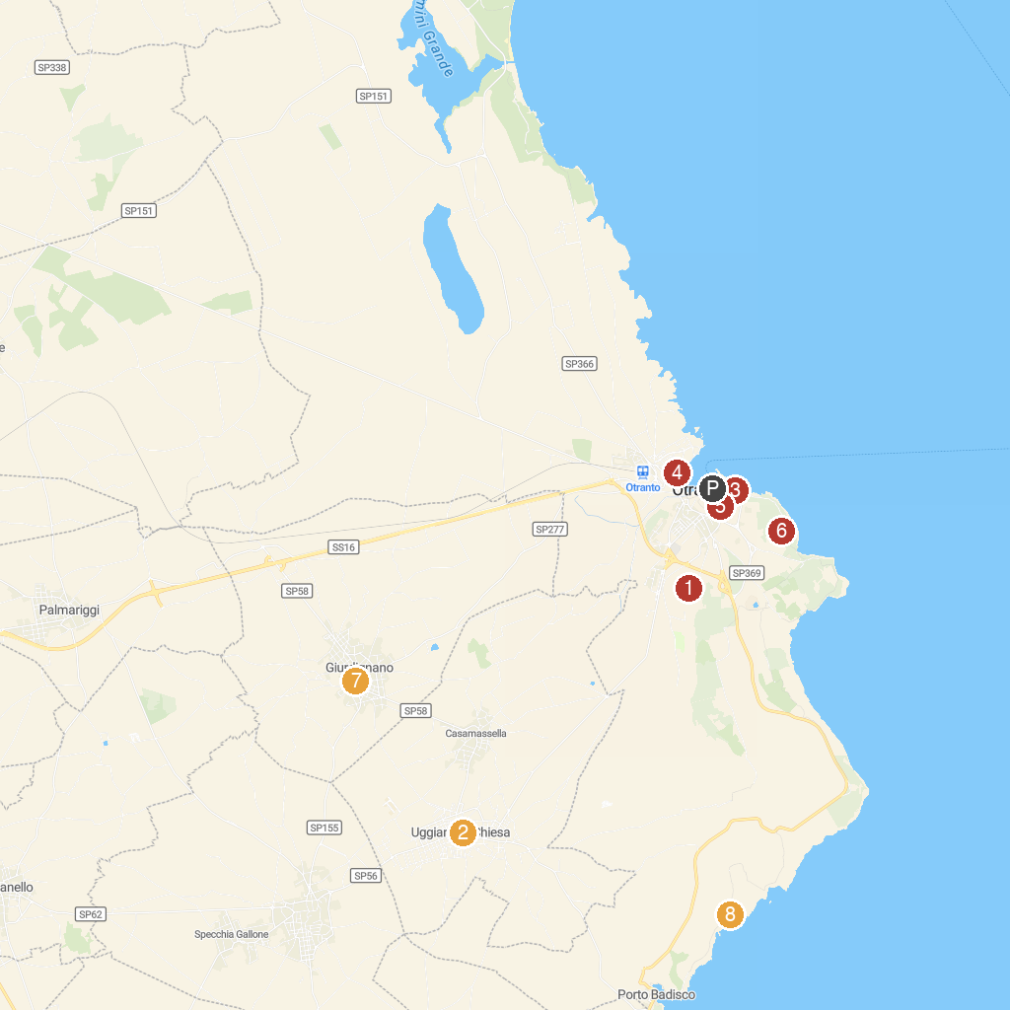
MAP KEY
1. Ipogeo di Torre Pinta | 5. Salento in BOAT TRIPS - Boat trip Otranto
2. Church of Saint Mary Magdalene | 6. Torre del Serpe
3. HYDRA Boat Trips | 7. Cripta Bizantina di San Salvatore
4. Cappella della Madonna dell'Altomare | 8. Torre Sant'Emiliano
P. Cruise port / terminal
Map © MapTiler © OpenStreetMap contributors · cruiseports.org

