Oudeschild, Texel Island, Netherlands
A compact fishing harbor on the Wadden Sea side of Texel, Oudeschild punches well above its size — UNESCO mudflats, world-class seafood, 140 km of cycling paths, and more sheep than people.
⚓ Tender (most ships) · 🕒 Typical call: 7-9 hrs · 💶 Euro (€) · 🗣️ Dutch / English widely spoken · 🐑 Sheep country
✍️ MY DAY IN PORT (FILL IN)
Ship / Date
In port | arrive ______ · all aboard ______
Booked excursion
Notes / meeting point
GETTING ASHORE
- Docking: Tender for most cruise ships; small expedition vessels may dock at quay
- Walk to village: 2–5 min from tender dock to Oudeschild harbor village
- Best For: Cycling, wildlife, fresh seafood, Wadden Sea nature
- Don't Miss: Museum Kaap Skil and a plate of fresh kibbeling at the harbor
GETTING AROUND
- 🚕 Taxi: €15–€19 to Den Burg — Local taxis operate 24/7 and can reach Den Burg in about 8 minutes (≈5 km). Pre-booking recommended; meter-based fares a
TOP THINGS TO DO
- Museum Kaap Skil — Maritime & Beachcombers Museum — Award-winning museum right at the harbor showcasing the 17th-century VOC Texel Roads anchorage and a stunning 'Palmwood Wreck'…
- Ecomare Seal & Nature Centre — Texel's famous nature centre rehabilitates seals and harbour porpoises.
- Wadden Sea Mudflat Walk (Wadlopen) — The UNESCO Wadden Sea is the world's largest unbroken intertidal mudflat system.
- Texel Brewery Tour & Tasting — The Texelse Bierbrouwerij brews Skuumkoppe — a beloved top-fermented dark wheat beer brewed since 1999.
- E-Bike Across Texel — With 140 km of flat, dedicated cycle paths, an e-bike is the ideal way to reach the North Sea beaches, the Hoge Berg sheep…
BEST WALKS
- Harbor Village Stroll: 1 km · 20 min · Flat · Free — From the tender dock, walk the fishing harbor to see the active cutter fleet (look for TX hull…
- Waddendijk Dike Walk: 2 km out-and-back · 30 min · Easy · Free — Climb the grassy Wadden Sea dike right next to the harbor for sweeping views across the mudflats…
WEATHER · DAYLIGHT · MONEY
Month | High °F | Low °F | Rainy days
May | 57 | 51 | 11
Jul | 67 | 61 | 13
Sep | 65 | 59 | 12
Daylight: May 5:42AM–9:32PM · Jul 5:33AM–9:58PM · Sep 7:15AM–7:55PM
cruiseports.org/oudeschild-texel-island · Confirm terminal & all-aboard time with your ship

Oudeschild, Texel Island, Netherlands — Port Map
Red = walkable sights · Amber = excursions farther out · P = cruise terminal
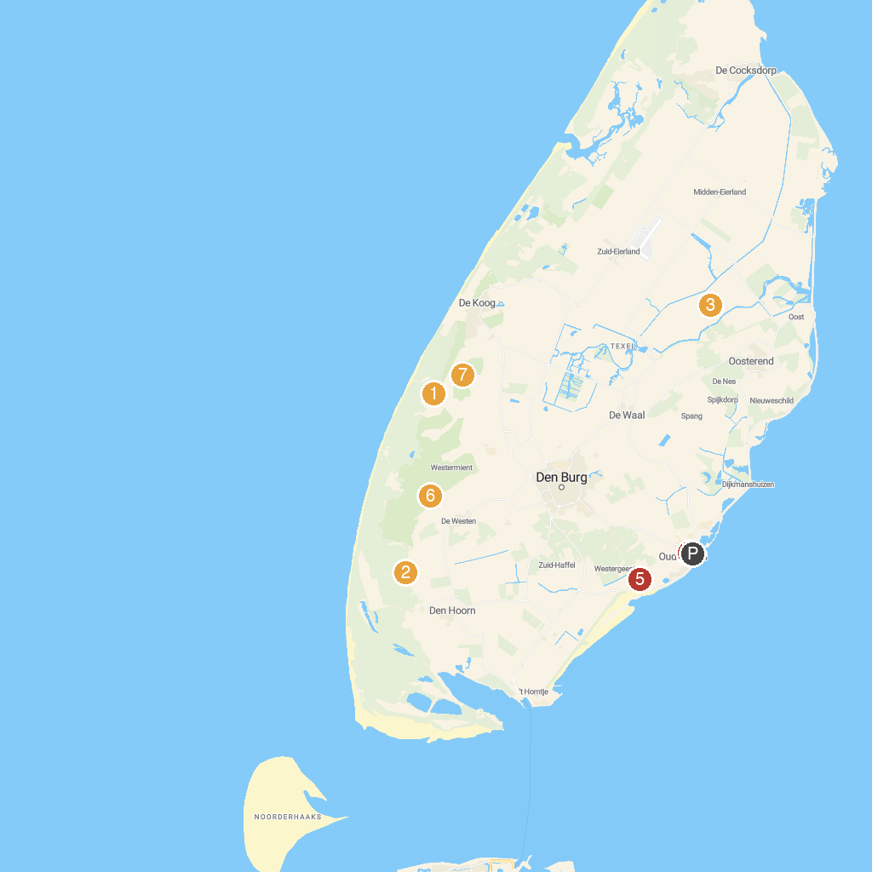
MAP KEY
1. Ecomare | 5. Museum Kaap Skil
2. Battery Den Hoorn WWII | 6. Fort De Schans
3. TX Store / TexelZoo | 7. Watchtower Fonteinsnol
4. Fort Kijkduin | 8. Sommeltjespad
P. Cruise port / terminal
Map © MapTiler © OpenStreetMap contributors · cruiseports.org

