Paamiut, Southwest Greenland
A quietly striking town at the edge of the world — red-painted wooden houses, a sea-eagle sky, and an early 20th-century wooden church that anchors a coastline most ships never reach.
⚓ Tender port (no cruise pier) · 🕒 Typical call: 4–6 hrs · 💵 Danish Krone (DKK) · 🗣️ Greenlandic (Kalaallisut) / Danish
✍️ MY DAY IN PORT (FILL IN)
Ship / Date
In port | arrive ______ · all aboard ______
Booked excursion
Notes / meeting point
GETTING ASHORE
- Docking: Tender to town quay
- Walk to center: ~5 min from quay
- Best For: Remote Arctic · Wildlife
- Don't Miss: Frelserens Kirke (Church of Paamiut)
GETTING AROUND
TOP THINGS TO DO
- Frelserens Kirke & Town Walk — The Church of Paamiut (Frelserens Kirke / Saviour's Church) is a beautifully preserved wooden church consecrated in 1909 — one of…
- Sea Eagle & Bird Watching — The fjords and cliffs around Paamiut are prime habitat for white-tailed sea eagles — one of Greenland's great wildlife spectacles.
- Tundra Hike Above Town — A short climb above Paamiut opens into open Arctic tundra with sweeping fjord views.
- Colonial & Inuit Heritage — Founded as Frederikshåb in 1742 by the Danish-Norwegian mission, Paamiut has a layered past visible in its architecture and the…
BEST WALKS
- Quay to Frelserens Kirke: ~1 km · 30–45 min · easy — From the town quay, walk up through the main street past traditional painted houses to the Church…
- Hillside viewpoint above town: ~2 km · 1–1.5 hrs · moderate — Follow the rising ground above Paamiut to reach open tundra with panoramic views over the fjord and…
WEATHER · DAYLIGHT · MONEY
Month | High °F | Low °F | Rainy days
May | 38 | 30 | 10
Jul | 50 | 42 | 10
Sep | 44 | 36 | 13
Daylight: May 5:24AM–11:07PM · Jul 5:02AM–11:44PM · Sep 7:45AM–8:40PM
cruiseports.org/paamiut · Confirm terminal & all-aboard time with your ship

Paamiut, Southwest Greenland — Port Map
Red = walkable sights · Amber = excursions farther out · P = cruise terminal
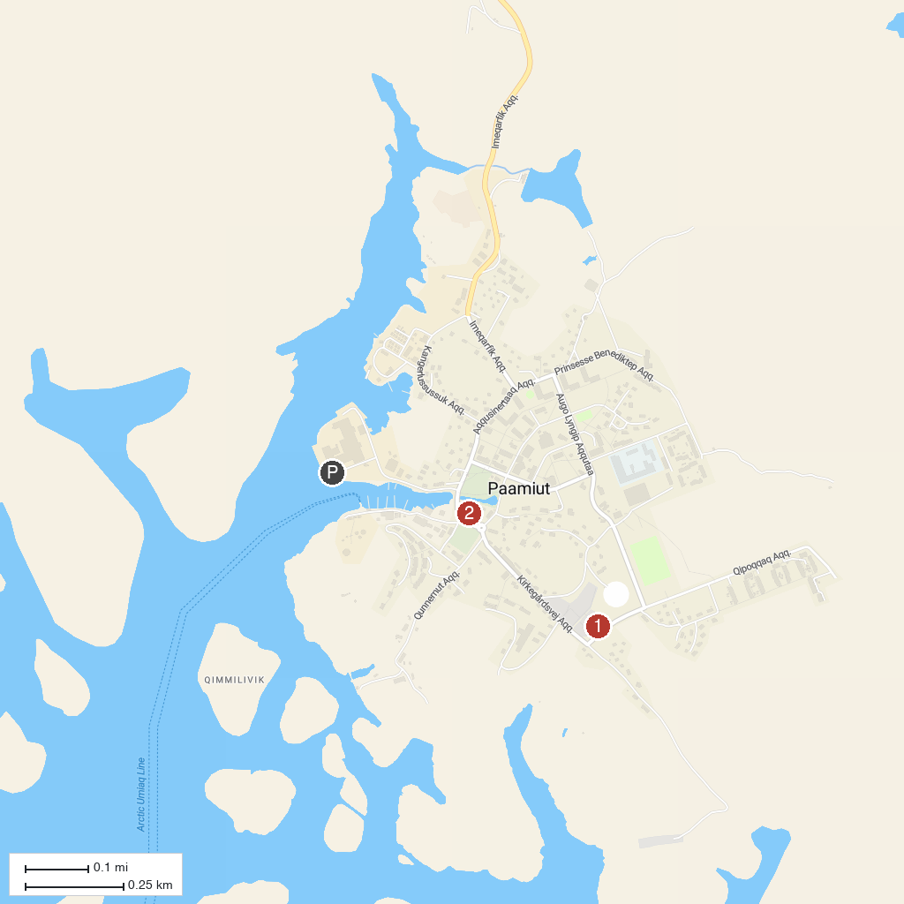
MAP KEY
1. Paamiut Church | 2. Paamiut Old Colonial Harbor
P. Cruise port / terminal
Map © MapTiler © OpenStreetMap contributors · cruiseports.org

