Palamós, Costa Brava, Spain
A working fishing port with serious culinary credentials — the Palamós prawn carries its own quality-guarantee mark and is worth every euro. The old town, sandy beach, and a first-rate fishing museum are all steps from the quay.
⚓ Pier (Moll de Ponent) or tender · 🕒 Typical call: 6-8 hrs · 💶 Euro (€) · 🗣️ Catalan / Spanish
✍️ MY DAY IN PORT (FILL IN)
Ship / Date
In port | arrive ______ · all aboard ______
Booked excursion
Notes / meeting point
GETTING ASHORE
- Docking: Most ships berth at Moll de Ponent, a short walk to the centre; some smaller vessels anchor and tender
- Walk to centre: 5-10 min from pier to Old Town and Platja Gran beach
- Best For: Seafood lovers, beach days, medieval village day trips
- Don't Miss: Fresh Palamós prawns at a harbourfront restaurant and the Museu de la Pesca
GETTING AROUND
- 🚕 Taxi: Meter (short trip ~€5–€10) — Taxis are available at the pier and operate 24/7. Advance reservation recommended for longer trips to nearby towns like
TOP THINGS TO DO
- Palamós Prawn Tasting — Palamós prawns (Aristeus antennatus) carry the official 'Gamba de Palamós' guarantee mark and are best eaten simply grilled at a…
- Museu de la Pesca — One of the Mediterranean's best fishing museums sits right at the port.
- Girona Old City — Forty-five minutes inland, Girona's cathedral, Arab Baths, and labyrinthine Jewish Quarter (El Call) make for an outstanding…
- Dalí Theatre-Museum, Figueres — Salvador Dalí designed his own museum — the world's largest surrealist object.
- Camí de Ronda Coastal Walk — The ancient coastal path links secluded coves and rocky headlands north and south of town.
BEST WALKS
- Port to Old Town & Platja Gran: 1.5 km loop • 30-45 min • Easy — From the cruise quay walk along the harbour promenade past fishing boats to the Old Town, wind…
- Camí de Ronda to Cala de la Fosca: 4 km one-way • 1.5-2 hrs • Easy-moderate — Head north from the port along the Camí de Ronda coastal path to reach the sheltered sandy bay of…
WEATHER · DAYLIGHT · MONEY
Month | High °F | Low °F | Rainy days
May | 69 | 57 | 8
Jul | 81 | 70 | 4
Sep | 76 | 65 | 9
Daylight: May 6:27AM–9:00PM · Jul 6:26AM–9:20PM · Sep 7:27AM–7:56PM
cruiseports.org/palamos · Confirm terminal & all-aboard time with your ship

Palamós, Costa Brava, Spain — Port Map
Red = walkable sights · Amber = excursions farther out · P = cruise terminal
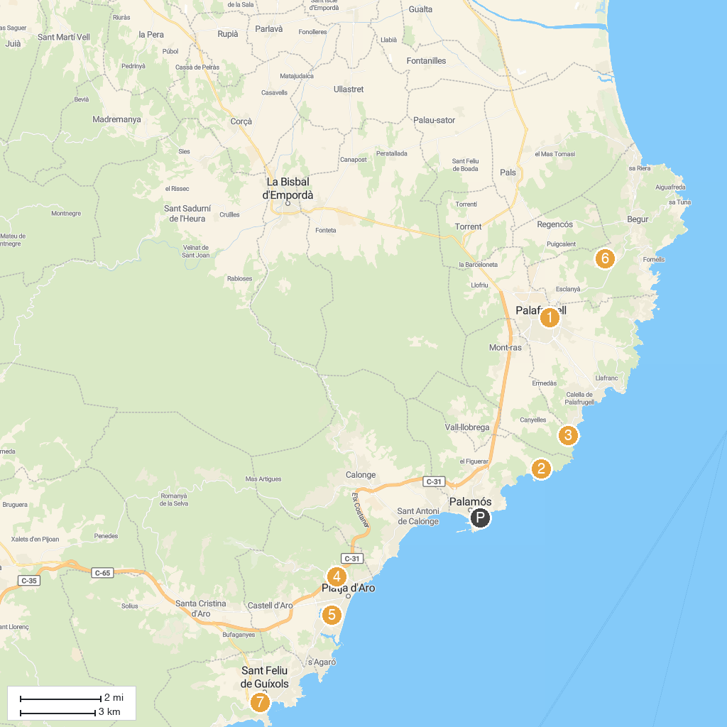
MAP KEY
1. Can Mario Museum | 5. Pp's Park Platja d'Aro
2. Barraca d'en Dalí | 6. Muntanyes de Begur
3. Jardíns de Cap Roig | 7. Sant Feliu de Guíxols History Museum
4. Aquadiver Parc | 8. Església de Sant Martí de Romanyà
P. Cruise port / terminal
Map © MapTiler © OpenStreetMap contributors · cruiseports.org

