Palma de Mallorca, Balearic Islands, Spain
Mallorca’s sun-drenched capital dazzles with a soaring Gothic cathedral kissing the sea, a labyrinthine Arab quarter, hidden aristocratic patios, and the iconic Sóller mountain railway — all easily reached from a city-centre pier.
⚓ Docked (city pier) · 🕒 Typical call: 8-10 hrs · 💶 Euro (€) · 🗣️ Spanish / Catalan
✍️ MY DAY IN PORT (FILL IN)
Ship / Date
In port | arrive ______ · all aboard ______
Booked excursion
Notes / meeting point
GETTING ASHORE
- Docking: Estació Marítima (Moll de Ponent), ~3-5 km from old town; shuttle, Bus 1, water taxi, or waterfront walk
- Walk to centre: 35-45 min on foot along the promenade, or 10 min by taxi/shuttle (~€12-€15)
- Best For: Cathedral, hidden patios, Sóller vintage train, beaches, Mallorcan tapas
- Don’t Miss: La Seu Cathedral at golden hour + Can Joan de S’Aigo pastry cafe (est. 1700)
GETTING AROUND
- 🚕 Taxi: €11–12 — Taxis are plentiful at the port exit. Under Mallorca's 2025 fare system: €2.50 base + €1.20/km + €4.65 port surcharge. Q
- 📱 Rideshare: ✅ Uber, Bolt
- 🚌 Hop-on hop-off: ✅ City Sightseeing
TOP THINGS TO DO
- La Seu Cathedral & Almudaina Palace — Palma’s Gothic cathedral rises directly above the sea with one of the world’s largest rose windows and a Gaudí-redesigned interior.
- Sóller Vintage Train & Tram — Board the 1912 wooden Red Lightning train from Palma’s Plaça d’Espanya station and wind through orange-grove valleys and mountain…
- Serra de Tramuntana Scenic Drive — This UNESCO World Heritage mountain range delivers dramatic coastal cliffs, ancient olive groves, and stone villages.
- Old Town Patios & Arab Baths — Explore the Casc Antic’s lanes to discover hidden aristocratic courtyards (patios mallorquines) open to visitors.
- Caves of Drach — East-coast cave complex near Porto Cristo with spectacular stalactites and Lake Martel, one of the world’s largest underground…
BEST WALKS
- Waterfront to Cathedral & Old Town Loop: ⏱ 1.5-2 hrs · 🚶 Easy · 📷 Best photo walk — Start at Plaça de la Reina and follow the seafront Passeig des Born to La Seu Cathedral.
- Passeig des Born & Santa Catalina: ⏱ 1-1.5 hrs · 🚶 Easy · 🍽️ Food & culture — Stroll the elegant Passeig des Born lined with mansions and boutiques, stop at the Casal Solleric…
- Bellver Castle Hilltop: ⏱ 2 hrs · 🚶 Moderate (uphill) · 🏰 Panoramic views — Take Bus Line 46 or a taxi to the base, then walk up to Bellver Castle — a rare circular Gothic…
WEATHER · DAYLIGHT · MONEY
Month | High °F | Low °F | Rainy days
May | 88 | 81 | 7
Jul | 87 | 80 | 11
Sep | 86 | 79 | 23
Daylight: May 6:35AM–8:56PM · Jul 6:34AM–9:15PM · Sep 7:30AM–7:57PM
Representative sunrise/sunset — 2025, 15th of each month; local civil time including DST (Europe/Madrid). Source: Astral; not a forecast or climate average.
cruiseports.org/palma-de-mallorca · Confirm terminal & all-aboard time with your ship

Palma de Mallorca, Balearic Islands, Spain — Port Map
Red = walkable sights · Amber = excursions farther out · P = cruise terminal
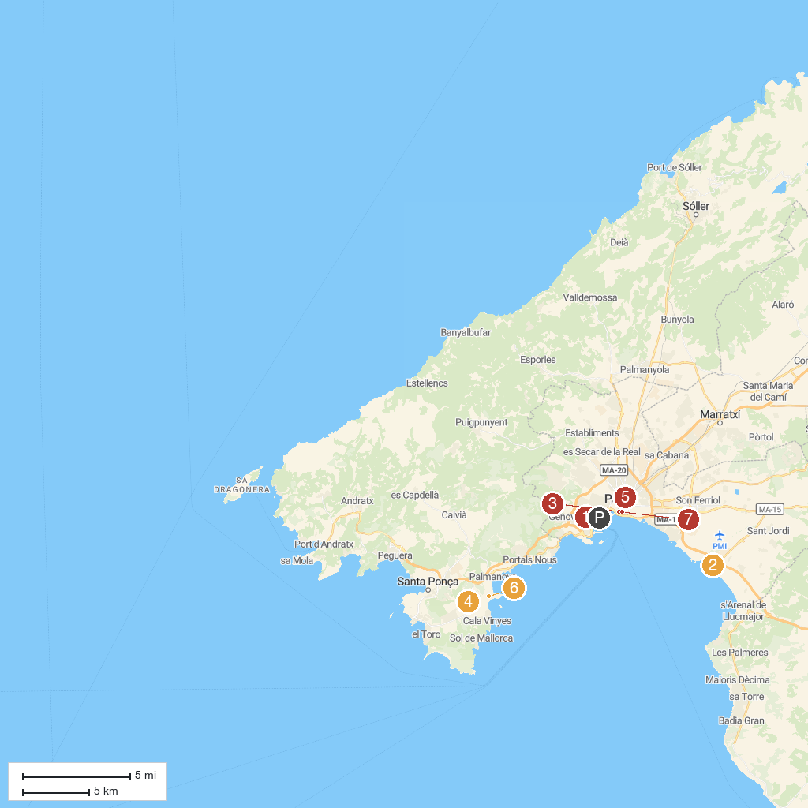
MAP KEY
1. Castillo de Bellver | 5. Train Sóller Station (Palma de Mallorca)
2. Palma Aquàrium | 6. Katmandu Park
3. Catedral-Basílica de Santa María de Mallorca | 7. Golf Santa Ponsa
4. Western Water Park | 8. Museum of Mallorca
P. Cruise port / terminal
Map © MapTiler © OpenStreetMap contributors · cruiseports.org

