Papeete, Tahiti, French Polynesia
The capital of French Polynesia docks ships right on the waterfront boulevard — step off into a city of overwater bungalow dreams, black-pearl boutiques, sizzling food trucks, and one of the Pacific's most colourful market halls.
⚓ Docked (downtown waterfront) · 🕒 Typical call: 8–10 hrs · 💵 CFP Franc (XPF) · 🗣️ French / Tahitian
✍️ MY DAY IN PORT (FILL IN)
Ship / Date
In port | arrive ______ · all aboard ______
Booked excursion
Notes / meeting point
GETTING ASHORE
- Docking: Papeete waterfront (downtown)
- Walk to center: 2–5 min on foot
- Best For: Pearls · Market · Lagoon
- Don't Miss: Le Marché & les roulottes
GETTING AROUND
- 🚕 Taxi: 1,000–2,000 XPF (~$10–19 USD) — Official taxis have a 1,000 XPF minimum fare (~$10 USD) with ~130 XPF/km daytime. Most rides within Papeete hit the mini
- 📱 Rideshare: ❌ not available
TOP THINGS TO DO
- Le Marché (Papeete Market) — The two-storey covered market is the beating heart of Papeete — ground floor overflows with tropical fruit, fish, and flower…
- Place Vai'ete — Les Roulottes — After dark (and some evenings during port days), the waterfront square fills with food trucks — les roulottes — serving poisson…
- Lagoon Snorkeling & Swim — Tahiti's lagoon shelters coral gardens and tropical fish just offshore.
- Point Venus Lighthouse — The historic lighthouse where Captain Cook observed the 1769 transit of Venus sits on a black-sand spit at the northern tip of…
- Fautaua Valley & Waterfall Hike — A marked trail from Papeete's outskirts leads up the Fautaua Valley to a dramatic 985-ft waterfall.
BEST WALKS
- Waterfront & Market Loop: ~2 km · 1–1.5 hrs · easy — From the pier, walk south along Boulevard Pomare past Place Vai'ete and the waterfront park, then…
- Robert Wan Pearl Museum: ~0.5 km · 30 min · easy — A short walk from the pier, the Robert Wan Pearl Museum showcases the history and cultivation of…
WEATHER · DAYLIGHT · MONEY
Month | High °F | Low °F | Rainy days
May | 82 | 77 | 21
Jul | 80 | 74 | 19
Sep | 80 | 74 | 20
cruiseports.org/papeete · Confirm terminal & all-aboard time with your ship

Papeete, Tahiti, French Polynesia — Port Map
Red = walkable sights · Amber = excursions farther out · P = cruise terminal
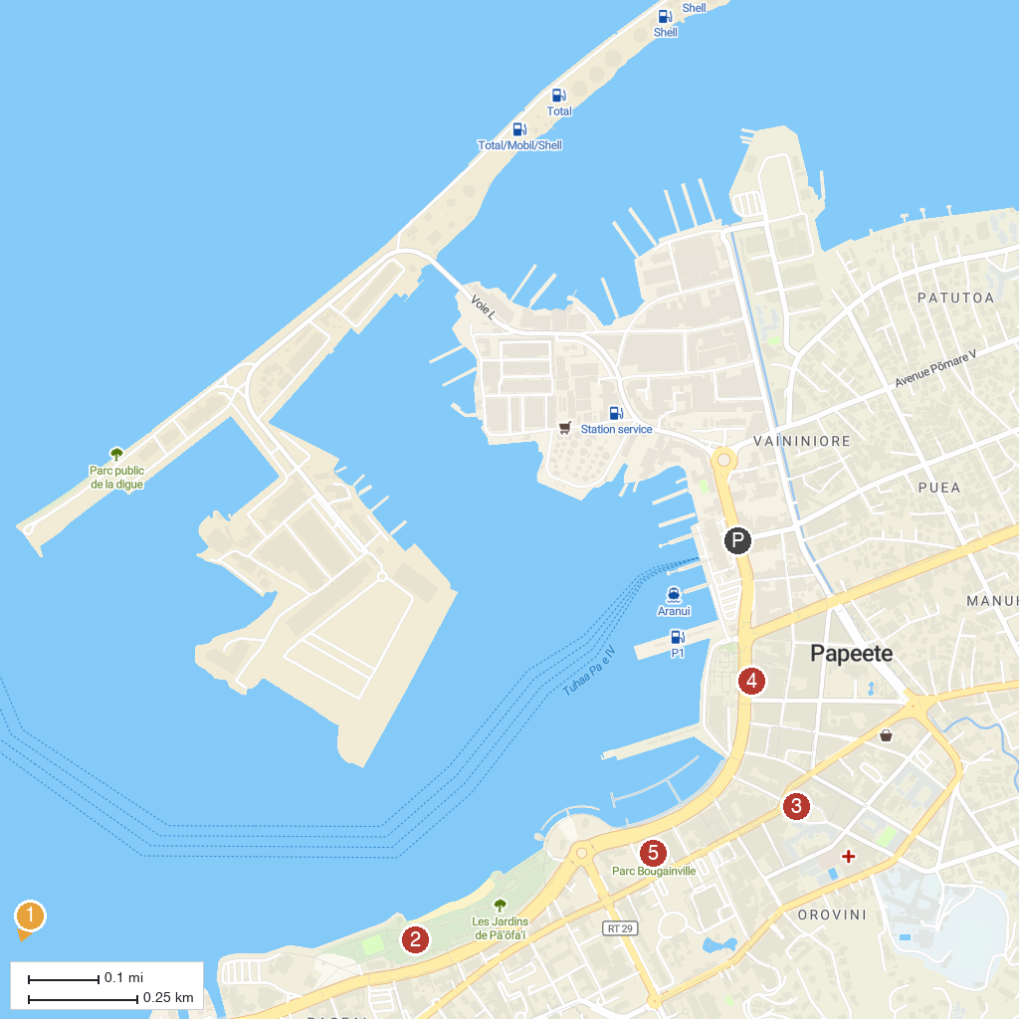
MAP KEY
1. Museum of Tahiti and The Islands | 4. MANUA Exquisite Tahitian Art
2. Pā'ōfa'i Gardens | 5. Bougainville Park
3. Notre Dame Cathedral
P. Cruise port / terminal
Map © MapTiler © OpenStreetMap contributors · cruiseports.org

