Paphos, Cyprus
Birthplace of Aphrodite and home to some of the finest Roman mosaics in the world, Paphos delivers a full day of UNESCO-listed wonders within easy walking distance of the tender pier.
⚓ Tender port (no cruise pier) · 🕒 Typical call: 6–8 hrs · 💶 Currency: Euro (€) · 🗣️ Language: Greek (English widely spoken)
✍️ MY DAY IN PORT (FILL IN)
Ship / Date
In port | arrive ______ · all aboard ______
Booked excursion
Notes / meeting point
GETTING ASHORE
- Docking: Tender — ships anchor offshore; boats drop at Paphos Harbour
- Walk to center: 0 min — tender lands in the heart of Kato Paphos
- Best For: Ancient ruins, Roman mosaics, Mediterranean beaches
- Don't Miss: Kato Paphos Archaeological Park mosaics (5-min walk)
GETTING AROUND
- 🚕 Taxi: €5–€10 to Upper Town — Government-regulated metered taxis are available at the harbour. Day rate starts at ~€3.42 + €0.73/km. A ride to Pano Pa
- 📱 Rideshare: ✅ Bolt
- 🚌 Hop-on hop-off: ✅
TOP THINGS TO DO
- Kato Paphos Archaeological Park — Walk five minutes from the tender pier to one of the finest Roman mosaic floors in the Mediterranean.
- Tombs of the Kings — A vast 4th-century BC necropolis carved from solid rock, where Paphian aristocrats were buried in Doric-columned underground…
- Aphrodite's Rock (Petra tou Romiou) — The legendary sea stack where Aphrodite supposedly rose from the foam.
- Ktima Old Town & Municipal Market — The authentic upper town of Paphos sits on a hill above the harbor.
- Coral Bay Beach — Paphos's most popular sandy beach — a horseshoe bay with calm turquoise water, sunbeds for hire, and beachside tavernas.
BEST WALKS
- Harbour to Mosaics to Castle Loop: ~2 km · 45–60 min · Easy — From the tender pier, walk to the Kato Paphos Archaeological Park for the Roman mosaics, then loop…
- St. Paul's Pillar & Agia Solomoni: ~1.5 km one-way · 30–40 min · Easy — Head inland from the harbor to St.
WEATHER · DAYLIGHT · MONEY
Month | High °F | Low °F | Rainy days
May | 76 | 63 | 5
Jul | 87 | 74 | 0
Sep | 84 | 72 | 2
Daylight: May 5:47AM–7:46PM · Jul 5:48AM–8:03PM · Sep 6:33AM–6:56PM
cruiseports.org/paphos · Confirm terminal & all-aboard time with your ship

Paphos, Cyprus — Port Map
Red = walkable sights · Amber = excursions farther out · P = cruise terminal
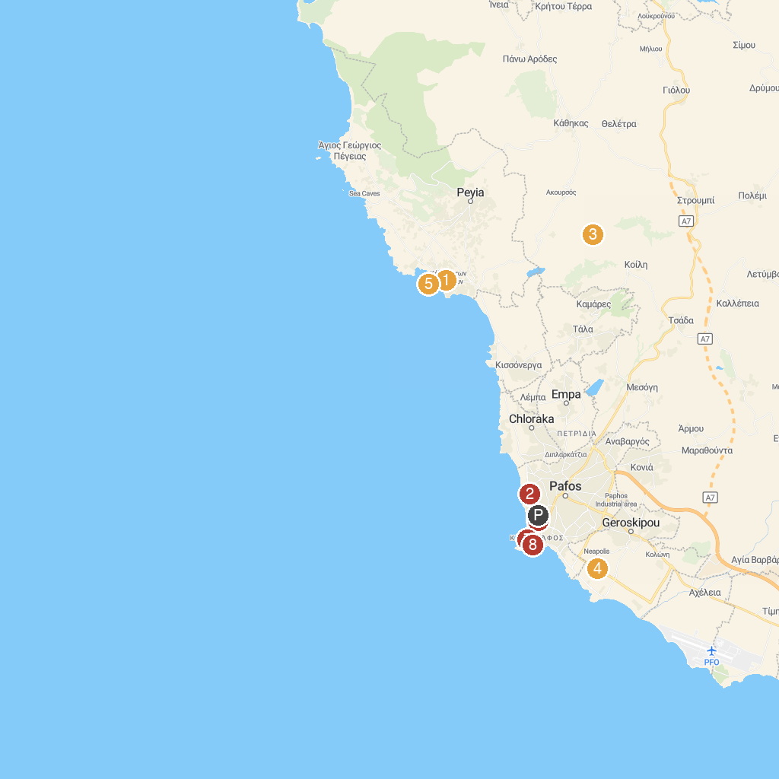
MAP KEY
1. Coral Bay | 5. Mycenaean settlement of Cyprus Museum
2. Archaeological Site of the Tombs of the Kings | 6. Lockdown Paphos Escape Games
3. Adonis Baths Waterfalls | 7. House of Dionysus
4. Island Cove Adventure Mini Golf | 8. Kato Pafos Archaeological Park
P. Cruise port / terminal
Map © MapTiler © OpenStreetMap contributors · cruiseports.org

