Paradise Island, New Providence, Bahamas
A 685-acre island of white-sand beaches and resort spectacle, Paradise Island rises just across the harbor from Nassau's cruise pier — home to the colossal Atlantis complex, Royal Caribbean's new Royal Beach Club, and miles of turquoise shoreline.
⚓ Ships dock at Nassau (Prince George Wharf) · 🚤 Water taxi or cab to Paradise Island · 🕒 Typical call: 8–10 hrs · 💵 USD accepted everywhere · 🗣️ English
✍️ MY DAY IN PORT (FILL IN)
Ship / Date
In port | arrive ______ · all aboard ______
Booked excursion
Notes / meeting point
GETTING ASHORE
- Docking: Ships berth at Nassau Cruise Port — water taxi or taxi to Paradise Island (~10 min)
- Walk to center: Not walkable from ship; ~2 miles with a steep bridge — take a taxi
- Best For: Atlantis Aquaventure, Cabbage Beach, Royal Beach Club (Royal Caribbean)
- Don't Miss: Marina Village is free to explore — walk the docks and grab conch salad at Potter's Cay
GETTING AROUND
- 🚕 Taxi: $7/person one-way, $14 round-trip — Scenic 10–15 min ferry from Woodes Rogers Walk (near Prince George Wharf) to Paradise Island near Margaritaville. Runs e
- 📱 Rideshare: ❌ not available
TOP THINGS TO DO
- Atlantis Aquaventure Waterpark — 141 acres of water slides, a mile-long lazy river with rapids, 11 pools, and the legendary Leap of Faith plunge through a shark…
- Royal Beach Club (Royal Caribbean) — Royal Caribbean's exclusive 17-acre beach club opened December 2025, featuring two beaches, three pool zones, the world's largest…
- The Dig — Atlantis Marine Habitat — Walk through glass tunnels as sharks, manta rays, and 50,000 marine animals surround you in the world's largest open-air marine…
- Cabbage Beach Day — Paradise Island's best public beach: powdery white sand, turquoise water, and chair rentals from local vendors.
- Marina Village & Atlantis Casino — Stroll the colorful open-air Marina Village — shops, mega-yachts, dining, and live music — all free to enter.
BEST WALKS
- Marina Village to Cabbage Beach: ~1.2 miles • 25 min • Easy — From the water taxi dock, walk through Marina Village past the mega-yachts and boutiques, continue…
- Nassau Waterfront Stroll (ship to bridge): ~0.8 miles one-way • 15 min • Easy — A flat, shaded walk from Prince George Wharf east along Bay Street and Woodes Rogers Walk to the…
WEATHER · DAYLIGHT · MONEY
Month | High °F | Low °F | Rainy days
May | 82 | 76 | 16
Jul | 87 | 81 | 17
Sep | 86 | 80 | 18
Daylight: May 6:24AM–7:46PM · Jul 6:29AM–8:01PM · Sep 6:55AM–7:12PM
cruiseports.org/paradise-island-bahamas · Confirm terminal & all-aboard time with your ship

Paradise Island, New Providence, Bahamas — Port Map
Red = walkable sights · Amber = excursions farther out · P = cruise terminal
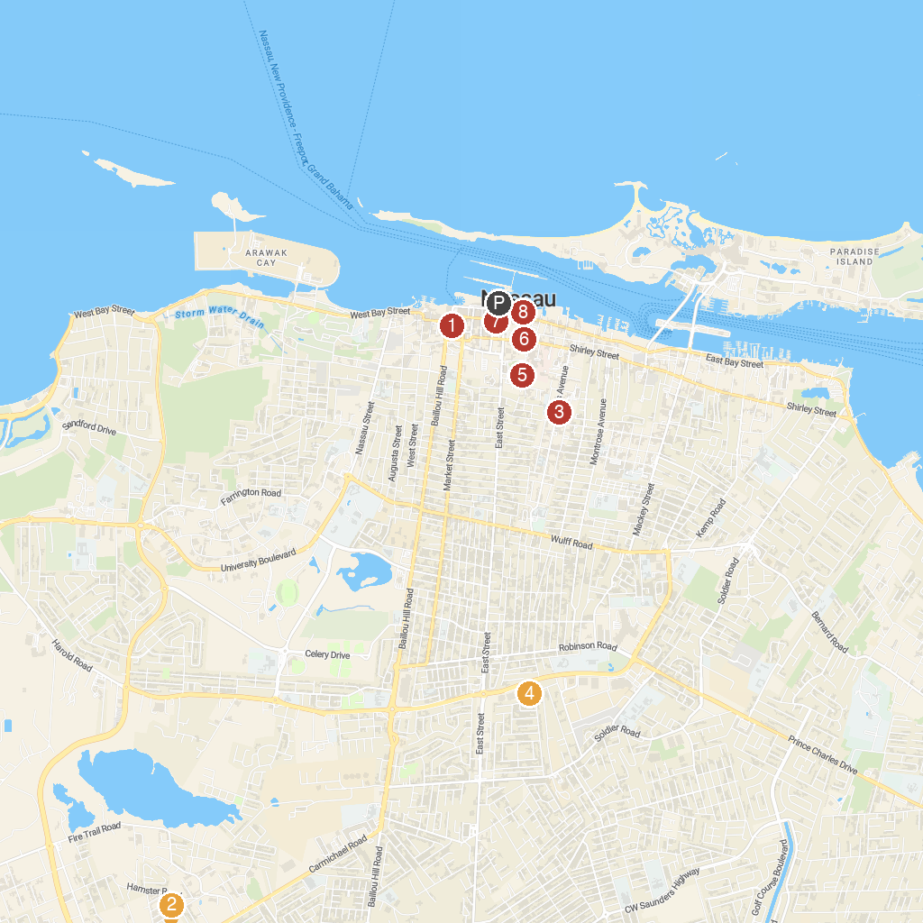
MAP KEY
1. Pirates of Nassau | 5. Fort Fincastle Water Tower
2. Jamaa' Ahlus-Sunnah Bahamas | 6. Bahamas Historical Society
3. Evangelistic Temple | 7. Parliament Square
4. New Covenant Baptist Church | 8. Bahamas Jet Boat
P. Cruise port / terminal
Map © MapTiler © OpenStreetMap contributors · cruiseports.org

